PRACTISE QUESTIONS – UNIT 1 MODULE 2
1 i) Describe the structure of a nucleotide and distinguish between a nucleotide and polynucleotide. (5)

ii) List THREE differences between DNA and RNA. (3)

2 i) The following is the sequence of bases in one of the two strands of part of a DNA molecule CAGGTACTG. What will be sequence of bases in the complementary strand? (1)

ii) The following sequence of bases in DNA codes for the formation of a short peptide chain: TACTTTAGAGGACCAGTAATT
(a) Show the sequence of bases you would expect to find in the corresponding messenger RNA molecule.(1)
(b) Using the table below work out the resulting sequence of amino acids in the finished peptide chain?
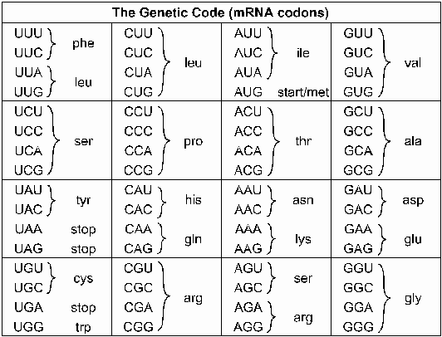(1)

3 Lysozyme is a protein made up of 129 amino acids.(a) How many DNA nucleotides are needed to encode for this chain of amino acids? (1)

(b) A complete turn of the DNA double helix contains 10 pairs of bases and is 3.4 nm long. What length of DNA molecule is occupied by the gene for lysozyme? (1)

(c) How many turns of the DNA double helix does this represent? (1)

1. | In 1961 biologists made synthetic mRNA. When they produced mRNA containing only uracil nucleotides, it coded for one type of amino acid, phenylalanine. When mRNA was produced with alternating uracil and guanine nucleotides, two types of amino acid were coded for, valine and cysteine. This is summarised in the table.
Nucleotide sequence in mRNA | Amino acids coded for
UUUUUUUUUUUUUUU | phenylalanine
UGUGUGUGUGUGUGU | valine and cysteine

 | (a) |  | For the amino acid phenylalanine what is
 |  |  | (i) | the corresponding DNA base sequence, (1)
(ii) |  | the tRNA anticodon? (1)
(b) |  | Explain how the information in the table supports the idea of a triplet code. (5)  2. The diagram shows the structure of a tRNA molecule.  (a) Give two ways in which the structure of a tRNA molecule differs from that of a DNA molecule. (2)
(b) |  | Explain how the specific shape of the tRNA molecule shown in the diagram is determined by the pattern of bonding. (2)  (c) (i) Give the base sequence of the anticodon of this tRNA molecule. (1)  (ii) Which mRNA codon would correspond to this anticodon? (1)

1. | (a) | State three ways in which the structure of messenger DNA differs from RNA.
 |  |  | (3)
 | (b) | Explain why exact replication of DNA is necessary in living organisms.
 |  |  | (2)
 | (c) | Name the enzyme involved in replicating the DNA molecule.
 |  |  | (1)

1.In the human thyroid gland the amino acid tyrosine is converted by a series of reactions into the hormone thyroxine. Insufficient thyroxine production may lead to mental and physical retardation.
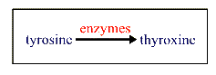
In about 1 in 5000 children, one of the enzymes involved in thyroxine production does not function effectively. The ineffective enzyme is a result of a gene mutation(a)(i) Give one way in which a gene mutation like this may have arisen.

(1)(ii)Give one factor which might increase the frequency at which gene mutation occurs.

(1)(b) Explain how a gene mutation may result in the production of an ineffective enzyme

(2)
NEAB1997

2.Mutations to DNA can affect the proteins produced by cells(a)Explain why a base deletion mutation, may have a greater effect than a base substitution mutation

(3)
(b)Name two agents, which can cause mutations.

(2)

1. |  | Read through the following passage on the cell cycle and mitosis, then write in the gaps the most appropriate word or words to complete the passage.
 | (a) | In the cell cycle DNA synthesis occurs during ________________. At the beginning of prophase _______________ condenses and chromosomes become visible. The end of prophase is characterized by the breakdown of the __________________________. The chromosomes become attached to the equator of the ______________ during ______________________. At anaphase the chromosome splits at the centromere and one copy heads towards each pole of the spindle. The final phase is called _______________ and it involves the formation of two new separate nuclei. In animal cells this phase is followed by ___________________. | (7)

2. | (a) | Explain why root tips are particularly suitable material to use for preparing slides to show mitosis.
 |  |  |  | (1)
 | (b) | Give a reason for carrying out each of the following steps in preparing a slide showing mitosis in cells from a root tip.
 |  | (i) | The tissue should be stained.
 |  |  |  | (1)
 |  | (ii) | The stained material should be pulled apart with a needle and gentle pressure applied to the cover slip during mounting.
 |  |  |  | (1)
 | (c) | The drawing has been made from a photograph showing a cell undergoing mitosis.
 |  | 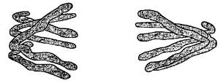
 |  | In which stage of mitosis is the cell shown in this drawing?
 |  |  |  | (1)

3. |  | The drawings A-E show stages of mitosis in an animal cell.
 |  | 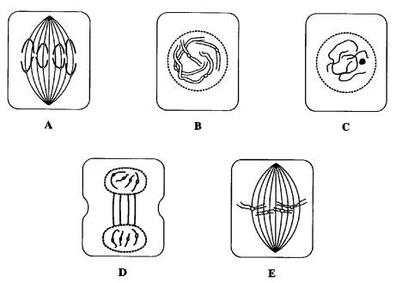
 | (a) | Which of the drawings A -E shows
 |  | (i) | anaphase;
 |  |  |  | (1)
 |  | (ii) | telophase;
 |  |  |  | (1)
 |  | (iii) | metaphase?
 |  |  |  | (1)
 | (b) | Give two processes which occur during interphase and which are necessary for nuclear division to take place.
 |  |  |  | (2)

1. | The table below diagrammatically shows the stages of mitosis in eukaryotic cells
 | a | Complete the table by filling in the missing stage labels and descriptions
 |  | ___________ - chromatin not visible - DNA, histones and centrioles all replicated  ___________ - _________________________________ - centrioles at opposite poles of cell - nucleolus disappears - phase ends with the breakdown of the nuclear membrane  Metaphase - _________________________________  Anaphase - _________________________________ - _________________________________  ___________ - spindle fibres disperse - nuclear membraness from - nucleoli form  ___________ - In animal cells a ring of actin filaments forms round the equator of the cell, and then tightens to form a cleavage furrow, which splits the cell in two. | (8)
 | b | Explain the importance of mitosis to living organisms.  1. The diagram shows the life cycle of a moss.  (a) Mark the diagram with a cross to show where meiosis occurs. (1)  (b) A spore of this organism contains 16 chromosomes. How many chromosomes would you expect to find in:  (i) a female gamete  (1)  (ii) a cell taken from the the moss during the diploid stage of its life cycle?  (1)  (c) Suggest two ways in which the male gametes of this organism are likely to differ from female gametes.  (2)  1. The diagram shows the life cycle of a single-celled organism. The zoospores are produced by cell division and are small versions of the adult  (a) Mark with an X on the diagram where meiosis takes place in this life cycle.  (1)  (b) Explain  (i) why the zoospores labelled X on the diagram all have the same genotype (genetic constitution)  (2)  (ii) why the zoospores labelled W will have a variety of different genotypes  (2)  (c) If a zoospore of this organism contained 4 chromosomes. How many chromosomes would you expect to find in  (i) the gamete from another organism  (1)  (ii) the adult organism  (1)  (iii) the zygote  (1)  1. The human gene for alpha-1-antitrypsin was introduced into fertilised eggs of sheep and the eggs implanted into surrogate mothers. Some surrogates produced transgenic female animals which secrete AAT in their milk  a State how the gene for AAT could have been inserted into the egg cells of sheep  (1)  b Give a human disease is AAT used to treat?  (1)  c Explain why bacteria could not be used to produce the human protein AAT  (2)  d Explain what is meant by transgenic animals  (2  1. Insulin is a hormone that is required to regulate blood glucose in humans. Certain forms of the disease diabetes are caused by an inability to produce insulin. In order to produce insulin artificially the insulin gene is isolated from a human cell and then inserted into a plasmid. The DNA responsible for the synthesis of insulin is then inserted into a bacterium.  (a) State a general term for this technique  (1)  (b) Explain why the plasmid is described as a vector.  (2)  (c) Outline the role of the bacterium in the process once the vector has been inserted into the host cell.  (4)  1. One of the aims of genetic engineering is to produce a protein as cheaply and easily as possible. In order to do this, the gene that triggers production of the desired protein is inserted into a host organism.  (a) State three reasons why bacteria make good host organisms.  (3)  (b) Define a vector in relation to genetic engineering?  (1)  (c) Define a plasmid in relation to genetic engineering?  (1)  Bacillus thuringiensis is a bacterium that parasitises the caterpillars of some harmful moths (e.g. gypsy moths). The bacteria kill by a toxin which they secrete. The gene for this toxin has been introduced into some crop plants in an effort to protect them from attack by gypsy moths without spraying. Transgenic cotton plants that express the gene for the Bt toxin are resistant to gypsy moth infestations.  (a) Explain the possible advantages and disadvantages of introducing what is effectively an insecticide producing gene into plants. | (3)

