PRACTISE QUESTIONS – UNIT 1 MODULE 1

- Glycogen, cellulose, polypeptides and phospholipids all have large molecules.
(a) |  | Which of these molecules is
 | (i) | not found in a plant cell;
 |  |  | (1)
 | (ii) | used primarily as a structural molecule?
 |  |  | (1)
(b) |  | Give one element found in polypeptides that is not present in those of glycogen, cellulose or phospholipids.
 |  |  | (1)
The diagram represents a phospholipid molecule
 |  | 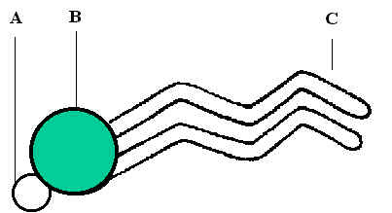
(c) |  | Name the following parts of the molecule
 | (i) | A
 |  |  | (1)
 | (ii) | B
 |  |  | (1)
 | (iii) | C
 |  |  | (1)
(d) |  | Phospholipids are found in cell membranes. Proteins are also found in cell membranes, give two functions of proteins in cell membranes
 |  |  | (2)

- The diagram below shows two amino acids
 |  | 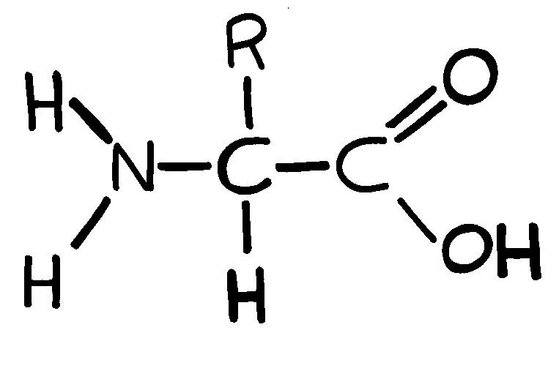 | +
a |  | Draw the result of these two amino acids forming a dipeptide
 |  |  |  |  | (2)
b |  | Name the chemical reaction used to form the dipeptide
 |  |  |  |  | (1)
c |  | Name the type of bond which links the two amino acids in the dipeptide
 |  |  |  |  | (1)
d |  | State what the R shown in the amino acid diagrams refers to
 |  |  |  |  | (1)
e |  | Describe how you perform a biochemical test to identify proteins
 |  |  |  |  | (2)

- a | Complete the table below by responding to each statement

Statement | Starch | Maltose | Glycogen
Is a polymer of glucose
Contains glycosidic bonds
Can act as an energy store in plant cells
Is a disaccharide

(4)

b | Describe how you would perform a test to check for the presence of starch

(2)

- The diagram below shows a molecule of maltose.
 |  | 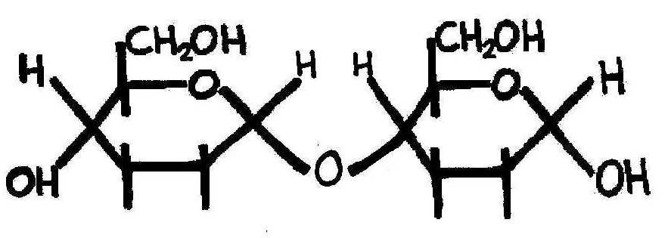
This molecule can be broken into two glucose molecules by a chemical reaction
(a) | (i) | What type of reaction would this be
 |  |  |  | (1)
 | (ii) | What substance would need to be added for this reaction to proceed
 |  |  |  | (1)
 | (iii) | Draw below one of the glucose molecules that would be formed by this reaction
 |  |  |  | (1)
(b) |  | Describe how you would perform a test to indicate that a substance contained sucrose and not glucose
 |  |  |  | (4)

- a) | The diagram shows the formula of a molecule of an organic compound
 | 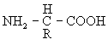
 | (i) | To which group of organic compounds does this molecule belong?
 |  |  | (1)
 | (ii) | Give one way in which this molecule differs from other compounds in the group.
 |  |  | (1)
(b) | The table shows some of the organic compounds found in a bacterial cell.
Compound | % of total dry mass | Number of different types of molecule
Protein | 55.0 | 1050
DNA | 3.1 | 1
Lipid | 9.1 | 4
Glycogen | 2.5 | 1

 | Glycogen and protein are both polymers. Explain why there can only be one type of glycogen molecule, but there can be many types of protein.
 |  |  | (2)

1. How an atom behaves when it comes into contact with other atoms is determined by its
- a. nucleus.
- b. size.
- c. protons.
- d. neutrons.
- e. electrons.
2. Cellulose is a _____ made of many _____.
- a. polypeptide . . . monomers
- b. carbohydrate . . . fatty acids
- c. polymer . . . glucose molecules
- d. protein . . . amino acids
- e. lipid . . . triglycerides
3. In a hydrolysis reaction, _____, and in this process water is _____ .
- a. a polymer breaks up to form monomers . . . consumed
- b. a monomer breaks up to form polymers . . . produced
- c. monomers are assembled to produce a polymer . . . consumed
- d. monomers are assembled to produce a polymer . . . produced
- e. a polymer breaks up to form monomers . . . produced
4. The four main categories of macromolecules in a cell are
- a. proteins, DNA, RNA, and steroids.
- b. monosaccharides, lipids, polysaccharides, and proteins.
- c. proteins, nucleic acids, carbohydrates, and lipids.
- d. nucleic acids, carbohydrates, monosaccharides, and proteins.
- e. RNA, DNA, proteins, and carbohydrates.
5. The characteristic that all lipids have in common is
- a. they are all made of fatty acids and glycerol.
- b. they all contain nitrogen.
- c. none of them is very high in energy content.
- d. they are all acidic when mixed with water.
- e. none of them dissolves in water.
6. The overall three-dimensional shape of a polypeptide is called the
- a. double helix.
- b. primary structure.
- c. secondary structure.
- d. tertiary structure.
- e. quaternary structure.
7. Which of the following do polysaccharides and proteins have in common?
- a. They are both made of amino acids.
- b. Their structures contain sugars.
- c. They are hydrophobic.
- d. They are large polymers.
- e. They each consist of four basic kinds of subunits.
8. A glucose molecule is to starch as
- a. a steroid is to a lipid.
- b. an amino acid is to a protein.
- c. a nucleic acid is to a polypeptide.
- d. a fat is to glycerol.
- e. an amino acid is to a nucleic acid.
9. Which of the following ranks the molecules in the correct order by size?
- a. water . . . sucrose . . . glucose . . . protein
- b. protein . . . water . . . glucose . . . sucrose
- c. water . . . protein . . . sucrose . . . glucose
- d. protein . . . sucrose . . . glucose . . . water
- e. glucose . . . water . . . sucrose . . . protein
10. Lipids differ from other large biological molecules in that they
- a. are much larger.
- b. are not truly polymers.
- c. do not have specific shapes.
- d. do not contain carbon.
- e. contain nitrogen atoms.

- The diagram below shows the structure of a chloroplast.
 |  | 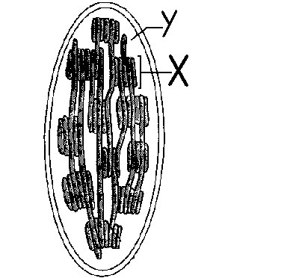
a. |  | Name the process that occurs in chloroplasts
 |  |  | (1)
b |  | Name the structures labeled.
 | (i) | X.
 |  |  | (1)
 | (ii) | Y
 |  |  | (1)
c |  | Give two similarities in structure between chloroplasts and mitochondria.
 |  |  | (2)
d |  | Some scientists think that chloroplasts and mitochondria have evolved from intracellular symbiotic bacteria. Explain why
 |  | the structures of mitochondria and chloroplasts can account for this hypothesis.

- a | Complete the following table with ticks and crosses

 | Osmosis | Facilitated Diffusion | Active Transport
From High to Low concentration
Requires ATP
Transport through intrinsic membrane proteins
Can be controlled by cell

 |  | (4)
b | Describe a cell capable of taking up glucose (a monosaccharide) by active transport may be incapable of taking up fructose (another monosaccharide) by active transport

Multiple choice Cells questions
1. To enter or leave a cell, substances must pass through
- a. a microtubule.
- b. the Golgi apparatus.
- c. a ribosome.
- d. the nucleus.
- e. the plasma membrane.
2. Bacterial cell are prokaryotic; in comparison to a typical eukaryotic cell they would
- a. be smaller.
- b. have a smaller nucleus.
- c. lack a plasma membrane.
- d. have fewer internal membranous compartments.
- e. have a greater variety of organelles.
3. You would expect a cell with an extensive Golgi apparatus to
- a. make a lot of ATP.
- b. secrete a lot of material.
- c. move actively.
- d. perform photosynthesis.
- e. store large quantities of food
4. Which of the following correctly matches an organelle with its function?
- a. mitochondrion . . . photosynthesis
- b. nucleus . . . cellular respiration
- c. ribosome . . . manufacture of lipids
- d. lysosome . . . movement
- e. central vacuole . . . storage
5. Of the following organelles, which group is involved in manufacturing substances needed by the cell?
- a. lysosome, vacuole, ribosome
- b. ribosome, rough ER, smooth ER
- c. vacuole, rough ER, smooth ER
- d. smooth ER, ribosome, vacuole
- e. rough ER, lysosome, vacuole
6. A cell has mitochondria, ribosomes, smooth and rough ER, and other parts. Based on this information, it could not be
- a. a cell from a pine tree.
- b. a grasshopper cell.
- c. a yeast (fungus) cell.
- d. a bacterium.
- e. Actually, it could be any of the above.
7. The electron microscope has been particularly useful in studying bacteria, because
- a. electrons can penetrate tough bacterial cell walls.
- b. bacteria are so small.
- c. bacteria move so quickly they are hard to photograph.
- d. with few organelles present, bacteria are distinguished by differences in individual macromolecules.
- e. their organelles are small and tightly packed together

8. Cell fractionation is the most appropriate procedure for preparing ____ for study.
- a. isolated cells which are normally found tightly attached to neighbouring cells
- b. cells without a functional cytoskeleton
- c. isolated organelles
- d. the basic macromolecules
- e. bone and other similar cells which are situated within a mineral framework
9. Which of the following clues would tell you whether a cell is prokaryotic or eukaryotic?
- a. the presence or absence of a rigid cell wall
- b. whether or not the cell is partitioned by internal membranes
- c. the presence or absence of ribosomes
- d. whether or not the cell carries out cellular metabolism
- e. whether or not the cell contains DNA
10. Sara would like to film the movement of chromosomes during cell division. Her best choice for a microscope would be a
- a. light microscope, because of its resolving power.
- b. transmission electron microscope, because of its magnifying power.
- c. scanning electron microscope, because the specimen is alive.
- d. transmission electron microscope, because of its great resolving power.
- e. light microscope, because the specimen is alive.

- The micrograph below of a fish's gill clearly shows the secondary lamellae arranged at 90degrees to the gill filaments
 |  | 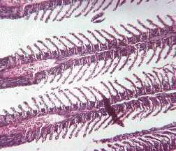
a | i | Using information from the micrograph explain why the structure of the gills make them efficient at exchanging gases between blood and water
 |  |  | (4)
 | ii | The flow of blood and water through the secondary lamellae is often described as countercurrent. Explain the significance of this in relation to gas exchange
 |  |  | (2)
b |  | Name the structure labelled X in the diagram below
 |  | 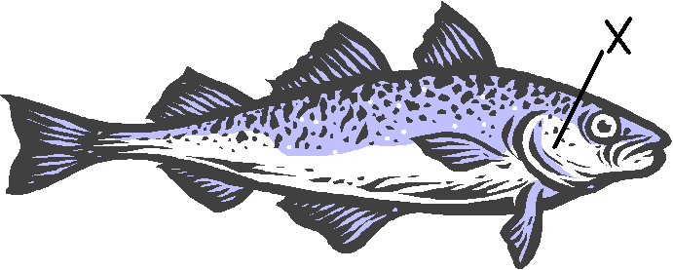

  - The diagram below shows the rate of an enzyme controled reaction. The solid line indicates the normal relationship between rate and substrate concentration and the dotted line indicates the relationship when a competitive inhibitor is added.
 | 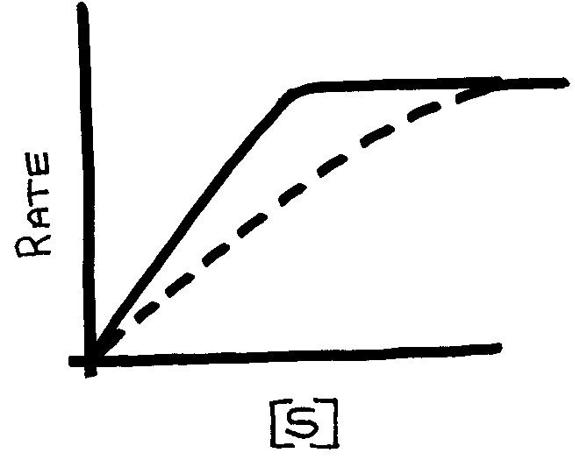
a.i) | Explain how a competitive inhibitor acts
 |  |  | (2)
ii) | Explain why in the graph above the inhibitor is a competitive inhibitor?
 |  |  | (2)
The graph below shows the relationship between rate of reaction and temperature of most enzyme reaction.
 | 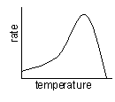
b. | Explain why the relationship is that shown on the graph.
 |  |  | (5)

  - Read through the following passage and then decide which words should be placed in the gaps.
a | Enzymes are globular proteins which act as biological catalysts. They are able to temporarily bind with substrate molecules due to an region know as the_____________________. Because enzymes are proteins their activity can be affected by pH and ___________________. The catalytic ability of enzymes depends on their three dimensional shape, this is more commonly refered to as the enzymes __________ structure. During an enzyme catalysed reaction a transition occurs during which the reactants are referred to as the ______________________.

