Immunology
An infectious disease is caused by pathogens, where they are said to be parasitic. Pathogens are organisms that live on or in their host, and gain nutrients from that host. There are two types of pathogens:
- Ectoparasites (i.e. bed bugs, louse, mites, ticks and fleas) attach themselves to the outside of the host. With the aid of specialised mouthparts they penetrate the skin and feed on their hosts blood. The parasites must have efficient structures for ‘hanging’ on because usually the host is quite mobile.
- Endoparasites (i.e. bacteria, viruses, roundworm, tapeworm, flukes and protozoa) – live inside the host. Therefore they have developed different ways of gaining nutrients from the host. Endoparasites inhabit the human gut, blood vessels, blood cells, muscles, liver and lungs. Their lifecycles are usually very complex, and have adapted highly specialised features in order to live a ‘life on the inside’.
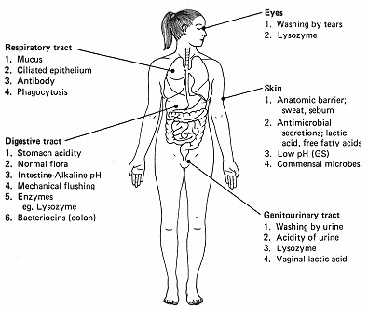
Many pathogens do not harm us because we have physical, chemical and cellular defences that prevent them from entering the body. If they do enter, then our immune system can prevent them from spreading though the body. The immune system is involved in the recognition and rejection of foreign cells and tissues.
All of the cells in your body contain membrane proteins. In module 1 you would have studied membrane proteins such as channel proteins, carrier proteins and protein pumps that transport material in and out of cells. Other membrane proteins can combine with carbohydrate and lipid molecules to function as a sort of ‘name tag’ that identifies your cells as belonging to your body. Most of the white blood cells of your immune system recognise a foreign cell or virus as something that does not belong in your body, because that foreign cell or virus does not have the correct ‘name tag’. When white blood cells of the immune system identify the foreign cell or virus, white blood cells respond by attacking the invader. Any protein/carbohydrate/lipid name tag that can trigger a response by the immune system is called an antigen.
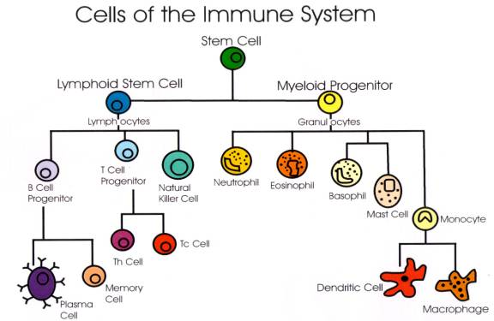
White blood cells are important in the body’s natural defenses against pathogens. The following table identifies the major WBCs function and the type of immune response:
White Blood Cell Type | Function | Immune System Category
Monocytes | Exit blood vessels and turn into macrophages. Engulf invaders and debris by phagocytosis | Non-specific
Neutrophils | Stay in blood vessels and engulf invaders and debris by phagocytosis | Mainly non-specific but can be specific when directed by antibody targeting.
Basophils | Release histamines and participate in the inflammatory and allergic reactions | Non-specific
Eosinophils | Chemically attack parasitic invaders similar to natural killer cells | Non-specific
Lymphocytes | Form T-cells and B-cells | Specific except for Natural killer cells
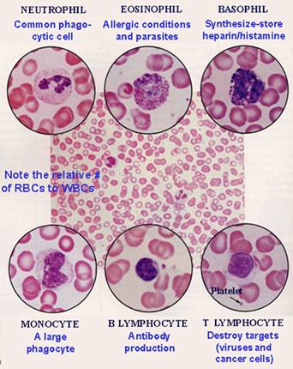
The immune system has two main components the non-specific and specific immune response
Non-specific immune response
  - Physical, chemical and cellular defenses that prevent microbes from entering the body
  - Present from birth.
  - A quick-response system effective against a wide range of pathogens and foreign substances.
  - This system does not distinguish between different pathogens
  - It always gives the same response.
  - E.g. foreign substance entering the skin
    - mast cells release histamine at the damaged tissue which cause acute inflammation involving pain, heat, redness, swelling, and sometimes loss of function of the affected part of the body. This increases blood flow to the area.
    - Histamines cause capillaries to leak, releasing phagocytes (large white blood cells) which engulf the foreign material
    - Platelets move out of capillary to seal the wounded area
    - cytokines can also be produces if a virus infects the body. Cytokines small proteins that inhibit the production of viruses
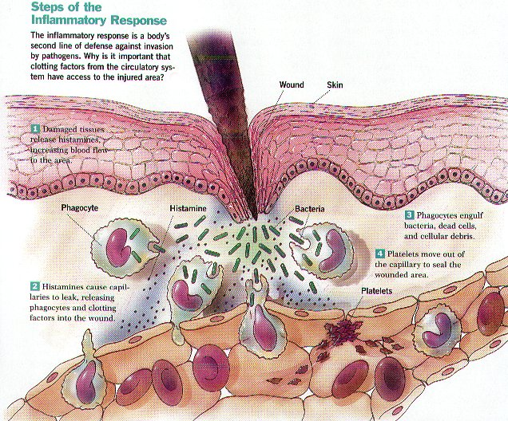

Summary of the Non-Specific Immune Response:
Component | Functions
Skin and mucous membranes – mechanical factors
Intact skin | Forms a physical barrier to the entrance of microbes.
Mucous membranes | Inhibit the entrance of many microbes, but not as effective as intact skin.
Mucus | Traps microbes in respiratory and digestive tracts.
Hairs | Filter microbes and dust in nose.
Cilia | Together with mucus, trap and remove microbes and dust from upper respiratory tract.
Tear ducts | Tears dilute and wash away irritating substances and microbes.
Saliva | Washes microbes from surfaces of teeth and mucous membranes of mouth.
Epiglottis | Prevents microbes and dust from entering trachea.
Urine | Washes microbes from urethra.
Skin and mucous membranes – chemical factors
Gastric juice | Destroys bacteria and most toxins in stomach.
Acid pH of skin | Discourages growth of many microbes.
Unsaturated fatty acids | Antibacterial substance in sebum.
Lysozyme | Antimicrobial substance in perspiration, tears, saliva, nasal secretions, and tissue fluids.
Antimicrobial substances
Interferon (IFN) | Protects uninfected host cells from viral infection.
Complement | Causes lysis of microbes. Promotes phagocytosis, contributes to inflammation attracts white blood cells to site of infection
Other responses
Phagocytosis | Ingestion and destruction of foreign particles by microphages and macrophages.
Inflammation | Confines and destroys microbes and repairs tissues.
Fever | Inhibits microbial growth and speeds up body reactions that aid repair.

Specific immune response
Specific immune response occurs when a particular antigen passes the body’s passive defenses. It involves cells and proteins within the blood and lymph that attach, disarm, destroy and remove foreign bodies. The specific system gives a highly effective, long lasting immunity against anything the body recognise as foreign. It responds to specific microorganisms and enhances the activity of the non-specific system.
The central feature of the specific immune system is the ability to distinguish between self and non-self. Every cell has complex molecules (proteins and glycoproteins) on its surface membrane which act as recognition devices and have specific shapes. These molecules are called antigens or immunoglobins. The immune system is usually tolerant to the body’s own antigens (self antigens) and does not attack against them. However, breakdown of the recognition system can lead to autoimmune disease such as AIDS and rheumatoid arthritis, which result in self-destruction of body parts.
When a foreign organism (bacteria, viruses or even another person’s cells) enters the body, the foreign antigens on the invading cells activate an immune response. The foreign antigens are called non-self antigens. The immune system produces antibodies and specialised cells that attempt to destroy foreign cells and particles that have entered the body. There are two types of responses:Humoral(antibody) response (involving B cells) and cell mediated immunity (involving T cells).
Humoral (antibody-mediated) Response - B-cells [back to top]
The humoral immune response is initiated by an activation phase. This is where macrophages (white blood cells) engulf and digest microbes (including their antigens) through a process of called phagocytosis.
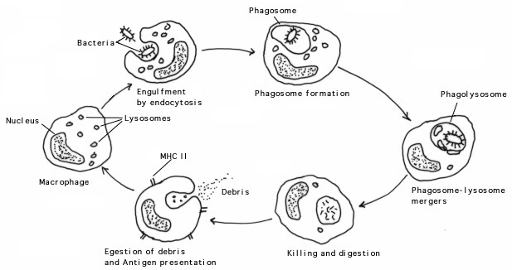
Some of the digested antigens are then displayed on the surfaces of the macrophages (called epitopes). This display provides other cells of the immune system with an opportunity to recognise the invader and become activated. This is called antigen presentation.
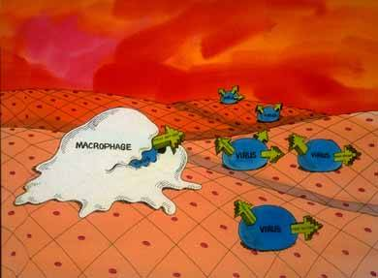
- During antigen presentation the macrophage selects T-helper cells and B-cells that have membrane receptors that are complementary in shape to the antigens exposed. This is known as clonal selection.
- T-helper cells (T_{h} cells – see cell mediated response) recognise and bind to the displayed antigens. This then initiates the next phase of the humoral response (B and T cells).
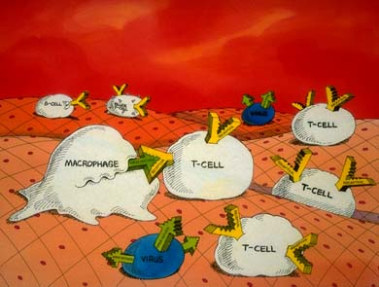
- In the next phase, called the effector phase, activated T_{h} cells trigger specific B-cells to proliferate and release antibodies. These antibodies bind to the invader and fight infection.
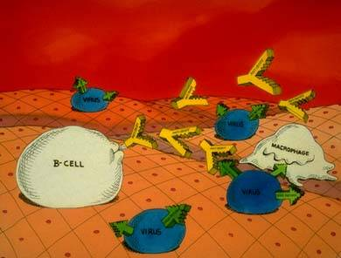
The effector phase involves specific lymphocytes (white blood cells) that mature in the bone marrow. These are called B lymphocytes (B-cells). B-cells can produce a specific antibody in response to a particular antigen. An antibody is a type of globular protein that reacts with a specific antigen.

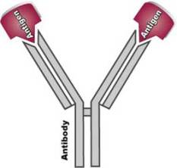 | 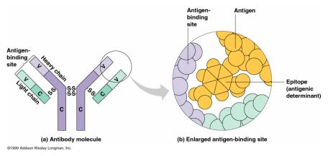
Antibodies are y-shaped molecules composed of heavy chains and light chains, which are kept together by S-S bonds. The ends of the Y arms are the binding sites for an antigen.
When a B cell meets an antigen it will divide through mitosis and after several generations will differentiate into plasma cells. All plasma cells are formed from one type of B cell and will secrete the same antibody. Plasma B-cells can synthesise and secrete up to 2000 antibody molecules per second! The antibodies produced circulate in the blood and lymph or secrete antibodies onto the surfaces of mucous membranes, such as those found lining the lungs.
Different antibodies work in different ways:
- agglutination makes pathogens clump together
- antitoxins neutralise the toxins produced by bacteria
- lysis digests the bacterial membrane, killing the bacterium
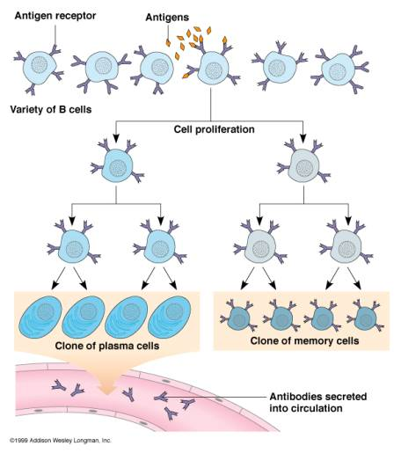
- opsonisation coats the pathogen in protein that identifies them as foreign cells.
When confronted with an antigen for the first time, B cells produce memory cells as well as plasma cells; this is called the primary response. The primary response is usually slow, taking days or even weeks to recruit enough plasma cells to bring an infection under control. However, when a second invasion occurs, the response is quicker. Memory cells are involved in the secondary response and stick to and destroy antigens

Cell Mediated Response - T Cells
The cell-mediated response involves cells that are specific to the antigens on the invading pathogens. The cells involved are lymphocytes, called T cells, which mature in the thymus. In the thymus the T cells develop surface receptors called T-cell receptors where they become ‘programmed’ for the antigen of their specific enemy. Many different kinds of T cells are produced which recognise, attach and destroy infected, mutant or ‘foreign’ cells. After encountering a specific foreign antigen, T cells reproduce rapidly, however they do not produce antibodies like B cells.
Macrophages that have ingested foreign material carry some of the foreign antigen on their surface. The macrophages then carry the foreign cells to the T helper (T_{h}) and T killer (T_{k}) cells in the lymph nodes, spleen and blood.
- The Helper T-cells, T_{h} (as the name would suggest, help other cells of the immune system) recognise the non-self antigen (from the foreign cells) that the macrophages display on their outer surface. The T_{h} recognise the antigens and stimulate B cells to proliferate - B cells will not reproduce and form plasma cells with out assistance from helper T cells.
- T helper cells also secrete proteins (interlukin and lymphokines) that stimulate other B and T cells to divide, where some of the cells become effector cells and memory T cells.
  - Lymphokines stimulate macrophages to engulf invading cells.
  - The interlukin can stimulate cytotoxic T cells (T_{c})
- Cytotoxic (killer) T cells attacks body cells that have been infected by virus, bacteria or fungus.
  - A T_{c} cell identifies its antigen, where in this case a viral protein coat is left outside the infected cell, and kills the infected cell before the virus has time to replicate.
  - T_{c} cells kill the infected cells by secreting proteins (perforin) that punch holes in the membrane of the cell, and the contents ooze out.
  - T_{c} cells cannot kill isolated virus particles, as they need the viral antigen before they become activated.
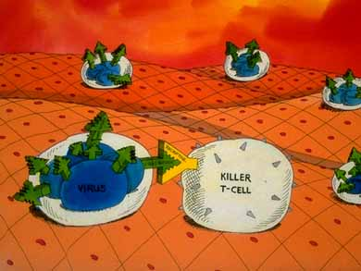
- Natural killer (N_{k}) cells have the same response as T_{c} cells, however they may attack tumor and other cancerous cells.
- Once the T_{h} and T_{c} cells are activated, they divide many times, where some of the cells become effector T cells, and others as memory cells, where they migrate to the lymph nodes to be activated quickly upon a second invasion.
Another type of T-cells is the T-suppressor cells, T_{s} – These play an important role in regulating that action of the lymphocytes, where they can help prevent the immune system overreacting to a stimulus.
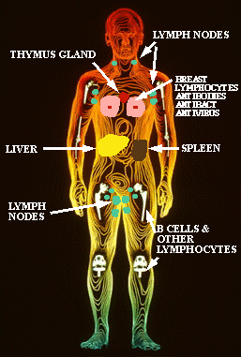
When the B and T cells develop in the bone marrow and thymus (respectively), they enter the blood stream, then leave it, and move around the body in the lymphatic system.
The immune system contains a number of lymphoid tissues and organs, such as the spleen, tonsils, and lymphnodes; these are connected to a network of vessels (similar to that of the blood).
The lymphatic vessels contain lymph, which drains from nearby tissues. Memory B and T cells circulate in the lymph, ready to react with their antigen. Antigens that enter the body are carried by the macrophages to a lymphatic organ, where there is a high concentration of white blood cells, such as T_{h} and T_{c} cells.
If you have an infection, you may have noticed that your glands (lymph nodes) may be swollen and sore, indicating that you have an infection of some kind
Summary of the immune response involving B and T cells
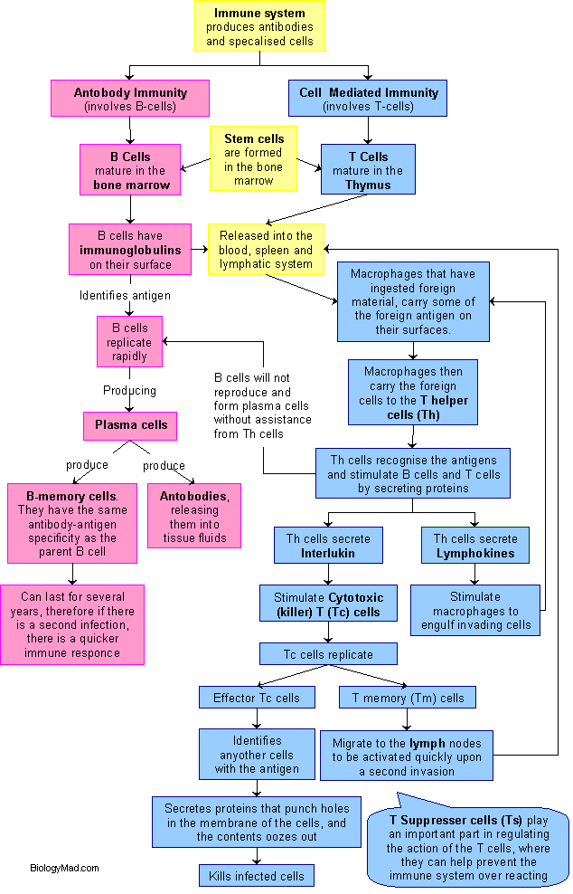
Immunity
Types of immunity:
Natural passive immunity - Antibodies made in one individual are passed into another individual of the same species. This only affords temporary protection, for, as the antibodies do their job, or are broken down by the body's natural processes, their number diminishes and protection is slowly lost. For example, antibodies from a mother can cross the placenta and enter her foetus. In this way they provide protection for the baby until its own immune system is fully functional. Passive immunity may also be conferred by colostrum (the mother’s first milk), from which antibodies are absorbed from the intestines of the baby.
Acquired passive immunity - Here, antibodies which have been made in one individual are extracted and then injected into the blood of another individual which may, or may not, be of the same species. For example, specific antibodies used for combating tetanus and hepatitis B are cultured in horses and later injected into Man. They act to prevent tetanus and hepatitis respectively. This type of immunity is again short-lived – a matter of weeks only.
Natural active immunity - The body manufactures its own antibodies when exposed to an infectious agent. Since memory cells produced on exposure to the first infection are able to stimulate the production of massive quantities of antibody, when exposed to the same antigen again. This type of immunity is most effective and generally persists for a long time - sometimes even for life.
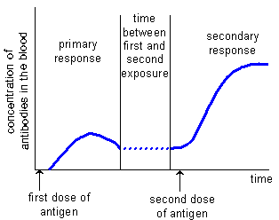
When a bacterial infection occurs and an antigen is presented for the first time, time is taken for the B and T cells to proliferate. Once the B cells have differentiated into plasma cells, specific antibodies can be secreted. This primary response lasts several days or weeks and then the concentration of antibody decreases as the plasma cells stops secreting them. Once the infection is eradicated, plasma cells die, but B memory cells are left in the body.
If another infection of the same pathogen occurs, then the same antigen is reintroduced. There is a more rapid response, called thesecondary response. This is much faster because there are many more memory B-cells that can produce many plasma cells and the appropriate antibody. These destroy the pathogen before it has the chance to cause any symptoms to occur.
Memory cells are the basis for immunological memory – they last for many years, often a lifetime. It is possible for suffer repeated infections from a single pathogen because pathogens occur in different form, each having minor changes in the shape of the antigen, due to a possible mutation, and therefore requiring a primary response.
Acquired active immunity - This is achieved by injecting small amounts of antigen - the vaccine - into the body of an individual. The whole process is called vaccination or immunisation. The small dose of antigen is usually safe because the pathogen is either killed or attenuated (= crippled). This ensures that the individual does not contract the disease itself, but is stimulated to manufacture antibodies against the antigen. Often a second, booster, injection is given and this stimulates a much quicker production of antibody which is long lasting and which protects the individual from the disease for a considerable time. Several types of vaccine are currently in use.

Vaccinations
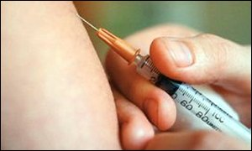
Currently vaccines come in three forms:
- Living attenuated microbes: These are mutants of microbes that have lost the ability, either naturally or by treatment in the laboratory, to produce the dangerous, clinical disease. Some examples are the cowpox virus, measles, mumps and rubella (MMR vaccine) and polio vaccine virus. A vaccination consists of infecting you with a living microbe which then produces a limited infection. Because these attenuated strains are weak the immune system of normal healthy people quickly kill and eliminate them from the body. During this process the infection elicits a vigorous immune response that protects the host from infection by the related virulent, disease-producing form of the pathogen. Live vaccines produce the best immunisation because they closely imitate the real thing. Immunity lasts for life.
- Dead Microbes: These vaccines consist of growing up cultures of the virulent, disease-producing microbial strains and killing them in such a way that they retain their ability to stimulate the body to produce an immunological response to the live form. Examples include anthrax and rabies vaccine. Immunity lasts several years.
- Virulence of Components of Pathogens: These vaccines consists of substances isolated from the virulent strains, such as polysaccharide material or proteins components. No whole organisms, living or dead are present in these vaccines. Examples include the toxins of diphtheria, tetanus and botulinum and the polysaccharide from virulent pneumococci.
- Vaccinations by eating: Experiments are underway to deliver vaccines through common foods like potatoes and bananas. Genes that make an antigen effective against a microbe are cloned into a common food. The food is eaten by the "patient" and the cloned-antigen stimulates the immune system.
- DNA Vaccines: Vaccines consisting of DNA fragments that can be transformed into host tissue. Once in the host tissue, the DNA is transcribed and translated and the protein produced is seen by the specific immune system as foreign material and an immune response is induced.
Are vaccines safe to use?
It is never possible to prove that any medical treatment is totally safe for all people under every set of conditions. The safety of medical procedures and agents always carry a degree of risk, just as driving your car to work always carries a degree of risk.
- The live vaccines present the highest risk because it is always possible that a mutation may occur that reverts the avirulent strain to virulence or that a particular individual will be susceptible to the avirulent strain; i.e., that it will be "virulent" only for that individual. This has happened in the case of smallpox where an occasional person, usually a child, develops a severe, often fatal, disease caused by the smallpox vaccine.
- Killed vaccines have had safety problems when the lethal treatment failed to kill 100% of the microbes. The problem is that if you over treat the microbe to be certain that all the organisms are dead you can destroy the immunising components and make the vaccine ineffective. So the killing treatments must balance. Also it is difficult to detect the one live organism present in a 1,000 liters of treated material, yet one live organism is sufficient to produce a lethal infection.
- The use of chemical components of pathogens also carries some risks. Some people will react violently to these substances, usually in an allergic reaction, and they can be seriously harmed or even killed as a result. The DPT vaccine combination has caused such reactions.
- Recent scientific studies have presented evidence that Haemophilus influenzae type b vaccination does not induce type 1 diabetes, nor is Pertussis vaccination a risk factor contributing to the rising rate of asthma and allergies.
This is a decision that each individual must make for themselves and their children, but it should be an informed decision and not one made from scary tales told over the back fence or from the tabloids. Modern vaccines are about as safe as anything in this dangerous world. Everyone who drives or is driven on the highways is in far more danger of harm than they are being vaccinated.
The UK is one of the safest countries in the world when it comes to communicable diseases, but we probably are not the safest. Diseases are always present and they do not recognise borders. We are so intimately connected with the rest of the world today that diseases can appear from anywhere. The strawberries or lettuce you just purchased at the supermarket yesterday may have come from a country with far less sanitation than we practice, or the person you sit by on the bus may be a recent immigrant or traveller coming from another country that is carrying a disease the UK is "free" of. In these cases your only real protection is vaccination. Think about it!

