The Nervous System - Summary

The 'neurone'
The nervous system carries messages around the body using specialised cells calledneurones. Neurones convey their 'messages' using electrical impulses.

The central nervous system and the peripheral nervous system
The nervous system (NS) is made up of two parts:
- Central nervous system comprising the brain and spinal cord.
- Peripheral nervous system.
A simple way of thinking about the interaction between the two systems is to imagine them as roads, and the messages as cars.
The 'car' starts off in small roads (peripheral nervous system) and heads towards to the brain. In order to get there faster it takes the motorway (central nervous system) which gets the 'car' to its final destination - the brain - very quickly.
See how this happens in the diagram below:

The somatic (voluntary) and autonomic (involuntary) nervous system
Different areas of the nervous system are used for different types of nervous reaction:
- Conscious control - for example, your brain consciously deciding to move a moving skeletal muscle, and this uses the somatic/voluntary NS.
- Non-conscious control - for example, your body automatically reacting to, and this uses the autonomic NS.
Generally, with the autonomic NS, if the outcome increases activity - for example, if the heart rate goes up, it involves the sympathetic NS.
If the outcome is to decrease activity - for example, if the breathing rate goes down, it involves theparasympathetic NS.

Sensory neurones and motor neurones
Receptors are cells that detect stimuli - for example, heat, pressure, light.
Sensory neurones bring impulses from receptors to the central nervous system (CNS).
From there, the impulse may pass on to a motor neurone to be taken to a muscle or gland (the effector).
Sometimes there is an intermediate neurone (also known as a 'relay' neurone) within the CNS linking the sensory neurone with the motor neurone.
To be able to understand how the impulses are transmitted through a neurone, you must first know what the cell is like at rest.

Formation and Transmission of Impulses

Resting potential
In the surface membrane of a cell there are protein carriers.
These actively pump Na⁺ (Sodium) ions out of the cytoplasm to the outside of the cell. At the same time, K⁺ (Potassium) ions are pumped from the outside in.
This active pumping of Na⁺ and K⁺ ions requires energy (in the form of ATP) because the ions are being moved against their concentration gradients (from where they are at a lower concentration to where they are at a higher concentration). K⁺ and Na⁺ ions diffuse back down their concentration gradient but K⁺ diffuses back out of the cell faster than Na⁺ can diffuse back in.
This means there is a net movement of positive ions out of the cell making the inside of the cell negatively charged, relative to the outside.
This charge is the resting potential of the cell and is about -70mV.

Action potential
When a receptor is stimulated, it will create a positive environment inside the cell.
This is caused by a change in the concentrations of Na⁺ and K⁺ ions in the cell and happens in a number of steps:
- There is a change in permeability (the ability of the cell membrane to let ions through it) to Na⁺ and K⁺ in the cell surface membrane at the area of stimulation, which causes Na⁺ channels in that area to open.
- Na⁺ therefore floods into the cytoplasm down the concentration gradient.
- As this happens the membrane depolarises (this means that the resting potential of the cells starts to decrease). If this depolarisation reaches a certain level, called the threshold level (about -55 to -50 mV), then an action potential has been generated and an impulse will be fired. If it does not reach this level, nothing will happen.
- Once +40mV is reached the Na⁺ channels close and K⁺ channels open. K⁺ floods out of the cytoplasm so that the overall charge inside goes back down. This stage is called repolarisation.
- The K⁺ channels then close, the sodium-potassium pump restarts, restoring the normal distribution of ions either side of the cell surface membrane and thus restoring the resting potential.
An example of an action potential being reached would be pressure receptors cells in the skin which. If your hand was squashed, the pressure receptors cells in your skin would be would be pressed out of shape (this would be the external stimuli).
In response to this the Na⁺ channels in that area would open up, allowing Na⁺ ions to flood into the cell and thus reducing the resting potential of the cells. If the resting potential of the cell drops to the threshold level, then an action potential has been generated and an impulse will be fired.
The above has only described one area of the neurone and not how the impulse is carried along the neuron, this happens by another chain reaction.
Once an impulse is made, a local current is set up between the area where there is an action potential and the resting area next to it. The flow of some Na⁺ sideways towards the negative area next to it causes the Na⁺channels in that area to open and depolarisation to occur there. That way, the action potential is moved down the neurone.
There is a length of time called the refractory period when the resting potential is being re-established. During this time no new action potential can be generated.
In this way the action potential can only travel in one direction down the neurone because the area behind the action potential is in a state of recovery.

Saltatory conduction
Generally cells are covered in a fatty myelin sheath and therefore the Na⁺ and K⁺ cannot flow through this. This means that the ions can only flow through unprotected cell-surface membrane.
In the case of a myelinated neurone, the ions can only move in and out of the cytoplasm at the nodes of Ranvier.
Because of this, the action potential will 'jump' from one node to the next, a process called saltatory conduction, and so will travel much faster than in an unmyelinated neurone.
Other factors that affect the speed of conduction are diameter of the axon (the bigger, the faster) and temperature (up to 40°C, the higher the faster).
Action potentials themselves do not change size as they move down the neurone. All stimuli, as long as they cause the threshold level to be reached, cause an action potential of +40mV, no more or less. The speed of conduction is not altered by the intensity of the stimulus either.
If the stimulus is large, it will produce a greater frequency of impulses. Another one will very quickly follow the previous action potential (i.e. the intensity is frequency modulated).
Another consequence of an intense stimulus is that more than one neurone is likely to be affected. That way the brain, receiving more action potentials from more neurones, will interpret the stimulus as being strong.

Synapses
When an action potential reaches the end of one neurone there must be a way to start an action potential in the next neurone.
The two neurons will not be in direct contact and action potentials cannot jump across the gap, called a synapse (or synaptic cleft), so another method is employed...

Release of neurotransmitters
As you can see above, the electrical impulse cannot cross the synaptic cleft, so a chemical called aneurotransmitter is released at the end of the first neurone out of the presynaptic membrane. It diffuses across the synapse, binds with the second neurone on the postsynaptic membrane and generates an action potential.
Two examples of neurotransmitters are acetylcholine (ACL) and noradrenaline. They are synthesised in vesicles, which requires energy, so the synaptic knobs have many ATP-producing mitochondria in them.

Generation of a new action potential
As the action potential reaches the end of the first neurone, Ca²⁺ channels are also opened. Ca²⁺ flows into the cell and this induces several hundred vesicles containing the neurotransmitter to fuse with the presynaptic membrane. The neurotransmitter is released into the synaptic cleft.
The molecules of neurotransmitter bind with complementary receptors (similar to an enzyme and substrate fitting together) in the postsynaptic membrane. This makes the Na⁺ channels open and depolarisation occurs in the postsynaptic membrane thus starting an action potential.
To stop the neurotransmitter continually generating action potentials either the neurotransmitter is actively absorbed back into the presynaptic neurone or an enzyme is released to break it down before reabsorption.
Synapses break up the flow of action potentials and so slow down the transmission of impulses but they are useful...
- they ensure that the impulses travel only in one direction.
- they allow neurons to connect via neurotransmitters with many, many other neurons. This increases the range of possible responses to any particular stimulus or group of stimuli.
Many drugs act by affecting the events at synapses:
Nicotine: | Lowers the threshold for activation of neurons by mimicking the action of acetylcholine on the post-synaptic membrane because it is a similar shape.
Caffeine: | Causes the release of calcium ions from cell stores, thereby making firing easier.
Organophosphate insecticides: | Prevent the enzyme breaking down acetylcholine after it has produced an action potential. This allows acetylcholine to produce a continuous stream of action potentials, leading to an uncoordinated response in the effectors.
Curare: | (Used on the tips of arrows by some tribes) blocks the acetylcholine at the junction between neurone and muscles. This means that the victim is paralysed. Also used medically as a reversible muscle relaxant during heart surgery.

The Nervous System – Details

Humans, like all living organisms, can respond to their environment. Humans have two complimentary control systems to do this: the nervous system and the endocrine (hormonal) system. The human nervous system controls everything from breathing and producing digestive enzymes, to memory and intelligence.
Nerve Cells
The nervous system composed of nerve cells, or neurones:
Motor Neurone:
- Efferent Neuron – Moving toward a central organ or point
- Relays messages from the brain or spinal cord to the muscles and organs
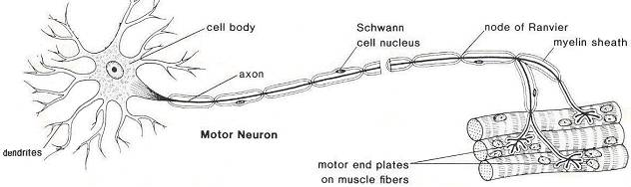

Sensory Neurone:
- Afferent Neuron – Moving away from a central organ or point
- Relays messages from receptors to the brain or spinal cord
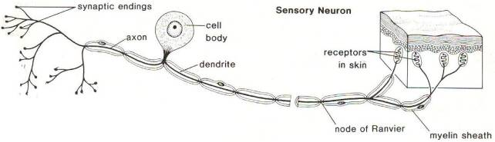

Interneuron (relay neurone):
- Relays message from sensory neurone to motor neurone
- Make up the brain and spinal cord
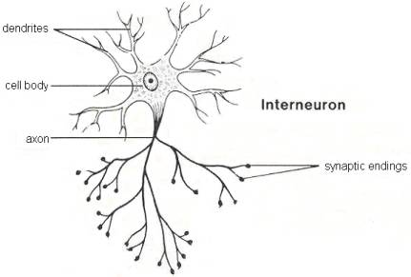

 | Sensory neuron | Interneuron | Motor Neuron
Length of Fibers | Long dendrites and short axon | Short dendrites and short or long anxon | Short dendrites and long axons
Location | Cell body and dendrite are outside of the spinal cord; the cell body is located in a dorsal root ganglion | Entirely within the spinal cord or CNS | Dendrites and the cell body are located in the spinal cord; the axon is outside of the spinal cord
Function | Conduct impulse to the spinal cord | Interconnect the sensory neuron with appropriate motor neuron | Conduct impulse to an effector (muscle or gland)
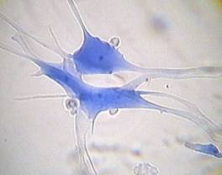
A neurone has a cell body with extensions leading off it. Numerous dendrons and dendrites provide a large surface area for connecting with other neurones, and carry nerve impulses towards the cell body. A single long axon carries the nerve impulse away from the cell body. The axon is only 10µm in diameter but can be up to 4m in length in a large animal (a piece of spaghetti the same shape would be 400m long)! Most neurones have many companion cells called Schwann cells, which wrap their cell membrane around the axon many times in a spiral to form a thick insulating lipid layer called the myelin sheath. Nerve impulse can be passed from the axon of one neurone to the dendron of another at a synapse. A nerve is a discrete bundle of several thousand neurone axons.
There are several differences between axons and dendrites:
Axons | Dendrites
- Take information away from the cell body  - Smooth Surface  - Generally only 1 axon per cell  - No ribosomes  - Can have myelin  - Branch further from the cell body | - Bring information to the cell body  - Rough Surface (dendritic spines)  - Usually many dendrites per cell  - Have ribosomes  - No myelin insulation  - Branch near the cell body

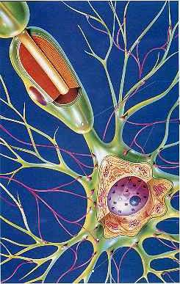 | Neurons are similar to other cells in the body because:
- Neurons are surrounded by a cell membrane.
- Neurons have a nucleus that contains genes.
- Neurons contain cytoplasm, mitochondria and other organelles.
- Neurons carry out basic cellular processes such as protein synthesis and energy production.
 | Neurons differ from other cells in the body because:
- Neurons have specialised extensions called dendrites and axons. Dendrites bring information to the cell body and axons take information away from the cell body.
- Neurons communicate with each other through an electrochemical process.
- Neurons contain some specialized structures (for example, synapses) and chemicals (for example, neurotransmitters).

The Reflex Arc
The three types of neurones are arranged in circuits and networks, the simplest of which is the reflex arc.
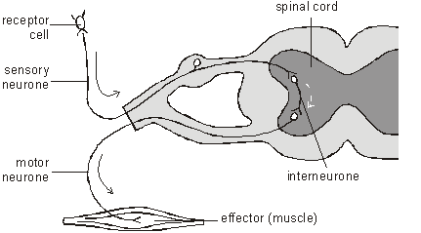
In a simple reflex arc, such as the knee jerk, a stimulus is detected by a receptor cell, which synapses with a sensory neurone. The sensory neurone carries the impulse from site of the stimulus to the central nervous system (the brain or spinal cord), where it synapses with an interneurone. The interneurone synapses with a motor neurone, which carries the nerve impulse out to an effector, such as a muscle, which responds by contracting.
Reflex arc can also be represented by a simple flow diagram:
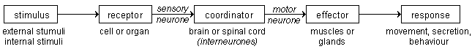

The Resting Membrane Potential
When a neurone is not sending a signal, it is at ‘rest’. The membrane is responsible for the different events that occur in a neurone. All animal cell membranes contain a protein pump called the sodium-potassium pump (Na⁺K⁺ATPase). This uses the energy from ATP splitting to simultaneously pump 3 sodium ions out of the cell and 2 potassium ions in.
The Sodium-Potassium Pump (Na+K+ATPase)
(Provided by: Doc Kaiser's Microbiology Website)
Three sodium ions from inside the cell first bind to the transport protein. Then a phosphate group is transferred from ATP to the transport protein causing it to change shape and release the sodium ions outside the cell. Two potassium ions from outside the cell then bind to the transport protein and as the phospate is removed, the protein assumes its original shape and releases the potassium ions inside the cell.
If the pump was to continue unchecked there would be no sodium or potassium ions left to pump, but there are also sodium and potassium ion channels in the membrane. These channels are normally closed, but even when closed, they “leak”, allowing sodium ions to leak in and potassium ions to leak out, down their respective concentration gradients.
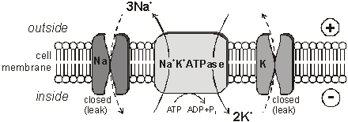
Concentration of ions inside and outside the neurone at rest:
Ion | Concentration inside cell/mmol dm⁻³ | Concentration outside cell/mmol dm⁻³ | Why don’t the ions move down their concentration gradient?
K+ | 150.0 | 2.5 | K+ ions do not move out of the neurone down their concentration gradient due to a build up of positive charges outside the membrane. This repels the movement of any more K+ ions out of the cell.
Na+ | 15.0 | 145.0
Cl- | 9.0 | 101.0 | The chloride ions do not move into the cytoplasm as the negatively charged protein molecules that cannot cross the surface membrane repel them.
The combination of the Na⁺K⁺ATPase pump and the leak channels cause a stable imbalance of Na⁺ and K⁺ ions across the membrane. This imbalance of ions causes a potential difference (or voltage) between the inside of the neurone and its surroundings, called the resting membrane potential. The membrane potential is always negative inside the cell, and varies in size from –20 to –200 mV (milivolt) in different cells and species (in humans it is –70mV). The Na⁺K⁺ATPase is thought to have evolved as an osmoregulator to keep the internal water potential high and so stop water entering animal cells and bursting them. Plant cells don’t need this as they have strong cells walls to prevent bursting.

The Resting Membrane Potential is always negative (-70mV)
- K+ pass easily into the cell
- Cl- and Na+ have a more difficult time crossing
- Negatively charged protein molecules inside the neurone cannot pass the membrane
- The Na+K+ATPase pump uses energy to move 3Na+ out for every 2K+ into neuron
- The imbalance in voltage causes a potential difference across the cell membrane - called the resting potential

The Action Potential
The resting potential tells us about what happens when a neurone is at rest. An action potential occurs when a neurone sends information down an axon. This involves an explosion of electrical activity, where the nerve and muscle cells resting membrane potential changes.
In nerve and muscle cells the membranes are electrically excitable, which means they can change their membrane potential, and this is the basis of the nerve impulse. The sodium and potassium channels in these cells are voltage-gated, which means that they can open and close depending on the voltage across the membrane.
The normal membrane potential inside the axon of nerve cells is –70mV, and since this potential can change in nerve cells it is called the resting potential. When a stimulus is applied a brief reversal of the membrane potential, lasting about a millisecond, occurs. This brief reversal is called the action potential:
An action potential has 2 main phases called depolarisation and repolarisation:
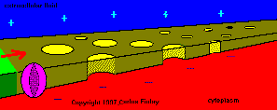 | At rest, the inside of the neuron is slightly negative due to a higher concentration of positively charged sodium ions outside the neuron.
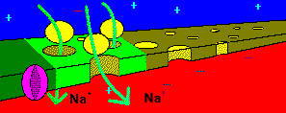 | When stimulated past threshold (about –30mV in humans), sodium channels open and sodium rushes into the axon, causing a region of positive charge within the axon. This is calleddepolarisation
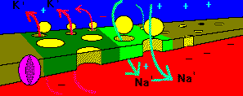 | The region of positive charge causes nearby voltage gated sodium channels to close. Just after the sodium channels close, the potassium channels open wide, and potassium exits the axon, so the charge across the membrane is brought back to its resting potential. This is called repolarisation.
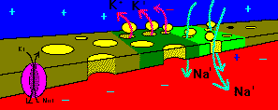 | This process continues as a chain-reaction along the axon. The influx of sodium depolarises the axon, and the outflow of potassium repolarises the axon.
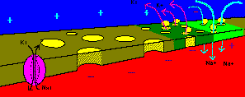 | The sodium/potassium pump restores the resting concentrations of sodium and potassium ions

(provided by: Markham)

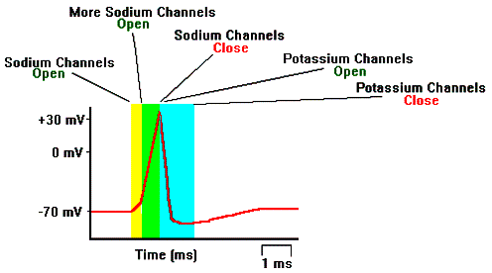

Action Potential has two main phases:
Depolarisation. A stimulus can cause the membrane potential to change a little. The voltage-gated ion channels can detect this change, and when the potential reaches –30mV the sodium channels open for 0.5ms. The causes sodium ions to rush in, making the inside of the cell more positive. This phase is referred to as a depolarisation since the normal voltage polarity (negative inside) is reversed (becomes positive inside). | 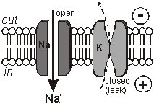
Repolarisation. At a certain point, the depolarisation of the membrane causes the sodium channels to close. As a result the potassium channels open for 0.5ms, causing potassium ions to rush out, making the inside more negative again. Since this restores the original polarity, it is called repolarisation. As the polarity becomes restored, there is a slight ‘overshoot’ in the movement of potassium ions (called hyperpolarisation). The resting membrane potential is restored by the Na+K+ATPase pump. | 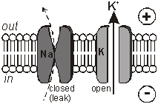

How do Nerve Impulses Start?
We and other animals have several types of receptors of mechanical stimuli. Each initiates nerve impulses in sensory neurons when it is physically deformed by an outside force such as:
- touch
- pressure
- stretching
- sound waves
- motion
Mechanoreceptors enable us to
- detect touch
- monitor the position of our muscles, bones, and joints - the sense of proprioception
- detect sounds and the motion of the body.

E.g. Touch
Light touch is detected by receptors in the skin. These are often found close to a hair follicle so even if the skin is not touched directly, movement of the hair is detected.
In the mouse, light movement of hair triggers a generator potential in mechanically-gated sodium channels in a neuron located next to the hair follicle. This potential opens voltage-gated sodium channels and if it reaches threshold, triggers an action potential in the neuron.
Touch receptors are not distributed evenly over the body. The fingertips and tongue may have as many as 100 per cm²; the back of the hand fewer than 10 per cm². This can be demonstrated with thetwo-point threshold test. With a pair of dividers like those used in mechanical drawing, determine (in a blindfolded subject) the minimum separation of the points that produces two separate touch sensations. The ability to discriminate the two points is far better on the fingertips than on, say, the small of the back.
The density of touch receptors is also reflected in the amount of somatosensory cortex in the brain assigned to that region of the body.

Proprioception
- Proprioception is our "body sense".
- It enables us to unconsciously monitor the position of our body.
- It depends on receptors in the muscles, tendons, and joints.
- If you have ever tried to walk after one of your legs has "gone to sleep", you will have some appreciation of how difficult coordinated muscular activity would be without proprioception.

An action occurs due to an increase in membrane permeability to Na+
- An action potential is initiated by receptor cells that cause sodium channels to open
- An action potential can only occur if the depolarisation of the membrane reaches the threshold point. This is the all or nothing law.

How are Nerve Impulses Propagated?
Once an action potential has started it is moved (propagated) along an axon automatically. The local reversal of the membrane potential is detected by the surrounding voltage-gated ion channels, which open when the potential changes enough.
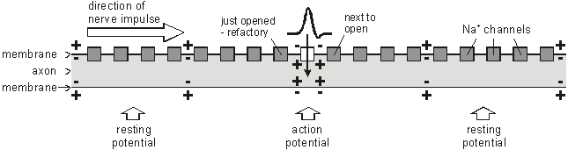
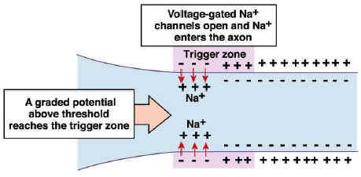
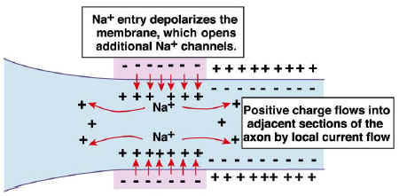
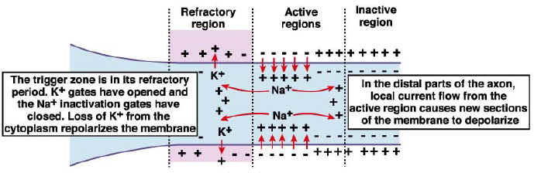
The ion channels have two other features that help the nerve impulse work effectively:
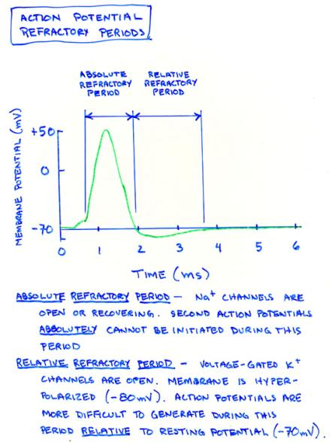
- For an action potential to begin, then the depolarisation of the neurone must reach the threshold value, i.e. the all or nothing law.
- After an ion channel has opened, it needs a “rest period” before it can open again. This is called therefractory period, and lasts about 2 ms. This means that, although the action potential affects all other ion channels nearby, the upstream ion channels cannot open again since they are in their refractory period, so only the downstream channels open, causing the action potential to move one-way along the axon.
The refractory period is necessary as it allows the proteins of voltage sensitive ion channels to restore to their original polarity.
- The absolute refractory period = during the action potential, a second stimulus will not cause a new action potential.
- Exception: There is an interval in which a second action potential can be produced but only if the stimulus is considerably greater than the threshold = relative refractory period
- The refractory period can limit the number o faction potentials in a given time.
- Average = about 100 action potentials per second.
Nerve Impulses travel in one direction
- This is due to the refractory period i.e. Na+ channels are open or recovering.
- The refractory period allows the voltage sensitive ion channels to restore their original polarity
  - Absolute refractory period - Na+ channels are open or recovering
  - Relative refractory period - Occurs when the membrane is hyperpolarised (-80mV), where the K+ channels are open. Action potentials are more difficult to generate during this period relative to resting potential (-70mV)

How Fast are Nerve Impulses?
Action potentials can travel along axons at speeds of 0.1-100 m/s. This means that nerve impulses can get from one part of a body to another in a few milliseconds, which allows for fast responses to stimuli. (Impulses are much slower than electrical currents in wires, which travel at close to the speed of light, 3x10⁸ m/s.) The speed is affected by 3 factors:
- Temperature - The higher the temperature, the faster the speed. So homoeothermic (warm-blooded) animals have faster responses than poikilothermic (cold-blooded) ones.
- Axon diameter - The larger the diameter, the faster the speed. So marine invertebrates, who live at temperatures close to 0°C, have developed thick axons to speed up their responses. This explains why squid have their giant axons.
- Myelin sheath - Only vertebrates have a myelin sheath surrounding their neurones. The voltage-gated ion channels are found only at the nodes of Ranvier, and between the nodes the myelin sheath acts as a good electrical insulator. The action potential can therefore jump large distances from node to node (1mm), a process that is called saltatory propagation. This increases the speed of propagation dramatically, so while nerve impulses in unmyelinated neurones have a maximum speed of around 1 m/s, in myelinated neurones they travel at 100 m/s.
