Homeostasis
Homeostasis literally means “same state” and it refers to the process of keeping the internal body environment in a steady state. The importance of this cannot be over-stressed, and a great deal of the hormone system and autonomic nervous system is dedicated to homeostasis.
All homeostatic mechanisms use negative feedback to maintain a constant value (called the set point). Negative feedback means that whenever a change occurs in a system, the change automatically causes a corrective mechanism to start, which reverses the original change and brings the system back to normal. It also means that the bigger then change the bigger the corrective mechanism. Negative feedback applies to electronic circuits and central heating systems as well as to biological systems.
So in a system controlled by negative feedback the level is never maintained perfectly, but constantly oscillates about the set point. An efficient homeostatic system minimises the size of the oscillations.

Temperature Homeostasis (thermoregulation)
One of the most important examples of homeostasis is the regulation of body temperature. Not all animals can do this. Animals that maintain a fairly constant body temperature (birds and mammals) are called homeotherms (also spelt homoiotherms), while those that have a variable body temperature (all others) are called poikilotherms. The homeotherms maintain their body temperatures at around 37°C, so are sometimes called warm-blooded animals, but in fact piokilothermic animals can also have very warm blood during the day by basking in the sun.
In humans temperature homeostasis is controlled by the thermoregulatory centre in the hypothalamus. It receives input from two sets of thermoreceptors: receptors in the hypothalamus itself monitor the temperature of the blood as it passes through the brain (the core temperature), and receptors in the skin monitor the external temperature. Both pieces of information are needed so that the body can make appropriate adjustments. The thermoregulatory centre sends impulses to several different effectors to adjust body temperature:
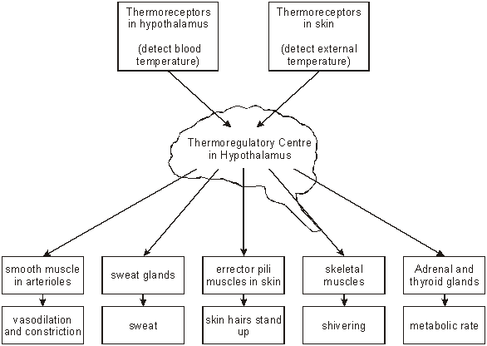
The thermoregulatory centre is part of the autonomic nervous system, so the various responses are all involuntary. The exact responses to high and low temperatures are described in the table below. Note that some of the responses to low temperature actually generate heat (thermogenesis), while others just conserve heat. Similarly some of the responses to cold actively cool the body down, while others just reduce heat production or transfer heat to the surface. The body thus has a range of responses available, depending on the internal and external temperatures.
Effector | Response to low temperature | Response to high temperature
Smooth muscles in peripheral arterioles in the skin. | Muscles contract causing vasoconstriction. Less heat is carried from the core to the surface of the body, maintaining core temperature. Extremities can turn blue and feel cold and can even be damaged (frostbite). | Muscles relax causing vasodilation. More heat is carried from the core to the surface, where it is lost by convection and radiation. Skin turns red.
Sweat glands | No sweat produced. | Glands secrete sweat onto surface of skin, where it evaporates. This is an endothermic process and water has a high latent heat of evaporation, so it takes heat from the body.
Erector pili muscles in skin  (attached to skin hairs) | Muscles contract, raising skin hairs and trapping an insulating layer of still, warm air next to the skin. Not very effective in humans, just causing “goosebumps”. | Muscles relax, lowering the skin hairs and allowing air to circulate over the skin, encouraging convection and evaporation.
Skeletal muscles | Muscles contract and relax repeatedly, generating heat by friction and from metabolic reactions. | No shivering.
Adrenal and thyroid glands | Glands secrete adrenaline and thyroxine respectively, which increase the metabolic rate in different tissues, especially the liver, so generating heat. | Glands stop releasing adrenaline and thyroxine.
Behaviour | Curling up, huddling, finding shelter, putting on more clothes. | Stretching out, finding shade, swimming, removing clothes.
The thermoregulatory centre normally maintains a set point of 37.5 ± 0.5 °C in most mammals. However the set point can be altered is special circumstances:
- Fever. Chemicals called pyrogens released by white blood cells raise the set point of the thermoregulatory centre causing the whole body temperature to increase by 2-3 °C. This helps to kill bacteria and explains why you shiver even though you are hot.
- Hibernation. Some mammals release hormones that reduce their set point to around 5°C while they hibernate. This drastically reduces their metabolic rate and so conserves their food reserves.
- Torpor. Bats and hummingbirds reduce their set point every day while they are inactive. They have a high surface area:volume ratio, so this reduces heat loss.

Blood Glucose Homeostasis
Glucose is the transport carbohydrate in animals, and its concentration in the blood affects every cell in the body. Its concentration is therefore strictly controlled within the range 80-100 mg 100cm⁻³, and very low level (hypoglycaemia) or very high levels (hyperglycaemia) are both serious and can lead to death.
Blood glucose concentration is controlled by the pancreas. The pancreas has glucose receptor cells, which monitor the concentration of glucose in the blood, and it also has endocrine cells (called theislets of Langerhans), which secrete hormones. The α cells secrete the hormone glucagon, while the β cells secrete the hormone insulin. These two hormones are antagonistic, and have opposite effects on blood glucose:
- insulin stimulates the uptake of glucose by cells for respiration, and in the liver it stimulates the conversion of glucose to glycogen (glycogenesis). It therefore decreases blood glucose.
- glucagon stimulates the breakdown of glycogen to glucose in the liver (glycogenolysis), and in extreme cases it can also stimulate the synthesis of glucose from pyruvate. It therefore increases blood glucose.
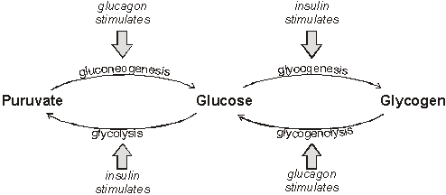
After a meal, glucose is absorbed from the gut into the hepatic portal vein, increasing the blood glucose concentration. This is detected by the pancreas, which secretes insulin from its β cells in response. Insulin causes glucose to be taken up by the liver and converted to glycogen. This reduces blood glucose, which causes the pancreas to stop secreting insulin. If the glucose level falls too far, the pancreas detects this and releases glucagon from its α cells. Glucagon causes the liver to break down some of its glycogen store to glucose, which diffuses into the blood. This increases blood glucose, which causes the pancreas to stop producing glucagon.
These negative feedback loops continue all day, as shown in this graph:
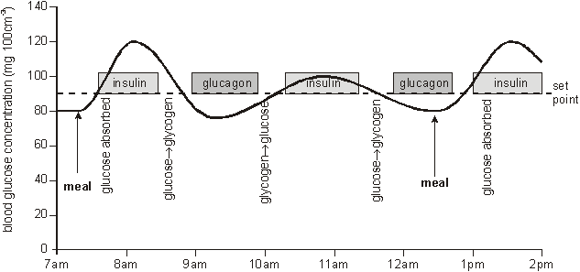

Diabetes Mellitus
Diabetes is a disease caused by a failure of glucose homeostasis. There are two forms of the disease. In insulin-dependent diabetes (also known as type 1 or early-onset diabetes) there is a severe insulin deficiency due to autoimmune killing of β€cells (possibly due to a virus). In non insulin-dependent diabetes (also known as type 2 or late-onset diabetes) insulin is produced, but the insulin receptors in the target cells don’t work, so insulin has no effect. In both cases there is a very high blood glucose concentration after a meal, so the active transport pumps in the proximal convoluted tubule of the kidney can’t reabsorb it all from the kidney filtrate, so much of the glucose is excreted in urine (diabetes mellitus means “sweet fountain”). This leads to the symptoms of diabetes:
- high thirst due to osmosis of water from cells to the blood, which has a low water potential.
- copious urine production due to excess water in blood.
- poor vision due to osmotic loss of water from the eye lens.
- tiredness due to loss of glucose in urine and poor uptake of glucose by liver and muscle cells.
- muscle wasting due to gluconeogenesis caused by increased glucagon.
Diabetes can be treated by injections with insulin or by careful diet. Until the discovery of insulin in 1922 by Banting and Best, diabetes was an untreatable, fatal disease.

Blood Water Homeostasis (Osmoregulation)
The water potential of the blood must be regulated to prevent loss or gain of water from cells. Blood water homeostasis is controlled by the hypothalamus. It contains osmosreceptor cells, which can detect changes in the water potential of the blood passing through the brain. In response, the hypothalamus controls the sensation of thirst, and it also secretes the hormone ADH (antidiuretic hormone). ADH is stored in the pituitary gland, and its target cells are the endothelial cells of the collecting ducts of the kidney nephrons. These cells are unusual in that water molecules can only cross their membranes via water channels called aquaporins, rather than through the lipid bilayer. ADH causes these water channels to open. The effects of ADH are shown in this diagram:
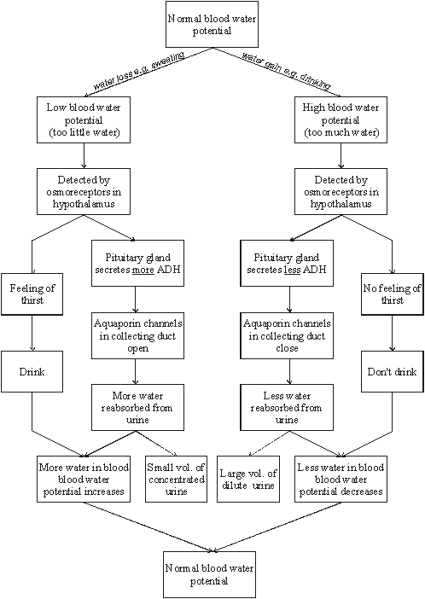

Excretion and Homeostasis
Excretion means the removal of waste products from cells. There are five important excretory organs in humans:
- Skin | excretes sweat, containing water, ions and urea
- Lungs | excrete carbon dioxide and water
- Liver | excretes bile, containing bile pigments, cholesterol and mineral ions
- Gut | excretes mucosa cells, water and bile in faeces. (The bulk of faeces comprises plant fibre and bacterial cells, which have never been absorbed into the body, so are not excreted but egested.)
- Kidneys | excrete urine, containing urea, mineral ions, water and other “foreign” chemicals from the blood.
This section is mainly concerned with the excretion of nitrogenous waste as urea. The body cannot store protein in the way it can store carbohydrate and fat, so it cannot keep excess amino acids. The “carbon skeleton” of the amino acids can be used in respiration, but the nitrogenous amino group must be excreted.

