Blood
Just over half of the blood volume is made up of a pale yellow fluid called plasma. The rest of the blood is made up of cells (red blood cells and white blood cells) and platelets.
Blood has several vital functions:
- Transport - oxygen in the red blood cells, absorbed, digested food by the plasma, excretory products by the plasma, hormones by the plasma etc.
- Defence - by the white blood cells (a.k.a. leucocytes).
- Formation of lymph and tissue fluid.
- Homeostasis.

Red blood cells
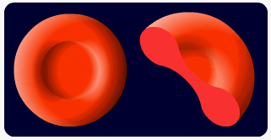
Also known as erythrocytes. These contain a pigment, haemoglobin, which gives them their colour.
Red blood cells are made in the bone marrow (the liver in a foetus) of many bones. They have a life span of about 120 days and are about 7µm in diameter (very small).
Being like a biconcave disc in shape, the surface area to volume ratio is very large. Oxygen can therefore diffuse very quickly into the cell and because the cell is so small, quickly bind to a haemoglobin molecule.
They lack organelles meaning that there is more room for haemoglobin. Their size and flexible membrane also means that they can squeeze through capillaries and transport oxygen extremely close to cells.

White blood cells
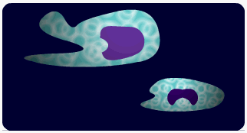
These cells all have a nucleus, most are much larger than red blood cells and are spherical or irregular in shape.
There are two basic types of white blood cells; the granulocytes (they have granular cytoplasm and lobed nuclei) and agranulocytes (the cytoplasm appears smooth and the nucleus is rounded or horseshoe in shape).
 |  | Made in: | Function:
Agranulocytes: | Monocytes | Red bone marrow | Phagocytic against bacteria and antibody-coated viruses
Lymphocytes | Spleen, lymph nodes | Produces antibodies
Granulocytes: | Neutrophils | Red bone marrow | Phagocytic and contain lysosomes to break down ingested bacteria
Eosinophils | Red bone marrow | Phagocytic. Works against allergens by making antihistamines
Basophils | Red bone marrow | Make antihistamines, make heparin (prevents unnecessary blood clotting) and make serotonin (makes the capillaries more leaky so that phagocytes can leave the blood and enter the site of infection
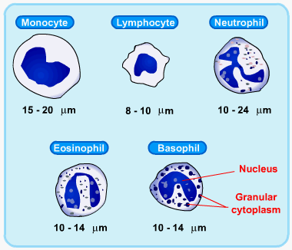
For more information, see the Learn It on Immunity.

Platelets
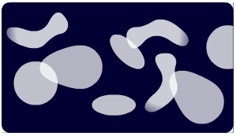
These are formed in the bone marrow and are fragments of larger cells. They have no nucleus but reactions do take place in the cytoplasm.
They have a variety of role such as blood clotting and the production of prostaglandins that regulate the degree of constriction or dilation in blood vessels.
Blood clotting: Platelets stick to damaged cells on the inner surface of blood vessels forming a plug. Unless the damage is small, platelets are involved in a chain of reactions by releasing particular chemicals. A soluble protein, fibrinogen (present in the plasma), becomes an insoluble protein, fibrin, and this forms layers of fibres across the wound. The mesh that this creates traps red blood cells and platelets and a scab is formed.
This has two useful effects:
- Blood does not leak out of he vessel.
- It is less likely that an infectious organism will enter from outside and cause harm.
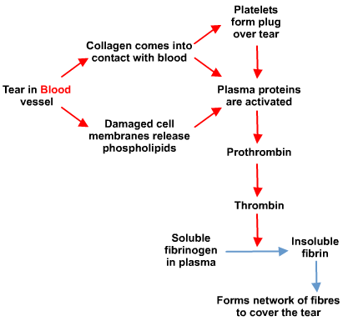

Blood groups (additional info)
The most commonly required blood-grouping system is the ABO system. It concerns two antigens that can occur on the surface of red blood cells. The antigens are called agglutinogens in this case and are: agglutinogen A and agglutinogen B.
Plasma also contains antigens, called agglutinins in this case, and they are agglutinin A and agglutinin B.
We shall call agglutinogens A or B and the agglutinins a or b. If A and a come into contact, the red cells will clump together. If B and b come into contact the red cells will clump together.
Therefore, in your blood you will not contain the agglutinogen and the agglutinin of the same type.

Oxygen carriage
Oxygen does dissolve in plasma but the solubility is low and decreases further if the temperature increases. The amount that could be carried by the plasma therefore would be completely insufficient to supply all cells.
There is a protein in the blood however that will carry 4 molecules of oxygen. The protein is called haemoglobin (Hb) and is made up of 4 polypeptide chains, each with a haem group. Each haem group can pick up 1 molecule of O₂. The protein, being fairly small, could pass out of the blood during ultrafiltration in the kidneys so, to ensure that it is not lost, it is found within red blood cells.
Note: During this topic you will come across the term of partial pressure of oxygen. It does not mean the pressure of the blood itself. Essentially it is a measure of the concentration of oxygen. It is written in shorthand aspO₂ and is measured in kilopascals (kPa).
Inhaled air in the alveoli has a pO₂ = 14kPa. The pO₂ of resting tissue = 5.3kPa (lower pO₂ = lower O₂concentration due to respiration) and the pO₂ of active tissues = 2.7kPa. In either case, blood arriving at the lungs has a lower pO₂ than that in the lungs.
There is therefore a diffusion gradient and oxygen will move from the alveoli into the blood. The O₂ is then loaded onto the Hb until the blood is about 96% saturated with oxygen. The Hb is now called oxyhaemoglobin (HbO₂).
Hb + 4O₂ → HbO₈

Dissociation curves
The blood is then taken to tissues where the cells are respiring all the time, using oxygen. The pO₂ will be low. As the red blood cell enters this region, the Hb will start to unload the O₂, which will diffuse into the tissues and be used for further respiration. Since much of the Hb will have unloaded the O₂, a much lower percentage of the blood will be saturated with O₂.
A graph of the percentage saturation of blood with O₂, i.e. the amount of HbO₂ as opposed to Hb at different pO₂is shown below. It is called an oxygen dissociation curve:
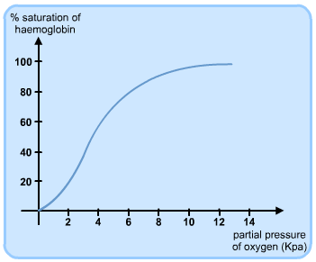
It is S-shaped because of the behaviour of the Hb in different pO₂.
The first molecule of O₂ combines with an Hb and slightly distorts it. The joining of the first is quite slow (the flatter part of the graph at the beginning) but after the Hb has changed shape a little, it becomes easier and easier for the second and third O₂ to join. This is shown by the curve becoming steeper. It flattens off at the top because joining the fourth O₂ is more difficult.
Overall, it shows that at the higher and lower end of the partial pressures, there isn't a great deal of change in the saturation of the Hb, but in the middle range, a small change in the pO₂ can result in a large change in the percentage saturation of the blood.

The effect of pH - The Bohr effect
The amount of O₂ carried and released by Hb depends not only on the pO₂ but also on pH.
An acidic environment causes HbO₂ to dissociate (unload) to release the O₂ to the tissues. Just a small decrease in the pH results in a large decrease in the percentage saturation of the blood with O₂.
Acidity depends on the concentration of hydrogen ions.
H⁺ displaces O₂ from the HbO₂, thus increasing the O₂ available to the respiring tissues.
H⁺ + HbO₂ → HHb + O₂
HHb is called haemoglobinic acid.
This means that the Hb mops up free H⁺. That way the Hb helps to maintain the almost neutral pH of the blood. Hb acts as a buffer.
This release of O₂ when the pH is low (even if the pO₂ is relatively high) is called the Bohr effect.
When does the pH decrease because of free H⁺ in the blood?
During respiration, CO₂ is produced. This diffuses into the blood plasma and into the red blood cells. Inside the red blood cells are many molecules of an enzyme called carbonic anhydrase. It catalyses the reaction between CO₂ and H₂O. The resulting carbonic acid then dissociates into HCO₃⁻ + H⁺. (Both reactions are reversible.)
CO₂ | + | H₂O | → | H₂CO₃
carbon dioxide |  | water |  | carbonic acid
H₂CO₃ | → | HCO₃⁻ | + | H⁺
Carbonic acid |  | hydrogencarbonate ion |  | hydrogen ion
Therefore, the more CO₂, the more the dissociation curve shifts to the right:
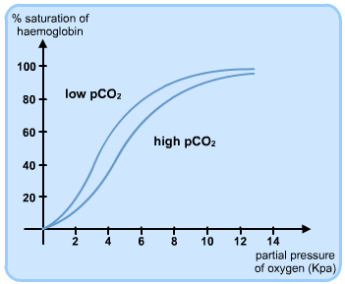

Carbon dioxide transport
About 85% of the CO₂ produced by respiration diffuses into the red blood cells and forms carbonic acid under the control of carbonic anhydrase.
The HCO₃⁻ diffuses out of the red blood cell into the plasma. This leaves a shortage of negatively charged ions inside the red blood cells. To compensate for this, chloride ions move from the plasma into the red blood cells. This restoration of the electrical charge inside the red blood cells is called the chloride shift.
About 5% of the CO₂ produced simply dissolves in the blood plasma.
Some CO₂ diffuses into the red blood cells but instead of forming carbonic acid, attaches directly onto the haemoglobin molecules to form carbaminohaemoglobin. Since the CO₂ doesn't bind to the haem groups the Hb is still able to pick up O₂ or H⁺.

Other effects

Carbon monoxide
If carbon monoxide is breathed in (for example from car exhaust fumes), it binds irreversibly with haemoglobin to form carboxyhaemoglobin. This means that the Hb cannot load and carry O₂.
To make matters worse, Hb combines with CO about 250 times more readily than it does with O₂ so that, even if the CO concentration is fairly low, it can cause death due to lack of O₂ to the tissues.
Cigarettes produce CO-containing smoke, which means that a small percentage of a smoker's blood is unable to transport O₂.

Foetal haemoglobin
A foetus developing in the uterus must be able to load O₂ from its mother's blood. Due to the respiration occurring in the foetus' cells, the pO₂ is lower in the foetus blood than in the mother's blood. Some will unload from the mother's HbO₂ and diffuse across to the foetus. However, because of the relatively small concentration difference, not much O₂ is passed across.
To maximise the amount of O₂ that the foetus receives, it has different haemoglobin - foetal haemoglobin. This has a higher affinity for O₂ than adult Hb (it combines more readily with O₂) so the foetus picks up enough O₂. The dissociation curve shifts to the left.
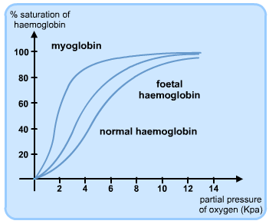

Myoglobin
Skeletal muscle contains a pigment called myoglobin. It is very similar to Hb but has a higher affinity for O₂.
It will load with O₂ as Hb unloads and will store the O₂ in the muscle until it is required. It only releases the O₂when the pO₂ is very low - when the Hb cannot supply O₂ fast enough and the demand is great. The dissociation curve shifts to the left.

Temperature
The higher the temperature, the less saturated the blood is with O₂, i.e. the more the HbO₂ unloads the O₂.
This situation might arise during exercise - heat is produced during metabolic activity and during this time, the O₂supply will need to increase. The dissociation curve shifts to the right:
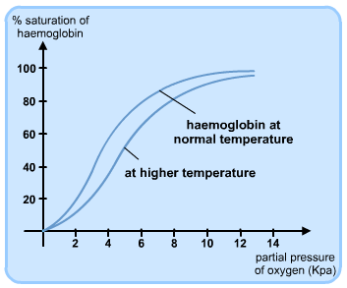

Environment
Animals living where there is a shortage of oxygen, animals living at high altitude need to be able to pick up O₂when it is at a very low pO₂. Their dissociation curves will look like those of foetal haemoglobin and myoglobin - the curve shifts to the left.
If somebody were to climb quickly from sea level to high altitude, they are likely to suffer from altitude sickness, which can be fatal. However if the body is given time to adapt, most people can cope well with high altitudes. Instead of taking up the normal 45% of blood volume, the red blood cells can increase in numbers to take up 60%.

