Ecosystems
Ecology is the study of inter-relationships between organisms and their environment. Its aim it to explain why organisms live where they do. To do this ecologists study ecosystems, areas that can vary in size from a pond to the whole planet.
Ecosystem | A reasonably self-contained area together with all its living organisms.
Habitat | The physical or abiotic part of an ecosystem, i.e. a defined area with specific characteristics where the organisms live, e.g. oak forest, deep sea, sand dune, rocky shore, moorland, hedgerow, garden pond, etc.
Community | The living or biotic part of an ecosystem, i.e. all the organisms of all the different species living in one habitat.
Biotic | Any living or biological factor.
Abiotic | Any non-living or physical factor.
Population | The members of the same species living in one habitat.
Species | A group of organisms that can successfully interbreed

Estimating Populations and Distribution
To study the dynamics of a population, or how the distribution of the members of a population is influenced by a biotic or an abiotic factor, it is necessary to estimate the population size. In other words, it will be necessary to count the number of individuals in a population. Such counting is usually carried out by taking samples.
One of the most fundamental problems faced by community and population ecologists is that of measuring population sizes and distributions. The data is important for comparing differences between communities and species. It is necessary for impact assessments (measuring effects of disturbance) and restoration ecology (restoring ecological systems). It is also used to set harvest limits on commercial and game species (e.g. fish, deer, etc.).
In most cases it is either difficult or simply not possible to census all of the individuals in the target area. The only way around this problem is to estimate population size using some form of sampling technique. There are numerous types of sampling techniques. Some are designed for specific types of organisms (e.g. plants vs. mobile animals). As well there are numerous ways of arriving at estimates from each sampling technique. All of these procedures have advantages and disadvantages. In general, the accuracy of an estimate depends on 1) the number of samples taken, 2) the method of collecting the samples, 3) the proportion of the total population sampled.
Sampling is viewed by statistical ecologists as a science in its own right. In most cases, the object is to collect as many randomly selected samples as possible (so as to increase the proportion of the total population sampled). The accuracy of an estimate increases with the number of samples taken. This is because the number of individuals found in any given sample will vary from the number found in other samples. By collecting numerous samples, the effect of these variations can be averaged out. The purpose for collecting the samples randomly is to avoid biasing the data. Data can become biased when individuals of some species are sampled more frequently, or less frequently, than expected at random. Such biases can cause the population size to be either over estimated or under estimated, and can lead to erroneous estimates of population size.
Population size generally refers to the number of individuals present in the population, and is self-explanatory. Density refers to the number of individuals in a given area. For ecologists density is usually a more useful measure. This is because density is standardized per unit area, and therefore, can be correlated with environmental factors or used to compare different populations.
The spatial distribution of a population is a much more complicated matter. Basically, there are three possible types of spatial distributions (dispersions) (see diagrams below). In a random dispersion, the locations of all individuals are independent of each other. In a uniform dispersion, the occurrence of one individual reduces the likelihood of finding another individual nearby. In this case the individuals tend to be spread out as far from each other as possible. In a clumped dispersion, the occurrence of one individual increases the likelihood of finding another individual nearby. In this case, individuals tend to form groups (or clumps).
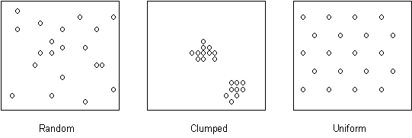
Ecologists are often interested in the spatial distribution of populations because it provides information about the social behaviour and/or ecological requirements of the species. For example, some plants occur in clumped distributions because they propagate by rhizomes (underground shoots) or because seed dispersal is limited. Clumped distributions in plants may also occur because of slight variations in soil chemistry or moisture content. Many animals exhibit rather uniform distributions because they are territorial (especially birds), expelling all intruders from their territories. Random distributions are also common, but their precise cause is more difficult to explain.
Unfortunately, it is often difficult to visually assess the precise spatial distribution of a population. Furthermore, it is often useful to obtain some number (quantitative measure) that describes spatial distribution in order to compare different populations. For this reason, there are a variety of statistical procedures that are used to describe spatial distributions.
Communities are assemblages of many species living in a common environment. Interactions between species can have profound influences of their distributions and abundances. Comprehensive understanding of how species interact can contribute to understanding how the community is organized. One way to look at species interactions is to evaluate the level of association between them. Two species are said to be positively associated if they are found together more often than expected by chance. Positive associations can be expected if the species share similar microhabitat needs or if the association provides some benefit to one (commensualisms) or both (mutualism) of the species involved. Two species are negatively associated if they are found together less frequently than expected by chance. Such a situation can arise if the species have very different microhabitat requirements, or if one species, in some way, inhibits the other. For example, some plants practice allelopathy, the production and release of chemicals that inhibit the growth of other plant species. Allelopathy results in a negative association between the allelopathic species and those species whose growth is inhibited.

Random sampling with quadrats
The quadrat method is used primarily in studies of plant populations, or where animals are immobile. The principal assumptions of this technique are that the quadrats are chosen randomly, the organisms do not move from one quadrat to another during the census period, and that the samples taken are representative of the population as a whole. It is often conducted by dividing the census area into a grid. Each square within the grid is known as a quadrat and represents the sample unit. Quadrats are chosen at random by using a random number generator or a random number table to select coordinates. The number of individuals of the target species is then counted in each of the chosen quadrats.
Ecologists use units to measure organisms within the quadrats. Frequency (f) is an indication of the presence of an organism in a quadrat area. This gives no measure of numbers, however the usualunit is that of density – the numbers of the organisms per unit area. Sometimes percentage cover is used, an indication of how much the quadrat area is occupied.

Counting along Transects
Transects are used to describe the distribution of species in a straight line across a habitat. Transects are particularly useful for identifying and describing where there is a change in habitat. A simple line transect records all of the species which actually touch the rope or tape stretched across the habitat. A belt transect records all the species present between two lines, and an interrupted belt transect records all those species present in a number of quadrats places at fixed points along a line stretched across the habitat.

Mark-release-recapture techniques for more mobile species
This method of sampling is most useful when dealing with an animal population that moves around. Ecologists must always ensure minimum disturbance of the organism if results are to be truly representative and that the population will behave as normal. In this method individual organisms are captured, unharmed, using a quantitative technique. They are counted and then discretely marked or tagged in some way, and then released back into the environment. After leaving time for dispersal, the population is then recaptured, and another count is made. This gives the number of marked animals and the number unmarked. This can allow ecologists to estimate of the entire population in a given habitat.
The following equation is used to estimate the population:  S = total number of individuals in the total population  S₁= number captured, marked and released in first sample e.g. 8  S₂= total number captured in second sample e.g. 8  S₃= total marked individuals captured in second sample e.g. 2 | S = S₁ X S₂  S₃  S = 8 X 10  2  population = 40 individuals

Diversity
Diversity depends on the number of species (species richness of a community) in an ecosystem and the abundance of each species – the number of individuals of each species. The populations of an ecosystem can support demands on abiotic and biotic factors. The growth of populations depends on limiting factors:
- Abiotic factors
  - physiological adaptations of organisms only allow them to live in a certain range of pH, light, temp etc – it is part of what defines their niche.
- Biotic factors (interactions between organisms)
  - Intraspecific competition occurs between individuals of the same species eg for a patch of soil to grow on, or a nesting site or food.
  - Interspecific competition occurs between different species needing the same resource – at the same trophic level.
  - Plant species compete for light, herbivore species compete for plants or carnivore species compete for prey
  - Predation – a predator is a limiting factor on growth on the population of its prey and the prey is a limiting factor on the predator population

An index of diversity is used as a measure of the range and numbers of species in an area. It usually takes into account the number of species present and the number of individuals of each species. It can be calculated by the following formulae:
d = | N(N-1)
 | Σn(n-1)
Where: N = total number of organisms of all species in the area
d = index of diversity
n = total number of organisms of each species in the area
e.g.
crested newt | 8 | d = 111 X 110  (8X7) + (20X19) + (15X14) + (20X19) + (2X1) + (10X9) + (6X5) + (30X29)  d = 12210 therefore d = 6.05  2018
stickleback | 20
Leech | 15
Great pond snail | 20
Dragon fly larva | 2
Stonefly larva | 10
Water boatman | 6
Caddisfly larva | 30
N = | 111

In another pond there were:
crested newt | 45 | d = 2.6  Comparing both indices, 6.05 is an indicator of greater diversity. The higher number indicates greater diversity
stickleback | 4
Leech | 18
Great pond snail | 10
In extreme environments the diversity of organisms is usually low (has a low index number). This may result in an unstable ecosystem in which populations are usually dominated by abiotic factors. The abiotic factor(s) are extreme and few species have adaptations allowing them to survive. Therefore food webs are relatively simple, with few food chains, or connections between them – because few producers survive. This can produce an unstable ecosystem because a change in the population of one species can cause big changes in populations of other species.
In less hostile environments the diversity of organisms is usually high (high index number). This may result in a stable ecosystem in which populations are usually dominated by biotic factors, and abiotic factors are not extreme. Many species have adaptations that allow them to survive, including many plants/producers. Therefore food webs are complex, with many inter-connected food chains. This results in a stable ecosystem because if the population of one species changes, there are alternative food sources for populations of other species.

Population Ecology
Population Ecology is concerned with the question: why is a population the size it is? This means understanding the various factors that affect the population.

Population Growth
When a species is introduced into a new environment its population grows in a characteristic way. This growth curve is often seen experimentally, for example bees in a hive, sheep in Tasmania, bacteria in culture. The curve is called a logistic or sigmoid growth curve.
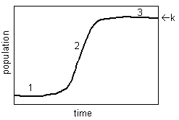
The growth curve has three phases, with different factors being responsible for the shape of each phase. The actual factors depend on the ecosystem, and this can be illustrated by considering two contrasting examples: yeast in a flask (reproducing asexually), and rabbits in a field (reproducing sexually).
 | Yeast in a flask | Rabbits in a field
1. Lag phase | Little growth while yeast starts transcribing genes and synthesising appropriate enzymes for new conditions. | Little growth due to small population. Individuals may rarely meet, so few matings. Long gestation so few births.
2. Rapid Growth Phase | Rapid exponential growth. No limiting factors since relatively low density. | Rapid growth, though not exponential. Few limiting factors since relatively low density.
3. Stable Phase | Slow growth due to accumulation of toxic waste products (e.g. ethanol) or lack of sugar. | Slow growth due to intraspecific competition for food/territory, predation, etc.
At the end of phase 3 the population is stable. This population is called the carrying capacity of the environment (K), and is the maximum population supported by a particular ecosystem.

Factors Affecting Population Size
Many different factors interact to determine population size, and it can be very difficult to determine which factors are the most important. Factors can be split into two broad group: abiotic factors and biotic factors. We’ll look at 7 different factors.
1. Abiotic Factors
The population is obviously affected by the abiotic environment such as: temperature; water/humidity; pH; light/shade; soil (edaphic factors); mineral supply; current (wind/water); topography (altitude, slope, aspect); catastrophes (floods/fire/frost); pollution. Successful species are generally well adapted to their abiotic environment.
In harsh environments (very cold, very hot, very dry, very acid, etc.) only a few species will have successfully adapted to the conditions so they will not have much competition from other species, but in mild environments lots of different species could live there, so there will be competition. In other words in harsh environments abiotic factors govern who survives, while in mild environments biotic factors (such as competition) govern who survives.
2. Seasons
Many abiotic factors vary with the seasons, and this can cause a periodic oscillation in the population size.
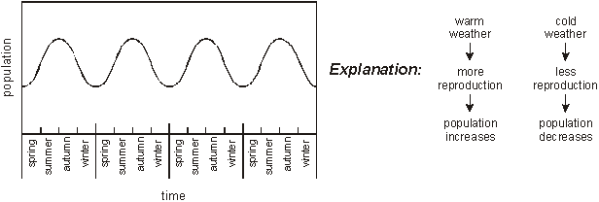
This is only seen in species with a short life cycle compared to the seasons, such as insects. Species with long life cycles (longer than a year) do not change with the seasons like this.
3. Food Supply
A population obviously depends on the population of its food supply: if there is plenty of food the population increases and vice versa. For example red deer introduced to an Alaskan island at first showed a population increase, but this large population grazed the vegetation too quickly for the slow growth to recover, so the food supply dwindled and the deer population crashed. | 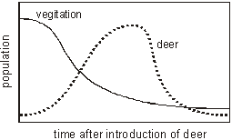
4. Interspecific Competition
Interspecific competition is competition for resources (such as food, space, water, light, etc.) between members of different species, and in general one species will out-compete another one. This can be demonstrated by growing two different species of the protozoan Paramecium in flasks in a lab. They both grow well in lab flasks when grown separately, but when grown together P.aurelia out-competesP.caudatum for food, so the population of P.caudatum falls due to interspecific competition:
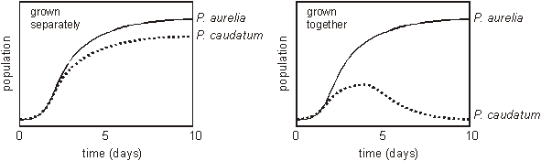
5. Intraspecific Competition
Intraspecific competition is competition for resources between members of the same species. This is more significant than interspecific competition, since member of the same species have the same niche and so compete for exactly the same resources.
Intraspecific competition tends to have a stabilising influence on population size. If the population gets too big, intraspecific population increases, so the population falls again. If the population gets too small, intraspecific population decreases, so the population increases again:
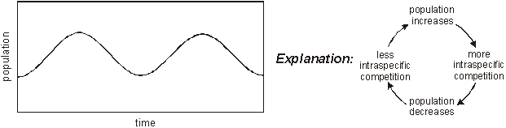
Intraspecific competition is also the driving force behind natural selection, since the individuals with the “best” genes are more likely to win the competition and pass on their genes. Some species use aggressive behaviour to minimise real competition. Ritual fights, displays, threat postures are used to allow some individuals (the “best”) to reproduce and exclude others (the “weakest”). This avoids real fights or shortages, and results in an optimum size for a population.

6. Predation
The populations of predators and their prey depend on each other, so they tend to show cyclical changes. This has been famously measured for populations of lynx (predator) and hare (prey) in Canada, and can also be demonstrated in a lab experiment using two species of mite: Eotetranchus (a herbivore) and Typhlodromus (a predator). If the population of the prey increases, the predator will have more food, so its population will start to increase. This means that more prey will be eaten, so its population will decrease, so causing a cycle in both populations:
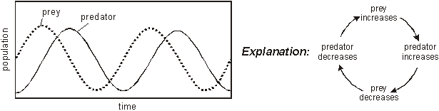
7. Parasitism and Disease
Parasites and their hosts have a close symbiotic relationship, so their populations also oscillate. This is demonstrated by winter moth caterpillars (the host species) and wasp larvae (parasites on the caterpillars). If the population of parasite increases, they kill their hosts, so their population decreases. This means there are fewer hosts for the parasite, so their population decreases. This allows the host population to recover, so the parasite population also recovers:
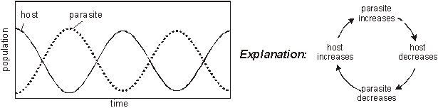
A similar pattern is seen for pathogens and their hosts.

The Ecological Niche
A population’s niche refers to its role in its ecosystem. This usually means its feeding role in the food chain, so a particular population’s niche could be a producer, a predator, a parasite, a leaf-eater, etc. A more detailed description of a niche should really include many different aspects such as its food, its habitat, its reproduction method etc, so gerbils are desert seed-eating mammals; seaweed is an inter-tidal autotroph; fungi are asexual soil-living saprophytes. Identifying the different niches in an ecosystem helps us to understand the interactions between populations. Members of the same population always have the same niche, and will be well-adapted to that niche, e.g. nectar feeding birds have long thin beaks.
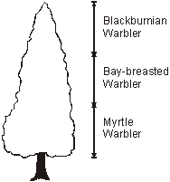
Species with narrow niches are called specialists (e.g. anteater). Many different specialists can coexist in the same habitat because they are not competing, so this can lead to high diversity, for example warblers in a coniferous forest feed on insects found at different heights. Specialists rely on a constant supply of their food, so are generally found in abundant, stable habitats such as the tropics.

Species with broad niches are called generalists (e.g. common crow). Generalists in the same habitat will compete, so there can only be a few, so this can lead to low diversity. Generalists can cope with a changing food supply (such as seasonal changes) since they can switch from one food to another or even one habitat to another (for example by migrating).
The niche concept was investigated in some classic experiments in the 1930s by Gause. He used flasks of different species of the protozoan Paramecium, which eats bacteria.
Experiment. 1:  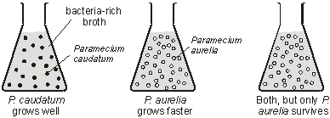 | Conclusion: These two species ofParamecium share the same niche, so they compete. P. aurelia is faster-growing, so it out-competes P. caudatum.
Experiment. 2:  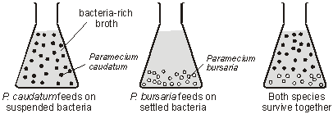 | Conclusion: These two species ofParamecium have slightly different niches, so they don't compete and can coexist.
It is important to understand the distribution in experiment 2. P. caudatum lives in the upper part of the flask because only it is adapted to that niche and it has no competition. In the lower part of the flask both species could survive, but only P. bursaria is found because it out-competes P. caudatum. If P. caudatum was faster-growing it would be found throughout the flask.
The niche concept is summarised in the competitive exclusion principle: Two species cannot coexist in the same habitat if they have the same niche.

