Metabolism

Metabolism refers to all the chemical reactions taking place in a cell. There are thousands of these in a typical cell, and to make them easier to understand, biochemists arrange them into metabolic pathways. The intermediates in these metabolic pathways are called metabolites.
- Reactions that release energy (usually breakdown reactions) are called catabolic reactions (e.g. respiration)
- Reactions that use up energy (usually synthetic reactions) are called anabolic reactions (e.g. photosynthesis).
Photosynthesis and respiration are the reverse of each other, and you couldn’t have one without the other. The net result of all the photosynthesis and respiration by living organisms is the conversion of light energy to heat energy.
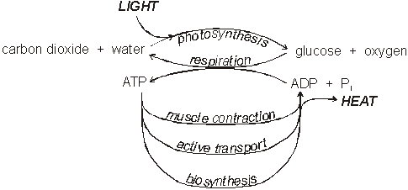

Cellular Respiration
The equation for cellular respiration is usually simplified to:
glucose + oxygen react to form carbon dioxide + water (+ energy)
But in fact respiration is a complex metabolic pathway, comprising at least 30 separate steps. To understand respiration in detail we can break it up into 3 stages:

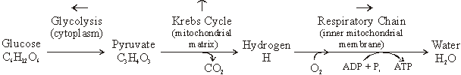
Before we look at these stages in detail, there are a few points from the above summary:
- The different stages of respiration take place in different parts of the cell. This allows the cell to keep the various metabolites separate, and to control the stages more easily.
- The energy released by respiration is in the form of ATP.
- Since this summarises so many separate steps (often involving H⁺ and OH⁻ ions from the solvent water), it is meaningless to try to balance the summary equation.
- The release of carbon dioxide takes place before oxygen is involved. It is therefore not true to say that respiration turns oxygen into carbon dioxide; it is more correct to say that respiration turns glucose into carbon dioxide, and oxygen into water.
- Stage 1 (glycolysis) is anaerobic respiration, while stages 2 and 3 are the aerobic stages.

Mitochondria
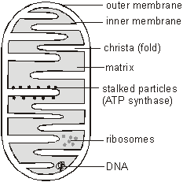
Much of respiration takes place in the mitochondria. Mitochondria have a double membrane: the outer membrane contains many protein channels, which let almost any small molecule through; while the inner membrane is more normal and is impermeable to most materials. The inner membrane is highly folded into folds called cristae, giving a larger surface area. The electron microscope reveals blobs on the inner membrane, which were originally called stalked particles. These have now been identified as the enzyme complex that synthesises ATP, are is more correctly called ATP synthase. the space inside the inner membrane is called the matrix, and is where the Krebs cycle takes place (the matrix also contains DNA and some genes are replicated and expressed here).
Details of Respiration
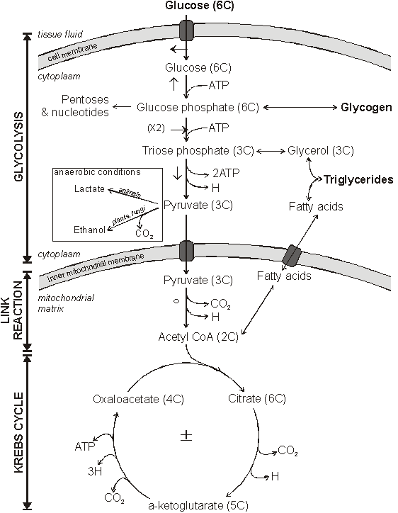

1. Glucose enters cells from the tissue fluid by facilitated diffusion using a specific glucose carrier protein. This carrier can be controlled (gated) by hormones such as insulin, so that uptake of glucose can be regulated.
2. The first step is the phosphorylation of glucose to form glucose phosphate, using phosphate from ATP. Glucose phosphate no longer fits the membrane carrier, so it can’t leave the cell. This ensures that pure glucose is kept at a very low concentration inside the cell, so it will always diffuse down its concentration gradient from the tissue fluid into the cell. Glucose phosphate is also the starting material for the synthesis of glycogen.
3. Glucose is phosphorylated again (using another ATP) and split into two triose phosphate (3 carbon) sugars. From now on everything happens twice per original glucose molecule.
4. The triose sugar is changed over several steps to form pyruvate, a 3-carbon compound. In these steps some energy is released to form ATP (the only ATP formed in glycolysis), and a hydrogen atom is also released. This hydrogen atom is very important as it stores energy, which is later used by the respiratory chain to make more ATP. The hydrogen atom is taken up and carried to the respiratory chain by the coenzyme NAD, which becomes reduced in the process.
(oxidised form Õ) NAD + H Õ NADH (← reduced form)
Note: rather than write NADH examiners often simply refer to it as reduced NAD or reduced coenzyme
Pyruvate marks the end of glycolysis, the first stage of respiration. In the presence of oxygen pyruvate enters the mitochondrial matrix to proceed with aerobic respiration, but in the absence of oxygen it is converted into lactate (in animals and bacteria) or ethanol (in plants and fungi). These are both examples of anaerobic respiration.
5. Once pyruvate has entered the inside of the mitochondria (the matrix), it is converted to a compound calledacetyl CoA. Since this step is between glycolysis and the Krebs Cycle, it is referred to as the link reaction. In this reaction pyruvate loses a CO₂ and a hydrogen to form a 2-carbon acetyl compound, which is temporarily attached to another coenzyme called coenzyme A (or just coA), so the product is called acetyl coA. The CO₂diffuses through the mitochondrial and cell membranes by lipid diffusion, out into the tissue fluid and into the blood, where it is carried to the lungs for removal. The hydrogen is taken up by NAD again.
6. The acetyl CoA then enters the Krebs Cycle. It is one of several cyclic metabolic pathways, and is also known as the citric acid cycle or the tricarboxylic acid cycle. The 2-carbon acetyl is transferred from acetyl coA to a 4-carbon intermediate (oxaloacetate) to form a 6-carbon intermediate (citrate). Citrate is then gradually broken down in several steps to re-form the 4-carbon intermediate (oxaloacetate), producing carbon dioxide and hydrogen in the process. As before, the CO₂ diffuses out the cell and the hydrogen is taken up by NAD, or by an alternative hydrogen carrier called FAD. These hydrogens are carried to the inner mitochondrial membrane for the final part of respiration.

The Respiratory Chain
The respiratory chain (or electron transport chain) is an unusual metabolic pathway in that it takes place withinthe inner mitochondrial membrane, using integral membrane proteins. These proteins form four huge trans-membrane complexes. In the respiratory chain the hydrogen atoms from NADH gradually release all their energy to form ATP, and are finally combined with oxygen to form water.

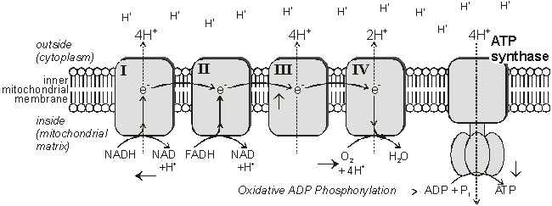
1. NADH molecules bind to Complex I and release their hydrogen atoms as protons (H⁺) and electrons (e⁻). The NAD molecules then returns to the Krebs Cycle to collect more hydrogen. FADH binds to complex II rather than complex I to release its hydrogen.
2. The electrons are passed down the chain of proteins complexes, each complex binding electrons more tightly than the previous one. In complexes I, II and IV the electrons give up some of their energy, which is then used to pump protons across the inner mitochondrial membrane by active transport through the complexes.
3. In complex IV the electrons are combined with protons and molecular oxygen to form water, the final end-product of respiration. The oxygen diffused in from the tissue fluid, crossing the cell and mitochondrial membranes by lipid diffusion. Oxygen is only involved at the very last stage of respiration as the final electron acceptor, but without the whole respiratory chain stops.
4. The energy of the electrons is now stored in the form of a proton gradient across the inner mitochondrial membrane. It’s a bit like using energy to pump water uphill into a high reservoir, where it is stored as potential energy. And just as the potential energy in the water can be used to generate electricity in a hydroelectric power station, so the energy in the proton gradient can be used to generate ATP in the ATP synthase enzyme. The ATP synthase enzyme has a proton channel through it, and as the protons "fall down" this channel their energy is used to make ATP, spinning the globular head as they go.

This method of storing energy by creating a protons gradient across a membrane is called chemiosmosis. Some poisons act by making proton channels in mitochondrial membranes, so giving an alternative route for protons and stopping the synthesis of ATP. This also happens naturally in the brown fat tissue of new-born babies and hibernating mammals: respiration takes place, but no ATP is made, with the energy being turned into heat instead.
How Much ATP is Made in Respiration?
We can now summarise respiration and see how much ATP is made from each glucose molecule. ATP is made in two different ways:
- Some ATP molecules are made directly by the enzymes in glycolysis or the Krebs cycle. This is calledsubstrate level phosphorylation (since ADP is being phosphorylated to form ATP).
- Most of the ATP molecules are made by the ATP synthase enzyme in the respiratory chain. Since this requires oxygen it is called oxidative phosphorylation. Scientists don’t yet know exactly how many protons are pumped in the respiratory chain, but the current estimates are: 10 protons are pumped by NADH; 6 by FADH; and 4 protons are needed by ATP synthase to make one ATP molecule. This means that each NADH can make 2.5 ATPs (10/4) and each FADH can make 1.5 ATPs (6/4). Previous estimates were 3 ATPs for NADH and 2 ATPs for FADH, and these numbers still appear in most textbooks, although they are now know to be wrong. (you don't need to know any numbers anyway so don't worry)
- Two ATP molecules are used at the start of glycolysis to phosphorylate the glucose, and these must be subtracted from the total.

The table below is an "ATP account" for aerobic respiration, and shows that 32 molecules of ATP are made for each molecule of glucose used in aerobic respiration. This is the maximum possible yield; often less ATP is made, depending on the circumstances. Note that anaerobic respiration (glycolysis) only produces 2 molecules of ATP.

Stage | molecules produced per glucose | Final ATP yield  old method  (interest only) | Final ATP yield  new method  (interest only)
Glycolysis | 2 ATP used | -2 | -2
 | 4 ATP produced (2 per triose phosphate) | 4 | 4
 | 2 NADH produced (1 per triose phosphate) | 6 | 5
Link Reaction | 2 NADH produced (1 per pyruvate) | 6 | 5
Krebs Cycle | 2 ATP produced (1 per acetyl coA) | 2 | 2
 | 6 NADH produced (3 per acetyl coA) | 18 | 15
 | 2 FADH produced (1 per acetyl coA) | 4 | 3
Total |  | 38 | 32

Other substances can also be used to make ATP. Triglycerides are broken down to fatty acids and glycerol, both of which enter the Krebs Cycle. A typical triglyceride might make 50 acetyl CoA molecules, yielding 500 ATP molecules. Fats are a very good energy store, yielding 2.5 times as much ATP per g dry mass as carbohydrates. Proteins are not normally used to make ATP, but in times of starvation they can be broken down and used in respiration. They are first broken down to amino acids, which are converted into pyruvate and Krebs Cycle metabolites and then used to make ATP.

Photosynthesis

Photosynthesis is essentially the reverse of respiration. It is usually simplified to:
carbon dioxide + water (+ light energy) reacts to form glucose + oxygen
But again this simplification hides numerous separate steps. To understand photosynthesis in detail we can break it up into 2 stages:

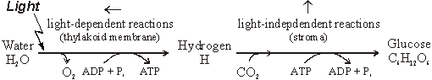
- The light-dependent reactions use light energy to split water and make some ATP and energetic hydrogen atoms. This stage takes place within the thylakoid membranes of chloroplasts, and is very much like the respiratory chain, only in reverse.
- The light-independent reactions don’t need light, but do need the products of the light-dependent stage (ATP and H), so they stop in the absence of light. This stage takes place in the stroma of the chloroplasts and involve the fixation of carbon dioxide and the synthesis of glucose.
We shall see that there are many similarities between photosynthesis and respiration, and even the same enzymes are used in some steps.
Chloroplasts
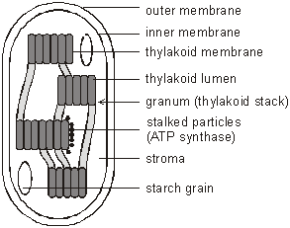
Photosynthesis takes place entirely within chloroplasts. Like mitochondria, chloroplasts have a double membrane, but in addition chloroplasts have a third membrane called the thylakoid membrane. This is folded into thin vesicles (the thylakoids), enclosing small spaces called the thylakoid lumen. The thylakoid vesicles are often layered in stacks called grana. The thylakoid membrane contains the same ATP synthase particles found in mitochondria. Chloroplasts also contain DNA, tRNA and ribososomes, and they often store the products of photosynthesis as starch grains and lipid droplets.

Chlorophyll
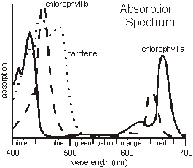
Chloroplasts contain two different kinds of chlorophyll, called chlorophyll a and b, together with a number of other light-absorbing accessory pigments, such as the carotenoids and luteins (or xanthophylls). These different pigments absorb light at different wavelengths, so having several different pigments allows more of the visible spectrum to be used. The absorption spectra of pure samples of some of these pigments are shown in the graph on the left. A low absorption means that those wavelengths are not absorbed and used, but instead are reflected or transmitted. Different species of plant have different combinations of photosynthetic pigments, giving rise to different coloured leaves. In addition, plants adapted to shady conditions tend to have a higher concentration of chlorophyll and so have dark green leaves, while those adapted to bright conditions need less chlorophyll and have pale green leaves.
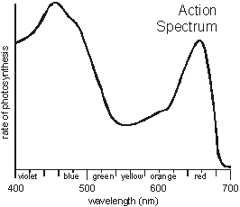
By measuring the rate of photosynthesis using different wavelengths of light, an action spectrum is obtained. The action spectrum can be well explained by the absorption spectra above, showing that these pigments are responsible for photosynthesis.
Chlorophyll is a fairly small molecule (not a protein) with a structure similar to haem, but with a magnesium atom instead of iron. Chlorophyll and the other pigments are arranged in complexes with proteins, calledphotosystems. Each photosystem contains some 200 chlorophyll molecules and 50 molecules of accessory pigments, together with several protein molecules (including enzymes) and lipids. These photosystems are located in the thylakoid membranes and they hold the light-absorbing pigments in the best position to maximise the absorbance of photons of light. The chloroplasts of green plants have two kinds of photosystem called photosystem I (PSI) and photosystem II (PSII). These absorb light at different wavelengths and have slightly different jobs in the light dependent reactions of photosynthesis.
The Light-Dependent Reactions
The light-dependent reactions take place on the thylakoid membranes using four membrane-bound protein complexes called photosystem I (PSI), photosystem II (PSII), cytochrome complex (C) and ferredoxin complex (FD). In these reactions light energy is used to split water, oxygen is given off, and ATP and hydrogen are produced
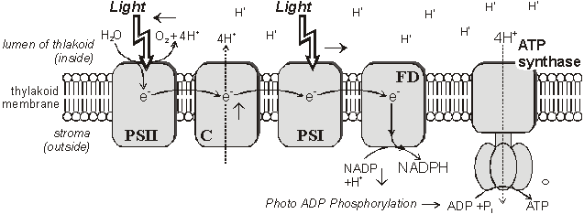
1. Chlorophyll molecules in PSII absorb photons of light, exciting chlorophyll electrons to a higher energy level and causing a charge separation within PSII. This charge separation drives the splitting (or photolysis) of water molecules to make oxygen (O₂), protons (H⁺) and electrons (e⁻):
2H₂O O₂ + 4H⁺ + 4e⁻
Water is a very stable molecule and it requires the energy from 4 photons of light to split 1 water molecule. The oxygen produced diffuses out of the chloroplast and eventually into the air; the protons build up in the thylakoid lumen causing a proton gradient; and the electrons from water replace the excited electrons that have been ejected from chlorophyll.
2. The excited, high-energy electrons are passed along a chain of protein complexes in the membrane, similar to the respiratory chain. They are passed from PSII to C, where the energy is used to pump 4 protons from stroma to lumen; then to PSI, where more light energy is absorbed by the chlorophyll molecules and the electrons are given more energy; and finally to FD.
3. In the ferredoxin complex each electron is recombined with a proton to form a hydrogen atom, which is taken up by the hydrogen carrier NADP. Note that while respiration uses NAD to carry hydrogen, photosynthesis always uses its close relative, NADP.
4. The combination of the water splitting and the proton pumping by the cytochrome complex cause protons to build up inside the thylakoid lumen. This generates a proton gradient across the thylakoid membrane. This gradient is used to make ATP using the ATP synthase enzyme in exactly the same way as respiration. This synthesis of ATP is called photophosphorylation because it uses light energy to phosphorylate ADP.

The Light-Independent Reactions
The light-independent, or carbon-fixing reactions, of photosynthesis take place in the stroma of the chloroplasts and comprise another cyclic pathway, called the Calvin Cycle, after the American scientist who discovered it.

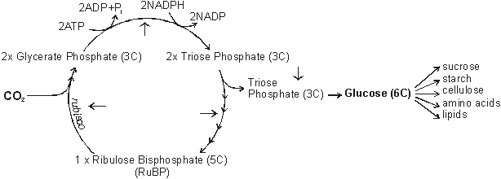
1. Carbon dioxide binds to the 5-carbon sugar ribulose bisphosphate (RuBP) to form 2 molecules of the 3-carbon compound glycerate phosphate. This carbon-fixing reaction is catalysed by the enzyme ribulose bisphosphate carboxylase, always known as rubisco. It is a very slow and inefficient enzyme, so large amounts of it are needed (recall that increasing enzyme concentration increases reaction rate), and it comprises about 50% of the mass of chloroplasts, making the most abundant protein in nature. Rubisco is synthesised in chloroplasts, using chloroplast (not nuclear) DNA.
2. Glycerate phosphate is an acid, not a carbohydrate, so it is reduced and activated to form triose phosphate, the same 3-carbon sugar as that found in glycolysis. The ATP and NADPH from the light-dependent reactions provide the energy for this step. The ADP and NADP return to the thylakoid membrane for recycling.
3. Triose phosphate is a branching point. Most of the triose phosphate continues through a complex series of reactions to regenerate the RuBP and complete the cycle. 5 triose phosphate molecules (15 carbons) combine to form 3 RuBP molecules (15 carbons).
4. Every 3 turns of the Calvin Cycle 3 CO₂ molecules are fixed to make 1 new triose phosphate molecule. This leaves the cycle, and two of these triose phosphate molecules combine to form one glucose molecule using the glycolysis enzymes in reverse. The glucose can then be used to make other material that the plant needs.

