Genetic Engineering
Genetic engineering, also known as recombinant DNA technology, means altering the genes in a living organism to produce a Genetically Modified Organism (GMO) with a new genotype. Various kinds of genetic modification are possible: inserting a foreign gene from one species into another, forming a transgenic organism; altering an existing gene so that its product is changed; or changing gene expression so that it is translated more often or not at all.

Techniques of Genetic Engineering
Genetic engineering is a very young discipline, and is only possible due to the development of techniques from the 1960s onwards. Watson and Crick have made these techniques possible from our greater understanding of DNA and how it functions following the discovery of its structure in 1953. Although the final goal of genetic engineering is usually the expression of a gene in a host, in fact most of the techniques and time in genetic engineering are spent isolating a gene and then cloning it. This table lists the techniques that we shall look at in detail.
Technique |  | Purpose
1 | cDNA | To make a DNA copy of mRNA
2 | Restriction Enzymes | To cut DNA at specific points, making small fragments
3 | DNA Ligase | To join DNA fragments together
4 | Vectors | To carry DNA into cells and ensure replication
5 | Plasmids | Common kind of vector
6 | Gene Transfer | To deliver a gene to a living cells
7 | Genetic Markers | To identify cells that have been transformed
8 | Replica Plating * | To make exact copies of bacterial colonies on an agar plate
9 | PCR | To amplify very small samples of DNA
10 | DNA probes | To identify and label a piece of DNA containing a certain sequence
11 | Shotgun * | To find a particular gene in a whole genome
12 | Antisense genes * | To stop the expression of a gene in a cell
13 | Gene Synthesis | To make a gene from scratch
14 | Electrophoresis | To separate fragments of DNA

1. Complementary DNA
Complementary DNA (cDNA) is DNA made from mRNA. This makes use of the enzyme reverse transcriptase, which does the reverse of transcription: it synthesises DNA from an RNA template. It is produced naturally by a group of viruses called the retroviruses (which include HIV), and it helps them to invade cells. In genetic engineering reverse transcriptase is used to make an artificial gene of cDNA as shown in this diagram.
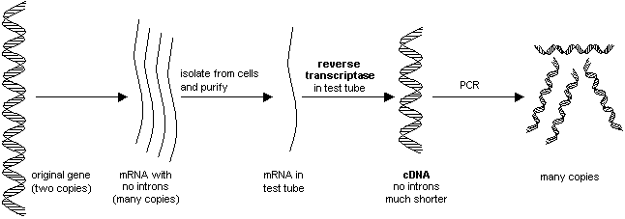
Complementary DNA has helped to solve different problems in genetic engineering:
It makes genes much easier to find. There are some 70 000 genes in the human genome, and finding one gene out of this many is a very difficult (though not impossible) task. However a given cell only expresses a few genes, so only makes a few different kinds of mRNA molecule. For example the b cells of the pancreas make insulin, so make lots of mRNA molecules coding for insulin. This mRNA can be isolated from these cells and used to make cDNA of the insulin gene.

2. Restriction Enzymes
These are enzymes that cut DNA at specific sites. They are properly called restriction endonucleases because they cut the bonds in the middle of the polynucleotide chain. Some restriction enzymes cut straight across both chains, forming blunt ends, but most enzymes make a staggered cut in the two strands, forming sticky ends.
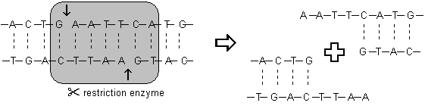

The cut ends are “sticky” because they have short stretches of single-stranded DNA with complementary sequences. These sticky ends will stick (or anneal) to another piece of DNA by complementary base pairing, but only if they have both been cut with the same restriction enzyme. Restriction enzymes are highly specific, and will only cut DNA at specific base sequences, 4-8 base pairs long, called recognition sequences.
Restriction enzymes are produced naturally by bacteria as a defence against viruses (they “restrict” viral growth), but they are enormously useful in genetic engineering for cutting DNA at precise places ("molecular scissors"). Short lengths of DNA cut out by restriction enzymes are called restriction fragments. There are thousands of different restriction enzymes known, with over a hundred different recognition sequences. Restriction enzymes are named after the bacteria species they came from, so EcoR1 is from E. coli strain R, and HindIII is from Haemophilis influenzae.

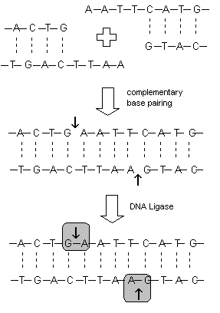
3. DNA Ligase
This enzyme repairs broken DNA by joining two nucleotides in a DNA strand. It is commonly used in genetic engineering to do the reverse of a restriction enzyme, i.e. to join together complementary restriction fragments.
The sticky ends allow two complementary restriction fragments to anneal, but only by weak hydrogen bonds, which can quite easily be broken, say by gentle heating. The backbone is still incomplete.
DNA ligase completes the DNA backbone by forming covalent bonds. Restriction enzymes and DNA ligase can therefore be used together to join lengths of DNA from different sources.

4. Vectors
In biology a vector is something that carries things between species. For example the mosquito is a disease vector because it carries the malaria parasite into humans. In genetic engineering a vector is a length of DNA that carries the gene we want into a host cell. A vector is needed because a length of DNA containing a gene on its own won’t actually do anything inside a host cell. Since it is not part of the cell’s normal genome it won’t be replicated when the cell divides, it won’t be expressed, and in fact it will probably be broken down pretty quickly. A vector gets round these problems by having these properties:
- It is big enough to hold the gene we want (plus a few others), but not too big.
- It is circular (or more accurately a closed loop), so that it is less likely to be broken down (particularly in prokaryotic cells where DNA is always circular).
- It contains control sequences, such as a replication origin and a transcription promoter, so that the gene will be replicated, expressed, or incorporated into the cell’s normal genome.
- It contain marker genes, so that cells containing the vector can be identified.
Many different vectors have been made for different purposes in genetic engineering by modifying naturally-occurring DNA molecules, and these are now available off the shelf. For example a cloning vector contains sequences that cause the gene to be copied (perhaps many times) inside a cell, but not expressed. An expression vector contains sequences causing the gene to be expressed inside a cell, preferably in response to an external stimulus, such as a particular chemical in the medium. Different kinds of vector are also available for different lengths of DNA insert:
Type of vector | Max length of DNA insert
Plasmid | 10 kbp
Virus or phage | 30 kbp
Bacterial Artificial Chromosome (BAC) | 500 kbp

5. Plasmids
Plasmids are by far the most common kind of vector, so we shall look at how they are used in some detail. Plasmids are short circular bits of DNA found naturally in bacterial cells. A typical plasmid contains 3-5 genes and there are usually around 10 copies of a plasmid in a bacterial cell. Plasmids are copied separately from the main bacterial DNA when the cell divides, so the plasmid genes are passed on to all daughter cells. They are also used naturally for exchange of genes between bacterial cells (the nearest they get to sex), so bacterial cells will readily take up a plasmid. Because they are so small, they are easy to handle in a test tube, and foreign genes can quite easily be incorporated into them using restriction enzymes and DNA ligase.
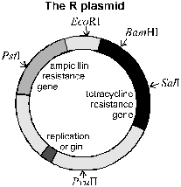
One of the most common plasmids used is the R-plasmid (or pBR322). This plasmid contains a replication origin, several recognition sequences for different restriction enzymes (with names like PstI and EcoRI), and two marker genes, which confer resistance to different antibiotics (ampicillin and tetracycline).
The diagram below shows how DNA fragments can be incorporated into a plasmid using restriction and ligase enzymes. The restriction enzyme used here (PstI) cuts the plasmid in the middle of one of the marker genes (we’ll see why this is useful later). The foreign DNA anneals with the plasmid and is joined covalently by DNA ligase to form a hybrid vector (in other words a mixture or hybrid of bacterial and foreign DNA). Several other products are also formed: some plasmids will simply re-anneal with themselves to re-form the original plasmid, and some DNA fragments will join together to form chains or circles. Theses different products cannot easily be separated, but it doesn’t matter, as the marker genes can be used later to identify the correct hybrid vector.
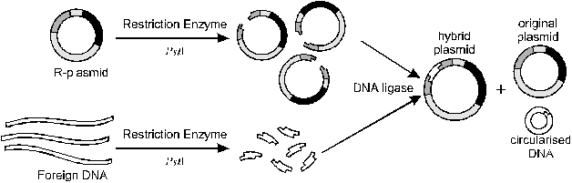

6. Gene Transfer
Vectors containing the genes we want must be incorporated into living cells so that they can be replicated or expressed. The cells receiving the vector are called host cells, and once they have successfully incorporated the vector they are said to be transformed. Vectors are large molecules which do not readily cross cell membranes, so the membranes must be made permeable in some way. There are different ways of doing this depending on the type of host cell.
- Heat Shock. Cells are incubated with the vector in a solution containing calcium ions at 0°C. The temperature is then suddenly raised to about 40°C. This heat shock causes some of the cells to take up the vector, though no one knows why. This works well for bacterial and animal cells.
- Electroporation. Cells are subjected to a high-voltage pulse, which temporarily disrupts the membrane and allows the vector to enter the cell. This is the most efficient method of delivering genes to bacterial cells.
- Viruses. The vector is first incorporated into a virus, which is then used to infect cells, carrying the foreign gene along with its own genetic material. Since viruses rely on getting their DNA into host cells for their survival they have evolved many successful methods, and so are an obvious choice for gene delivery. The virus must first be genetically engineered to make it safe, so that it can’t reproduce itself or make toxins. Three viruses are commonly used:
1. Bacteriophages (or phages) are viruses that infect bacteria. They are a very effective way of delivering large genes into bacteria cells in culture.
2. Adenoviruses are human viruses that causes respiratory diseases including the common cold. Their genetic material is double-stranded DNA, and they are ideal for delivering genes to living patients in gene therapy. Their DNA is not incorporated into the host’s chromosomes, so it is not replicated, but their genes are expressed.
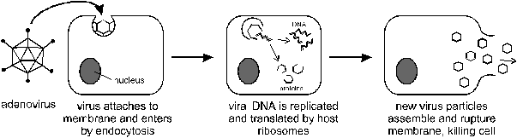
The adenovirus is genetically altered so that its coat proteins are not synthesised, so new virus particles cannot be assembled and the host cell is not killed.
3. Retroviruses are a group of human viruses that include HIV. They are enclosed in a lipid membrane and their genetic material is double-stranded RNA. On infection this RNA is copied to DNA and the DNA is incorporated into the host’s chromosome. This means that the foreign genes are replicated into every daughter cell.
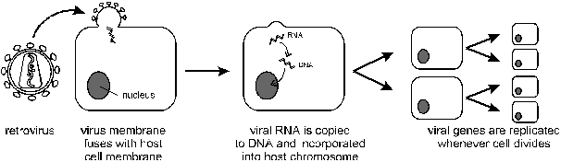
After a certain time, the dormant DNA is switched on, and the genes are expressed in all the host cells.
- Plant Tumours. This method has been used successfully to transform plant cells, which are perhaps the hardest to do. The gene is first inserted into the Ti plasmid of the soil bacteriumAgrobacterium tumefaciens, and then plants are infected with the bacterium. The bacterium inserts the Ti plasmid into the plant cells' chromosomal DNA and causes a "crown gall" tumour. These tumour cells can be cultured in the laboratory and whole new plants grown from them by micropropagation. Every cell of these plants contains the foreign gene.
- Gene Gun. This extraordinary technique fires microscopic gold particles coated with the foreign DNA at the cells using a compressed air gun. It is designed to overcome the problem of the strong cell wall in plant tissue, since the particles can penetrate the cell wall and the cell and nuclear membranes, and deliver the DNA to the nucleus, where it is sometimes expressed.
- Micro-Injection. A cell is held on a pipette under a microscope and the foreign DNA is injected directly into the nucleus using an incredibly fine micro-pipette. This method is used where there are only a very few cells available, such as fertilised animal egg cells. In the rare successful cases the fertilised egg is implanted into the uterus of a surrogate mother and it will develop into a normal animal, with the DNA incorporated into the chromosomes of every cell.
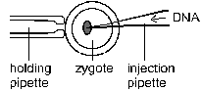 | 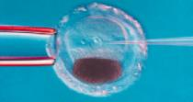
- Liposomes. Vectors can be encased in liposomes, which are small membrane vesicles (see module 1). The liposomes fuse with the cell membrane (and sometimes the nuclear membrane too), delivering the DNA into the cell. This works for many types of cell, but is particularly useful for delivering genes to cell in vivo (such as in gene therapy).
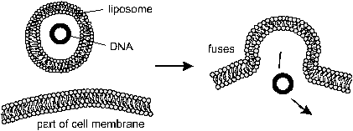

Applications of Genetic Engineering
This section contains additional information that is not directly included in AS Biology. However it can be useful to help support and consolidate GE techniques.

We have now looked at some of the many techniques used by genetic engineers. What can be done with these techniques? By far the most numerous applications are still as research tools, and the techniques above are helping geneticists to understand complex genetic systems. Despite all the hype, genetic engineering still has very few successful commercial applications, although these are increasing each year. The applications so far can usefully be considered in three groups.
- Gene Products | using genetically modified organisms (usually microbes) to produce chemicals, usually for medical or industrial applications.
- New Phenotypes | using gene technology to alter the characteristics of organisms (usually farm animals or crops)
- Gene Therapy | using gene technology on humans to treat a disease

Gene Products
The biggest and most successful kind of genetic engineering is the production of gene products. These products are of medical, agricultural or commercial value. This table shows a few of the examples of genetically engineered products that are already available.
Product | Use | Host Organism
Insulin | human hormone used to treat diabetes | bacteria /yeast
HGH | human growth hormone, used to treat dwarfism | bacteria
BST | bovine growth hormone, used to increase milk yield of cows | bacteria
Factor VIII | human blood clotting factor, used to treat haemophiliacs | bacteria
Anti-thrombin | anti-blood clotting agent used in surgery | goats
Penicillin | antibiotic, used to kill bacteria | fungi / bacteria
Vaccines | hepatitis B antigen, for vaccination | yeast
AAT | enzyme used to treat cystic fibrosis and emphysema | sheep
α-glucosidase | enzyme used to treat Pompe’s disease | rabbits
DNase | enzyme used to treat CF | bacteria
rennin | enzyme used in manufacture of cheese | bacteria /yeast
cellulase | enzyme used in paper production | bacteria
PHB | biodegradable plastic | plants
The products are mostly proteins, which are produced directly when a gene is expressed, but they can also be non-protein products produced by genetically-engineered enzymes. The basic idea is to transfer a gene (often human) to another host organism (usually a microbe) so that it will make the gene product quickly, cheaply and ethically. It is also possible to make “designer proteins” by altering gene sequences, but while this is a useful research tool, there are no commercial applications yet.
Since the end-product is just a chemical, in principle any kind of organism could be used to produce it. By far the most common group of host organisms used to make gene products are the bacteria, since they can be grown quickly and the product can be purified from their cells. Unfortunately bacteria cannot not always make human proteins, and recently animals and even plants have also been used to make gene products. In neither case is it appropriate to extract the product from their cells, so in animals the product must be secreted in milk or urine, while in plants the product must be secreted from the roots. This table shows some of the advantages and disadvantages of using different organisms for the production of genetically-engineered gene products.

Type of organism | Advantages | Disadvantages
Prokaryotes (Bacteria) | No nucleus so DNA easy to modify; have plasmids; small genome; genetics well understood; asexual so can be cloned; small and fast growing; easy to grow commercially in fermenters; will use cheap carbohydrate; few ethical problems. | Can’t splice introns; no post-translational modification; small gene size
Eukaryotes | Can splice introns; can do post-translational modifications; can accept large genes | Do not have plasmids (except yeast); often diploid so two copies of genes may need to be inserted; control of expression not well understood.
Fungi (yeast, mould) | Asexual so can be cloned; haploid, so only one copy needed; can be grown in vats | Can’t always make animals gene products
Plants | Photosynthetic so don’t need much feeding; can be cloned from single cells; products can be secreted from roots or in sap. | Cell walls difficult to penetrate by vector; slow growing; must be grown in fields; multicellular
Animals (pharming) | Most likely to be able to make human proteins; products can be secreted in milk or urine | Multicellular; slow growing

Human Insulin
Insulin is a small protein hormone produced by the pancreas to regulate the blood sugar concentration. In the disease insulin-dependent diabetes the pancreas cells don’t produce enough insulin, causing wasting symptoms and eventually death. The disease can be successfully treated by injection of insulin extracted from the pancreases of slaughtered cows and pigs. However the insulin from these species has a slightly different amino acid sequence from human insulin and this can lead to immune rejection and side effects.
The human insulin gene was isolated, cloned and sequenced in the 1970s, and so it became possible to insert this gene into bacteria, who could then produce human insulin in large amounts. Unfortunately it wasn’t that simple. In humans, pancreatic cells first make pro-insulin, which then undergoes post-translational modification to make the final, functional insulin. Bacterial cells cannot do post-translational modification. Eventually a synthetic cDNA gene was made and inserted into the bacterium E. coli, which made pro-insulin, and the post-translational conversion to insulin was carried out chemically. This technique was developed by Eli Lilly and Company in 1982 and the product, “humulin” became the first genetically-engineered product approved for medical use.
In the 1990s the procedure was improved by using the yeast Saccharomyces cerevisiae instead of E. coli. Yeast, as a eukaryote, is capable of post-translational modification, so this simplifies the production of human insulin. However another company has developed a method of converting pig insulin into human insulin by chemically changing a few amino acids, and this turns out to be cheaper than the genetic engineering methods. This all goes to show that genetic engineers still have a lot to learn.

