CELL CYCLES: Contents

The Cell Cycle
The life of a cell is called the cell cycle and has three phases:
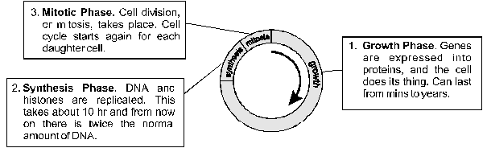
In different cell types the cell cycle can last from hours to years. E.g. bacterial cells can divide every 30 minutes under suitable conditions, skin cells divide about every 12 hours on average, liver cells every 2 years.
The mitotic phase can be sub-divided into four phases (prophase, metaphase, anaphase and telophase). Mitosis is strictly nuclear division, and is followed by cytoplasmic division, or cytokinesis, to complete cell division. The growth and synthesis phases are collectively called interphase (i.e. in between cell division). Mitosis results in two "daughter cells", which are genetically identical to each other, and is used for growth and asexual reproduction. The details of each of these phases follows.
Cell Division by Mitosis
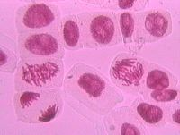
Interphase |  |  | - chromatin not visible  - DNA replicated
Prophase |  |  | - chromosomes condensed and visible  - centrioles at opposite poles of cell  - phase ends with the breakdown of the nuclear membrane
Metaphase |  |  | - chromosomes align along equator of cell  - spindle fibres(microtubules) connect centrioles to chromosomes
Anaphase |  |  | - centromeres split, allowing chromatids to separate  - chromatids move towards poles
Telophase |  |  | - spindle fibres disperse  - nuclear membranes form
Cytokinesis  (division of cytoplasm) |  |  | - In animal cells a ring of filaments form round the equator of the cell, and then tighten to split the cell in two.
 |  |  | - In plant cells a new cell wall is laid down inside the existing cell splitting the cell into two

Asexual Reproduction
Asexual reproduction is the production of offspring from a single parent using mitosis. Therefore the offspring are genetically identical to each other and to their "parent"- i.e. they are clones. Asexual reproduction can be either natural or artificial.
 | Methods of Asexual Reproduction
 | Natural Methods | Artificial Methods
Microbes | binary fission,  budding,  spores,  fragmentation | cell culture,  fermenters
Plants | vegetative propagation,  parthenogenesis | cuttings,  grafting,  tissue culture
Animals | budding,  fragmentation,  parthenogenesis | embryo splitting,  somatic cell cloning

Natural Methods
Binary Fission. The simplest and fastest method of asexual reproduction. The nucleus divides by mitosis and the cell splits into two. | 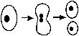
Budding. A small copy of the parent develops as an outgrowth, or bud, from the parent, and then is released as a separate individual. | 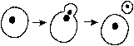
Spores. These are simply specialised cells that are released from the parent (usually in large numbers) to be dispersed. Each spore can grow into a new individual.
Vegetative Reproduction. (note also the name of an artificial technique) This term describes all the natural methods of asexual reproduction used by plants. A bud grows from a vegetative part of the plant (usually the stem) and develops into a complete new plant, which eventually becomes detached from the parent plant. There are numerous forms of vegetative reproduction, including:
- bulbs (e.g. daffodil)  - rhizomes (e.g. couch grass)  - runners (e.g. strawberry)  - tubers (e.g. potato) | 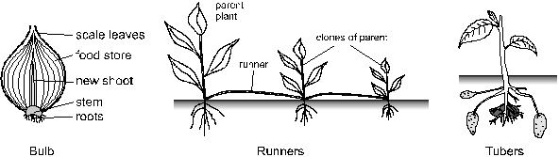
Many of these methods are also perenating organs, which means they contain a food store and are used for survival over winter as well as for asexual reproduction. Since vegetative reproduction relies entirely on mitosis, all offspring are clones of the parent.
Parthenogenesis. This is used by some plants (e.g. citrus fruits) and some invertebrate animals (e.g. honeybees & aphids) as an alternative to sexual reproduction. Egg cells simply develop into adult clones without being fertilised. These clones may be haploid, or the chromosomes may replicate to form diploid cells.

Artificial Methods: (Plants)
Cloning is of great commercial importance, as brewers, pharmaceutical companies, farmers and plant growers all want to be able to reproduce "good" organisms exactly. Natural methods of asexual reproduction can be used for some organisms (such as potatoes and strawberries), but many important plants and animals do not reproduce asexually, so artificial methods have to be used.
Cell Culture. Microbes can be cloned very easily in the lab using their normal asexual reproduction. Microbial cells can be isolated and identified by growing them on a solid medium in anagar plate, and can then be grown up on a small scale in a liquid medium in a culture flask.
Fermenters. In biotechnology, fermenters are vessels used for growing microbes on a large scale. Fermenters must be stirred, aerated and thermostated, materials can added or removed during the fermentation, and the environmental conditions (such as pH, O₂, pressure and temperature) must be constantly monitored using probes. This will ensure the maximum growth rate of the microbes.
Cuttings. A very old method of cloning plants. Part of a plant stem is cut off and simply replanted in wet soil. Each cutting produces roots and grows into a complete new plant, so the original plant can be cloned many times. Rooting is helped if the cuttings are dipped in rooting hormone (auxin). Many flowering plants, such as geraniums are reproduced commercially by cuttings.
Tissue Culture (or micropropagation). A more modern way of cloning plants. Small samples of plant tissue are grown on agar plates in the laboratory in much the same way that bacteria are grown. The plant tissue is separated into individual cells, each which can grow into a mass of cells called a callus, and if the correct plant hormones are added these cells can develop into whole plantlets, which can eventually be planted outside, where they will grow into normal-sized plants. Conditions must be kept sterile to prevent infection by microbes.

Micropropagation is used on a large scale for many plants including fruit trees, sugar cane and banana. The advantages are:
- thousands of clones of a good plant can be made quickly and in a small space
- disease-free plants can be grown from a few disease-free cells
- the technique works for plants species that cannot be asexually propagated by other means
- a single cell can be genetically modified and turned into many identical plants
Although some animal cells can be grown in culture, they cannot be grown into complete animals, so tissue culture cannot be used for cloning animals.

Artificial Methods: (Animals)
Embryo Cloning (or Embryo Splitting). The most effective technique for cloning animals is to duplicate embryo cells before they have irreversibly differentiated into tissues. It is difficult and quite expensive, so is only worth it for commercially-important farm animals, such as prize cows, or genetically engineered animals. A female animal is fed a fertility drug so that she produces many mature eggs (superovulation). The eggs are then removed from the female’s ovaries. The eggs are fertilised in vitro (IVF) using selected sperm from a prize male. The fertilised eggs (zygotes) are allowed to develop in vitro for a few days until the embryo is at the 16-cell stage. This young embryo can be split into 16 individual cells, which will each develop again into an embryo. (This is similar to the natural process when a young embryo splits to form identical twins.) The identical embryos can then be transplanted into the uterus of surrogate mothers, where they will develop and be born normally.
Could humans be cloned this way? Almost certainly yes. A human embryo was split and cloned to the stage of a few cells in the USA in 1993, just to show that it is possible. However experiments with human embryos are now banned in most countries including the UK for ethical reasons.
Nuclear Transfer. The problem with embryo cloning is that you don’t know the characteristics of the animal you are cloning. By selecting good parents you hope it will have good characteristics, but you will not know until the animal has grown. It would be far better to clone a mature animal, whose characteristics you know. Until recently it was thought impossible to grow a new animal from the somatic cells of an existing animal (in contrast to plants). However, techniques have gradually been developed to do this most recently with sheep (the famous "Dolly") in 1996.
The cell used for Dolly was from the skin of the udder, so was a fully differentiated somatic cell. This cell was fused with a unfertilised egg cell which had had its nucleus removed. This combination of a diploid nucleus in an unfertilised egg cell was a bit like a zygote, and it developed into an embryo. The embryo was implanted into the uterus of a surrogate mother, and developed into an apparently normal sheep, Dolly.
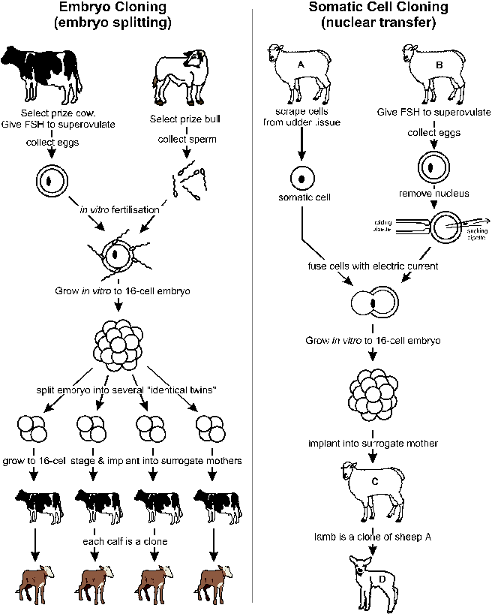

Sexual Reproduction
Sexual reproduction is the production of offspring from two parent using gametes. The cells of the offspring have two sets of chromosomes (one from each parent), so are diploid. Sexual reproduction involves two stages:
- Meiosis- the special cell division that makes haploid gametes
- Fertilisation- the fusion of two gametes to form a diploid zygote
These two stages of sexual reproduction can be illustrated by a sexual life cycle:
All sexually-reproducing species have the basic life cycle shown on the right, alternating between diploid and haploid forms. In addition, they will also use mitosis to grow into adult organisms, the details vary with different organisms.
In the animal kingdom (including humans), and in flowering plants the dominant, long-lived adult form is diploid, and the haploid gamete cells are only formed briefly.
In the fungi kingdom the long-lived adult form is haploid. Haploid spores undergo mitosis and grow into complete adults (including large structures like mushrooms). At some stage two of these haploid cells fuse to form a diploid zygote, which immediately undergoes meiosis to reestablish the haploid state and complete the cycle.
In the plant kingdom the life cycle shows alternation of generations. Plants have two distinct adult forms; one diploid and the other haploid.

Meiosis
Meiosis is a form of cell division. It starts with DNA replication, like mitosis, but then proceeds with two divisions one immediately after the other. Meiosis therefore results in four daughter cells rather than the two cells formed by mitosis. It differs from mitosis in two important aspects:
- The chromosome number is halved from the diploid number (2n) to the haploid number (n). This is necessary so that the chromosome number remains constant from generation to generation. Haploid cells have one copy of each chromosome, while diploid cells have homologous pairs of each chromosome.
- The chromosomes are re-arranged during meiosis to form new combinations of genes. This genetic recombination is vitally important and is a major source of genetic variation. It means for example that of all the millions of sperm produced by a single human male, the probability is that no two will be identical.
You don’t need to know the details of meiosis at this stage (It's covered in module 4).

Gametes
The usual purpose of meiosis is to form gametes- the sex cells that will fuse together to form a new diploid individual.
In all plants and animals the gametes are different sizes. This is called heterogamy.
Summary table (you need to learn this)
Female gametes (ova or eggs in animals, ovules in plants) are produced in fairly small numbers. Human females for example release about 500 ova in a lifetime. They are the larger gametes and tend to be stationary. They often contain food reserves (lipids, proteins, carbohydrates) to nourish the embryo after fertilisation.
Male gametes are produced in very large numbers. Human males for example release about 100 million sperm in one ejaculation. They are the smaller gametes and can move. If they can propel themselves they are called motile (e.g. animal sperm). If they can easily be carried by the wind or animals they are called mobile (e.g. plant pollen).

These diagrams of human gametes illustrate the differences between male and female.
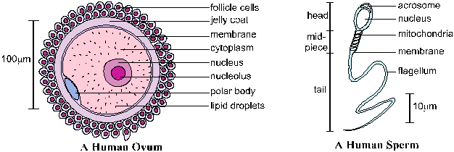

Fertilisation
Fertilisation is the fusion of two gametes to form a zygote.
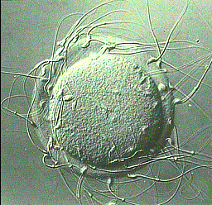 | In humans this takes place near the top of the oviduct. Hundreds of sperm reach the egg (shown in this photo). When a sperm reaches the ovum cell the two membranes fuse and the sperm nucleus enters the cytoplasm of the ovum. This triggers a series of reactions in the ovum that cause the jelly coat to thicken and harden, preventing any other sperm from entering the ovum. The sperm and egg nuclei then fuse, forming a diploid zygote.
In plants fertilisation takes place in the ovary at the base of the carpel. The haploid male nuclei travel down the pollen tube from the pollen grain on the stigma to the ovules in the ovary. In the ovule two fusions between male and female nuclei take place: one forms the zygote (which will become the embryo) while the other forms the endosperm (which will become the food store in the seed). This double fertilisation is unique to flowering plants.

The Advantages of Sex
For most of the history of life on Earth, organisms have reproduced only by asexual reproduction. Each individual was a genetic copy (or clone) of its "parent", and the only variation was due to random genetic mutation. The development of sexual reproduction in the eukaryotes around one billion years ago led to much greater variation and diversity of life. Sexual reproduction is slower and more complex than asexual, but it has the great advantage of introducing genetic variation (due to genetic recombination in meiosis and random fertilisation). This variation allows species to adapt to their environment and so to evolve. This variation is clearly such an advantage that practically all species can reproduce sexually. Some organisms can do both, using sexual reproduction for genetic variety and asexual reproduction to survive harsh times.

