Classical Genetics

Gregor Mendel
Mendel (1822-1884) was an Austrian monk at Brno monastery. He was a keen gardener and scientist, and studied at Vienna University, where he learnt statistics. He investigated inheritance in pea plants and published his results in 1866. They were ignored at the time, but were rediscovered in 1900, and Mendel is now recognised as the “Father of Genetics”. His experiments succeeded where other had failed because:
- Mendel investigated simple well-defined characteristics (or traits), such as flower colour or seed shape, and he varied one trait at a time. Previous investigators had tried to study many complex traits, such as human height or intelligence.
- Mendel use an organism whose sexual reproduction he could easily control by carefully pollinating stigmas with pollen using a brush. Peas can also be self-pollinated, allowing self crosses to be performed. This is not possible with animals.
- Mendel repeated his crosses hundreds of times and applied statistical tests to his results.
- Mendel studied two generations of peas at a time.
A typical experiment looked like this:
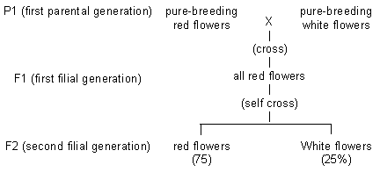
Mendel made several conclusions from these experiments:
1. There are no mixed colours (e.g. pink), so this disproved the widely-held blending theories of inheritance that characteristics gradually mixed over time.
2. A characteristic can disappear for a generation, but then reappear the following generation, looking exactly the same. So a characteristic can be present but hidden.
3. The outward appearance (the phenotype) is not necessarily the same as the inherited factors (the genotype) For example the P1 red plants are not the same as the F1 red plants.
4. One form of a characteristic can mask the other. The two forms are called dominant and recessive respectively.
5. The F2 ratio is always close to 3:1. Mendel was able to explain this by supposing that each individual has two versions of each inherited factor, one received from each parent. We’ll look at his logic in a minute.
6. Mendel’s factors are now called genes and the two alternative forms are called alleles. So in the example above we would say that there is a gene for flower colour and its two alleles are “red” and “white”. One allele comes from each parent, and the two alleles are found on the same position (or locus) on the homologous chromosomes. With two alleles there are three possible combinations of alleles (or genotypes) and two possible appearances (or phenotypes):
Genotype | Name | Phenotype
RR | homozygous dominant | red
rr | homozygous recessive | white
Rr, rR | heterozygous | red

The Monohybrid Cross [back to top]
A simple breeding experiment involving just a single characteristic, like Mendel’s experiment, is called a monohybrid cross. We can now explain Mendel’s monohybrid cross in detail.
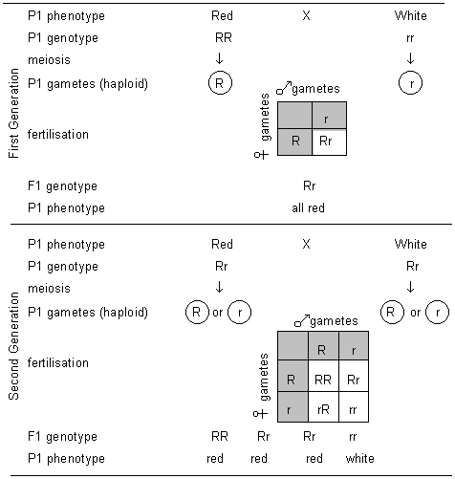
At fertilisation any male gamete can fertilise any female gamete at random. The possible results of a fertilisation can most easily be worked out using a Punnett Square as shown in the diagram. Each of the possible outcomes has an equal chance of happening, so this explains the 3:1 ratio (phenotypes) observed by Mendel.
This is summarised in Mendel’s First Law, which states that individuals carry two discrete hereditary factors (alleles) controlling each characteristic. The two alleles segregate (or separate) during meiosis, so each gamete carries only one of the two alleles.

The Test Cross
You can see an individual’s phenotype, but you can’t see its genotype. If an individual shows the recessive trait (white flowers in the above example) then they must be homozygous recessive as it’s the only genotype that will give that phenotype. If they show the dominant trait then they could be homozygous dominant or heterozygous. You can find out which by performing a test cross with a pure-breeding homozygous recessive. This gives two possible results:
- If the offspring all show the dominant trait then the parent must be homozygous dominant.
- If the offspring are a mixture of phenotypes in a 1:1 ratio, then the parent must be heterozygous.

How does Genotype control Phenotype?
Mendel never knew this, but we can explain in detail the relation between an individual’s genes and its appearance. A gene was originally defined as an inherited factor that controls a characteristic, but we now know that a gene is also a length of DNA that codes for a protein. It is the proteins that actually control phenotype in their many roles as enzymes, pumps, transporters, motors, hormones, or structural elements. For example the flower colour gene actually codes for an enzyme that converts a white pigment into a red pigment:
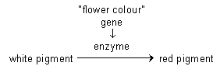
- The dominant allele is the normal (or “wild-type”) form of the gene that codes for functioning enzyme, which therefore makes red-coloured flowers.
- The recessive allele is a mutation of the gene. This mutated gene codes for non-functional enzyme, so the red pigment can’t be made, and the flower remains white. Almost any mutation in a gene will result in an inactive gene product (usually an enzyme), since there are far more ways of making an inactive protein than a working one.
Sometimes the gene actually codes for a protein apparently unrelated to the phenotype. For example the gene for seed shape in peas (round or wrinkled) actually codes for an enzyme that synthesises starch! The functional enzyme makes lots of starch and the seeds are full and rounded, while the non-functional enzyme makes less starch so the seeds wrinkle up.
This table shows why the allele that codes for a functional protein is usually dominant over an allele that codes for a non-function protein. In a heterozygous cell, some functional protein will be made, and this is usually enough to have the desired effect. In particular, enzyme reactions are not usually limited by the amount of enzyme, so a smaller amount will have little effect.
Genotype | Gene product | Phenotype
homozygous dominant (RR) | all functional enzyme | red
homozygous recessive (rr) | no functional enzyme | white
heterozygous (Rr) | some functional enzyme | red

Sex Determination [back to top]
In module 2 we saw that sex is determined by the sex chromosomes (X and Y). Since these are non-homologous they are called heterosomes, while the other 22 pairs are called autosomes. In humans the sex chromosomes are homologous in females (XX) and non-homologous in males (XY), though in other species it is the other way round. The inheritance of the X and Y chromosomes can be demonstrated using a monohybrid cross:
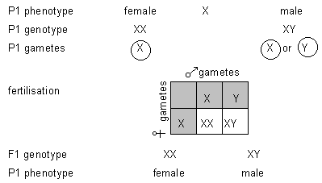
This shows that there will always be a 1:1 ratio of males to females. Note that female gametes (eggs) always contain a single X chromosome, while the male gametes (sperm) can contain a single X or a single Y chromosome. Sex is therefore determined solely by the sperm. There are techniques for separating X and Y sperm, and this is used for planned sex determination in farm animals using IVF.

Sex Linkage
The X and Y chromosomes don’t just determine sex, but also contain many other genes that have nothing to do with sex determination. The Y chromosome is very small and seems to contain very few genes, but the X chromosome is large and contains thousands of genes for important products such as rhodopsin (a protein in the membrane of a photoreceptor cell in the retina of the eye, basically a light absorbing pigment), blood clotting proteins and muscle proteins. Females have two copies of each gene on the X chromosome (i.e. they’re diploid), but males only have one copy of each gene on the X chromosome (i.e. they’re haploid). This means that the inheritance of these genes is different for males and females, so they are called sex linked characteristics.
The first example of sex linked genes discovered was eye colour in Drosophila fruit flies. Red eyes (R) are dominant to white eyes (r) and when a red-eyed female is crossed with a white-eyed male, the offspring all have red eyes, as expected for a dominant characteristic (left cross below). However, when the opposite cross was done (a white-eye male with a red-eyed female) all the male offspring had white eyes (right cross below). This surprising result was not expected for a simple dominant characteristic, but it could be explained if the gene for eye colour was located on the X chromosome. Note that in these crosses the alleles are written in the form X^{R} (red eyes) and X^{r} (white eyes) to show that they are on the X chromosome.
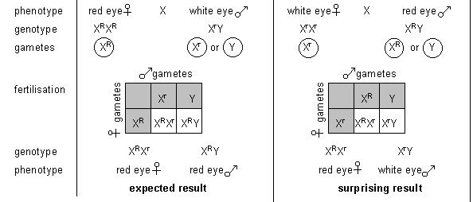
Males always inherit their X chromosome from their mothers, and always pass on their X chromosome to their daughters.
Another well-known example of a sex-linked characteristic is colour blindness in humans. 8% of males are colour blind, but only 0.7% of females. The genes for green-sensitive and red-sensitive rhodopsin are on the X chromosome, and mutations in either of these lead to colour blindness. The diagram below shows two crosses involving colour blindness, using the symbols X^{R} for the dominant allele (normal rhodopsin, normal vision) and X^{r} for the recessive allele (non-functional rhodopsin, colour blind vision).
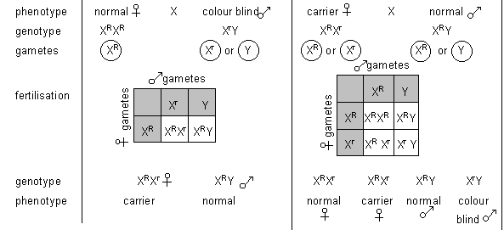
Other examples of sex linkage include haemophilia, premature balding and muscular dystrophy.

Codominance
In most situations (and all of Mendel’s experiments) one allele is completely dominant over the other, so there are just two phenotypes. But in some cases there are three phenotypes, because neither allele is dominant over the other, so the heterozygous genotype has its own phenotype. This situation is called codominance or incomplete dominance. Since there is no dominance we can no longer use capital and small letters to indicate the alleles, so a more formal system is used. The gene is represented by a letter, and the different alleles by superscripts to the gene letter.
A good example of codominance is flower colour in snapdragon (Antirrhinum) plants. The flower colour gene C has two alleles: C^{R} (red) and C^{W} (white). The three genotypes and their phenotypes are:
Genotype | Gene product | Phenotype
homozygous RR | all functional enzyme | red
homozygous WW | no functional enzyme | white
heterozygous (RW) | some functional enzyme | pink
In this case the enzyme is probably less active, so a smaller amount of enzyme will make significantly less product, and this leads to the third phenotype. The monohybrid cross looks like this:
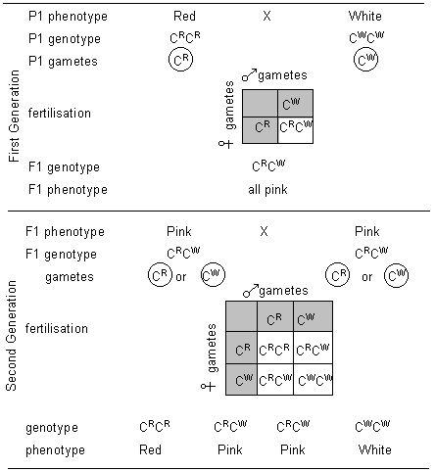
Note that codominance is not an example of “blending inheritance” since the original phenotypes reappear in the second generation. The genotypes are not blended and they still obey Mendel’s law of segregation. It is only the phenotype that appears to blend in the heterozygotes.
Another example of codominance is sickle cell haemoglobin in humans. The gene for haemoglobin Hb has two codominant alleles: Hb^{A} (the normal gene) and Hb^{S} (the mutated gene). There are three phenotypes:
Hb^{A}Hb^{A} | Normal. All haemoglobin is normal, with normal red blood cells.
Hb^{A}Hb^{S} | Sickle cell trait. 50% of the haemoglobin in every red blood cell is normal, and 50% is abnormal. The red blood cells are slightly distorted, but can carry oxygen, so this condition is viable. However these red blood cells cannot support the malaria parasite, so this phenotype confers immunity to malaria.
Hb^{S}Hb^{S} | Sickle cell anaemia. All haemoglobin is abnormal, and molecules stick together to form chains, distorting the red blood cells into sickle shapes. These sickle red blood cells are destroyed by the spleen, so this phenotype is fatal.
Other examples of codominance include coat colour in cattle (red/white/roan), and coat colour in cats (black/orange/tortoiseshell).

Lethal Alleles
An unusual effect of codominance is found in Manx cats, which have no tails. If two Manx cats are crossed the litter has ratio of 2 Manx kittens to 1 normal (long-tailed) kitten. The explanation for this unexpected ratio is explained in this genetic diagram:
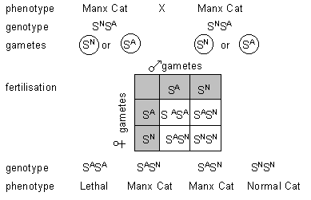
The gene S actually controls the development of the embryo cat’s spine. It has two codominant alleles: S^{N} (normal spine) and S^{A} (abnormal, short spine). The three phenotypes are:
S^{N}S^{N} | Normal. Normal spine, long tail
S^{N}S^{A} | Manx Cat. Last few vertebrae absent, so no tail.
S^{A}S^{A} | Lethal. Spine doesn’t develop, so this genotype is fatal early in development. The embryo doesn’t develop and is absorbed by the mother, so there is no evidence for its existence.
Many human genes also have lethal alleles, because many genes are so essential for life that a mutation in these genes is fatal. If the lethal allele is expressed early in embryo development then the fertilised egg may not develop enough to start a pregnancy, or the embryo may miscarry. If the lethal allele is expressed later in life, then we call it a genetic disease, such as muscular dystrophy or cystic fibrosis.

Multiple Alleles
An individual has two copies of each gene, so can only have two alleles of any gene, but there can be more than two alleles of a gene in a population. An example of this is blood group in humans. The red blood cell antigen is coded for by the gene I (for isohaemaglutinogen), which has three alleles I^{A}, I^{B} and I^{O}. (They are written this way to show that they are alleles of the same gene.) I^{A} and I^{B} are codominant, while I^{O} is recessive. The possible genotypes and phenotypes are:
Phenotype  (blood group) | Genotypes | antigens on red blood cells | plasma antibodies
A | I^{A}I^{A}, I^{A}I^{O} | A | anti-B
B | I^{B}I^{B}, I^{B}I^{O} | B | anti-A
AB | I^{A}I^{B} | A and B | none
O | I^{O}I^{O} | none | anti-A and anti-B
The cross below shows how all four blood groups can arise from a cross between a group A and a group B parent.
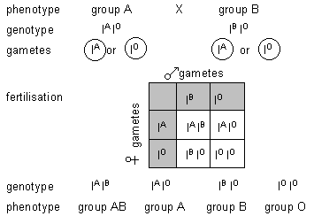
Other examples of multiple alleles are: eye colour in fruit flies, with over 100 alleles; human leukocyte antigen (HLA) genes, with 47 known alleles.

Multiple Genes
So far we have looked at the inheritance of a single gene controlling a single characteristic. This simplification allows us to understand the basic rules of heredity, but inheritance is normally much more complicated than that. We’ll now turn to the inheritance of characteristics involving two genes. This gets more complicated, partly because there are now two genes to consider, but also because the two genes can interact with each other. We’ll look at three situations:
- 2 independent genes, controlling 2 characteristics (the dihybrid cross).
- 2 independent genes controlling 1 characteristic (polygenes)
- 2 interacting genes controlling 1 characteristic (epistasis)

The Dihybrid Cross
Mendel also studied the inheritance of two different characteristics at a time in pea plants, so we’ll look at one of his dihybrid crosses. The two traits are seed shape and seed colour. Round seeds (R) are dominant to wrinkled seeds (r), and yellow seeds (Y) are dominant to green seeds (y). With these two genes there are 4 possible phenotypes:
Genotypes | Phenotype
RRYY, RRYy, RrYY, RrYy | round yellow
RRyy, Rryy | round green
rrYY, rrYy | wrinkled yellow
rryy | wrinkled green
Mendel’s dihybrid cross looked like this:
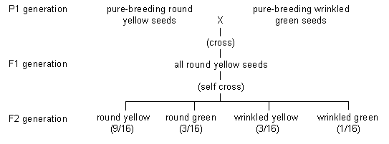
All 4 possible phenotypes are produced, but always in the ratio 9:3:3:1. Mendel was able to explain this ratio if the factors (genes) that control the two characteristics are inherited independently; in other words one gene does not affect the other. This is summarised in Mendel’s second law (or the law of independent assortment), what states that alleles of different genes are inherited independently.
We can now explain the dihybrid cross in detail.
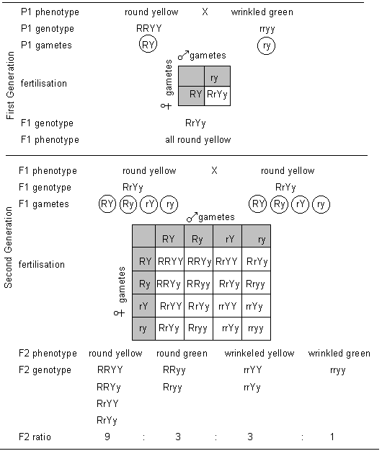
The gametes have one allele of each gene, and that allele can end up with either allele of the other gene. This gives 4 different gametes for the second generation, and 16 possible genotype outcomes.

Dihybrid Test Cross
There are 4 genotypes that all give the same round yellow phenotype. Just like we saw with the monohybrid cross, these four genotypes can be distinguished by crossing with a double recessive phenotype. This gives 4 different results:
Original genotype | Result of test cross
RRYY | all round yellow
RRYy | 1 round yellow : 1 round green
RrYY | 1 round yellow : 1 wrinkled yellow
RrYy | 1 round yellow : 1 round green: 1 wrinkled yellow: 1 wrinkled green

Polygenes
Sometimes two genes at different loci (i.e. separate genes) can combine to affect one single characteristic. An example of this is coat colour in Siamese cats. One gene controls the colour of the pigment, and black hair (B) is dominant to brown hair (b). The other gene controls the dilution of the pigment in the hairs, with dense pigment (D) being dominant to dilute pigment (d). This gives 4 possible phenotypes:
Genotypes | Phenotype | F₂ ratio
BBDD, BBDd, BbDD, BbDd | “seal” (black dense) | 9
BBdd, Bbdd | “blue” (black dilute) | 3
bbDD, bbDd | “chocolate” (brown dense) | 3
bbdd | “lilac” (brown dilute) | 1
The alleles are inherited in exactly the same way as in the dihybrid cross above, so the same 9:3:3:1 ratio in the F2 generation is produced. The only difference is that here, we are looking at a single characteristic, but with a more complicated phenotype ratio than that found in a monohybrid cross.
A more complex example of a polygenic character is skin colour in humans. There are 5 main categories of skin colour (phenotypes) controlled by two genes at different loci. The amount of skin pigment (melanin) is proportional to the number of dominant alleles of either gene:
Phenotype  (skin colour) | Genotypes | No. of dominant alleles | F₂ ratio
Black | AABB | 4 | 1
Dark | AaBB, AABb | 3 | 4
Medium | AAbb, AaBb, aaBB | 2 | 6
Light | Aabb, aaBb | 1 | 4
White (albino) | aabb | 0 | 1
Some other examples of polygenic characteristics are: eye colour, hair colour, and height. The important point about a polygenic character is that it can have a number of different phenotypes, and almost any phenotypic ratio

Epistasis
In epistasis, two genes control a single character, but one of the genes can mask the effect of the other gene. A gene that can mask the effect of another gene is called an epistatic gene (from the Greek meaning “to stand on”). This is a little bit like dominant and recessive alleles, but epistasis applies to two genes at different loci. Epistasis reduces the number of different phenotypes for the character, so instead of having 4 phenotypes for 2 genes, there will be 3 or 2. We’ll look at three examples of epistasis.
1. Dependent genes. In mice one gene controls the production of coat pigment, and black pigment (B) is dominant to no pigment (b). Another gene controls the dilution of the pigment in the hairs, with dense pigment (D) being dominant to dilute pigment (d). This is very much like the Siamese cat example above, but with one important difference: the pigment gene (B) is epistatic over the dilution gene (D) because the recessive allele of the pigment gene is a mutation that produces no pigment at all, so there is nothing for the dilution gene to affect. This gives 3 possible phenotypes:
Genotypes | Phenotype | F₂ ratio
BBDD, BBDd, BbDD, BbDd | Black (black dense) | 9
BBdd, Bbdd | Brown (black dilute) | 3
bbDD, bbDd, bbdd | White (no pigment) | 4
2. Enzymes in a pathway. In a certain variety of sweet pea there are two flower colours (white and purple), but the F2 ratio is 9:7. This is explained if the production of the purple pigment is controlled by two enzymes in a pathway, coded by genes at different loci.
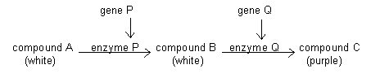
Gene P is epistatic over gene Q because the recessive allele of gene P is a mutation that produces inactive enzyme, so there is no compound B for enzyme Q to react with. This gives just two possible phenotypes:
Genotypes | Phenotype | F₂ ratio
PPQQ, PPQq, PpQQ, PpQq | Purple | 9
PPqq, Ppqq, ppQQ, ppQq, ppqq | White | 7
3. Duplicate Genes. This occurs when genes at two different loci make enzyme that can catalyse the same reaction (this can happen by gene duplication). In this case the coloured pigment is always made unless both genes are present as homozygous recessive (ppqq), so the F2 ratio is 15:1.
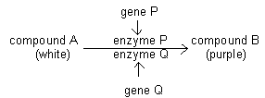
Genotypes | Phenotype | F₂ ratio
PPQQ, PPQq, PpQQ, PpQq, PPqq, Ppqq, ppQQ, ppQq | Purple | 15
ppqq | White | 1
So epistasis leads to a variety of different phenotype ratios.

Expected ratios, observed ratios and the chi-squared test
In the monohybrid cross, the F₂ ratio was 3:1, and with the dihybrid cross the ratio was 9:3:3:1. These are expected ratios, calculated from genotypes of the parental generation - assuming independent assortment, no sex linkage, or codominance. In real crosses the offspring produced depends on chance fusion of gametes (fertilisation), leading to observed ratios. There are differences between expected and observed ratios and the questions is, are these differences due to chance alone, or are they statistically significant? If they are, then the assumptions used to predict the expected ratio might be wrong, for example, the gene(s) might be sex linked.
Chi-squared (χ²) is used to decide if differences between sets of results/data are significant. This compares observed counts with some expected counts and tells you the probability (P) that there is no difference between them
χ² = S d²  x | S = the sum of  d = difference between observed and expected results  x = expected results
Null hypothesis – that there are no significant differences between sets of data
E.g. Dianthus (campion) has flowers of three different colours, red, pink and white. Two pink flowered plants were crossed and the collected seeds grown to the flowering stage.
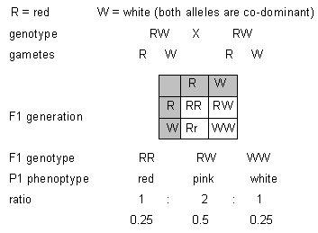
 |  |  | Actual numbers | Expected numbers
 |  | red flowers | 34 | 0.25 x 160 = 40
 |  | pink flowers | 84 | 0.5 x 160  = 80
 |  | white flowers | 42 | 0.25 x 160 = 40
 |  | Total | 160 | 160
χ² = | (40-34 )² | + | (80-84)² | + | (40-42)²
 | 40 |  | 80 |  | 40
= | 0.9 | + | 0.2 | + | 0.1
= | 1.2

The next stage is to assess the degrees of freedom. This value is always one less than the number of classes of results. In this case there are three classes i.e. red, pink and white.
Degrees of freedom = (3-1) = 2
Now check the χ² value against the table:
Degrees of freedom | No. of classes | χ²
1 | 2 | 0.00 | 0.10 | 0.45 | 1.32 | 2.71 | 3.84 | 5.41 | 6.64
2 | 3 | 0.02 | 0.58 | 1.39 | 2.77 | 4.61 | 5.99 | 7.82 | 9.21
3 | 4 | 0.12 | 1.21 | 2.37 | 4.11 | 6.25 | 7.82 | 9.84 | 11.34
Probability that deviation is due to chance alone |  | 0.99  (99%) | 0.75  (75%) | 0.50  (50%) | 0.25  (25%) | 0.10  (10%) | 0.05  (5%) | 0.02  (2%) | 0.01  (1%)
If you were given a c² question you will be given a data table.
- Go to the 2 degrees freedom line
- Find the nearest figures to 1.2, which comes between 75% and 50% columns
- A€χ² value of 1.2 shows that it is at least 50% probable that the result is by chance alone.
- For a significant difference the value should fall between 1-5% columns. The difference of this result against the expected is not significant. Therefore the null hypothesis is accepted.

Genetic Variation in Sexual Reproduction
As mentioned in module 2, the whole point of meiosis and sex is to introduce genetic variation, which allows species to adapt to their environment and so to evolve. There are three sources of genetic variation in sexual reproduction:
- Independent assortment in meiosis
- Crossing over in meiosis
- Random fertilisation
We’ll look at each of these in turn.

1. Independent Assortment
This happens at metaphase I in meiosis, when the bivalents line up on the equator. Each bivalent is made up of two homologous chromosomes, which originally came from two different parents (they’re often called maternal and paternal chromosomes). Since they can line up in any orientation on the equator, the maternal and paternal versions of the different chromosomes can be mixed up in the final gametes.
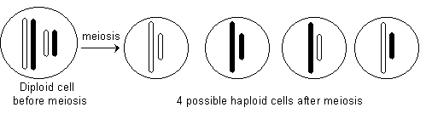
In this simple example with 2 homologous chromosomes (n=2) there are 4 possible different gametes (2²). In humans with n=23 there are over 8 million possible different gametes (2²³). Although this is an impressively large number, there is a limit to the mixing in that genes on the same chromosome must always stay together. This limitation is solved by crossing over.

2. Crossing Over
This happens at prophase I in meiosis, when the bivalents first form. While the two homologous chromosomes are joined in a bivalent, bits of one chromosome are swapped (crossed over) with the corresponding bits of the other chromosome.
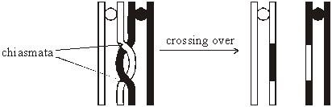
The points at which the chromosomes actually cross over are called chiasmata (singular chiasma), and they involve large, multi-enzyme complexes that cut and join the DNA. There is always at least one chiasma in a bivalent, but there are usually many, and it is the chiasmata that actually hold the bivalent together. The chiasmata can be seen under the microscope and they can give the bivalents some strange shapes at prophase I. There are always equal amounts crossed over, so the chromosomes stay the same length. Ultimately, crossing over means that maternal and paternal alleles can be mixed, even though they are on the same chromosome i.e. chiasmata result in different allele combinations.

3. Random Fertilisation
This takes place when two gametes fuse to form a zygote. Each gamete has a unique combination of genes, and any of the numerous male gametes can fertilise any of the numerous female gametes. So every zygote is unique.
These three kinds of genetic recombination explain Mendel’s laws of genetics (described above).

Gene Mutation also contributes to Variation
Mutations are changes in genes, which are passed on to daughter cells. As mentioned in module 2, DNA is a very stable molecule, and it doesn't suddenly change without reason, but bases can change when DNA is being replicated. Normally replication is extremely accurate but very occasionally mistakes do occur (such as a T-C base pair). Changes in DNA can lead to changes in cell function like this:
There are basically three kinds of gene mutation, shown in this diagram:
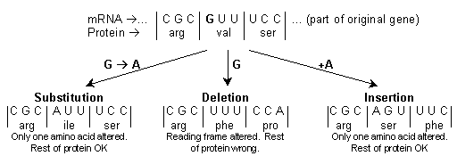
The actual effect of a single mutation depends on many factors:
- A substitution on the third base of a codon may have no effect because the third base is less important (e.g. all codons beginning with CC code for proline).
- If a single amino acid is changed to a similar one (e.g. both small and uncharged), then the protein structure and function may be unchanged, but if an amino acid is changed to a very different one (e.g. an acidic R group to a basic R group), then the structure and function of the protein will be very different.
- If the changed amino acid is at the active site of the enzyme then it is more likely to affect enzyme function than if it is part of the supporting structure.
- Additions and Deletions are Frame shift mutations and are far more serious than substitutions because more of the protein is altered.
- If a frame-shift mutation is near the end of a gene it will have less effect than if it is near the start of the gene.
- If the mutation is in a gene that is not expressed in this cell (e.g. the insulin gene in a red blood cell) then it won't matter.
- If the mutation is in a non-coding section of DNA then it probably won't matter.
- Some proteins are simply more important than others. For instance non-functioning receptor proteins in the tongue may lead to a lack of taste but is not life threatening, whereas non-functioning haemoglobin is fatal.
- Some cells are more important than others. Mutations in somatic cells (i.e. non-reproductive body cells) will only affect cells that derive from that cell, so will probably have a small local effect like a birthmark (although they can cause widespread effects like diabetes or cancer). Mutations in germ cells (i.e. reproductive cells) will affect every single cell of the resulting organism as well as its offspring. These mutations are one source of genetic variation.
As a result of a mutation there are three possible phenotypic effects:
- Most mutations have no phenotypic effect. These are called silent mutations, and we all have a few of these.
- Of the mutations that have a phenotypic effect, most will have a negative effect. Most of the proteins in cells are enzymes, and most changes in enzymes will stop them working (because there are far more ways of making an inactive enzyme than there are of making a working one). When an enzyme stops working, a metabolic block can occur, when a reaction in cell doesn't happen, so the cell's function is changed. An example of this is the genetic disease phenylketonuria (PKU), caused by a mutation in the gene for the enzyme phenylalanine hydroxylase. This causes a metabolic block in the pathway involving the amino acid phenylalanine, which builds up, causing mental retardation.
- Very rarely a mutation can have a beneficial phenotypic effect, such as making an enzyme work faster, or a structural protein stronger, or a receptor protein more sensitive. Although rare beneficial mutations are important as they drive evolution.
The kinds of mutations discussed so far are called point or gene mutations because they affect specific points within a gene. There are other kinds of mutation that can affect many genes at once or even whole chromosomes. These chromosome mutations can arise due to mistakes in cell division. A well-known example is Down syndrome (trisonomy 21) where there are three copies of chromosome 21 instead of the normal two.

Mutation Rates and Mutagens
Mutations are normally very rare, which is why members of a species all look alike and can interbreed. However the rate of mutations is increased by chemicals or by radiation. These are called mutagenic agents or mutagens, and include:
- High energy ionising radiation such as x-rays, ultraviolet rays, α,€β, or γ rays from radioactive sources. These ionise the bases so that they don't form the correct base pairs.
- Intercalating chemicals such as mustard gas (used in World War 1), which bind to DNA separating the two strands.
- Chemicals that react with the DNA bases such as benzene, nitrous acid, and tar in cigarette smoke.
- Viruses. Some viruses can change the base sequence in DNA causing genetic disease and cancer.
During the Earth's early history there were far more of these mutagens than there are now, so the mutation rate would have been much higher than now, leading to a greater diversity of life. Some of these mutagens are used today in research, to kill microbes or in warfare. They are often carcinogens since a common result of a mutation is cancer.

Variation
Variation means the differences in characteristics (phenotype) within a species. There are many causes of variation as this chart shows:
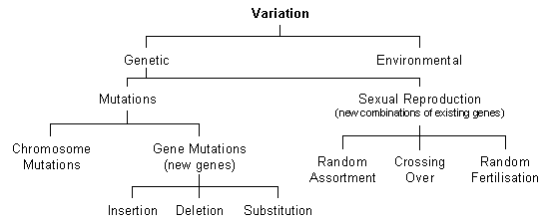
Variation consists of differences between species as well as differences within the same species. Each individual is influenced by the environment, so this is another source of variation.
genotype + environment = phenotype
The alleles that are expressed in the phenotype can only perform their function efficiently if they have a supply of suitable substances and have appropriate conditions. Any study of variation inevitably involves the collection of large quantities of data.
When collecting the data there is a need for random sampling. This involves choosing a sample ‘at random’ from a population. This means that every member of the population has the same chance of being chosen, and that the choices are independent of one another. In choosing a random sample some things are very important:
- the selection criteria must not correspond to what you are studying i.e. not introduce any systematic bias.
- you must try to maintain independence of the sample points
- you muse be careful in making inference: the population might not be what you wish it were
Variation in a population can be studied by measuring the characteristic (height, eye colour, seed shape, or whatever) in a large number of different individuals and by then plotting a frequency histogram. This graph has the values of the characteristic on the X axis (grouped into bins if necessary) and the number of individuals showing that characteristic on the Y axis. These histograms show that there are two major types of variation: discontinuous and continuous.

Discontinuous Variation [back to top]
Sometimes the characteristic has just a few discrete categories (like blood group). The frequency histogram has separate bars (or sometimes peaks).
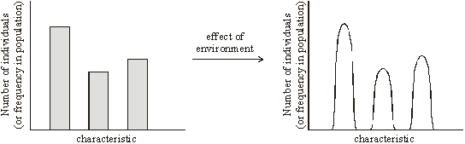
This is discontinuous variation. The characteristics:
- have distinct categories into which individuals can be placed
- tend to be qualitative, with no overlap between categories
- are controlled by one gene, or a small number of genes
- are largely unaffected by the environment
Discontinuous characteristics are rare in humans and other animals, but are more common in plants. Some examples are human blood group, detached ear lobes, flower colour, seed colour, etc. these characteristics are very useful for geneticists because they give clear-cut results.

Continuous Variation
Sometimes the character has a continuous range of values (like height). The frequency histogram is a smooth curve (usually the bell-shaped normal distribution curve).
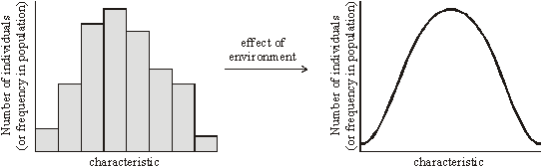
This is continuous variation. The characteristics:
- have no distinct categories into which individuals can be placed
- tend to be quantitative, with overlaps between categories
- are controlled by a large number of genes (polygenic)
- are significantly affected by the environment
Continuous characteristics are very common in humans and other animals. Some examples are height, hair colour, heart rate, muscle efficiency, intelligence, growth rate, rate of photosynthesis, etc.
Characteristics that show continuous variation are controlled not by one, but by the combined effect of a number of genes, called polygenes. Therefore any character, which results from the interaction of many genes, is called a polygenic character. The random assortment of genes during prophase I of meiosis ensures that individuals possess a range of genes from any polygenic complex.
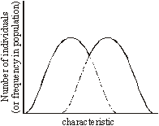
Sometimes you can see the effect of both variations. For example the histogram of height of humans can be bimodal (i.e. it’s got two peaks). This is because the two sexes (a discontinuous characteristic) each have their own normal distribution of height (a continuous characteristic).

Standard Deviation and Standard Error
Standard deviation is a measure of the spread of results at either side of the mean (average).
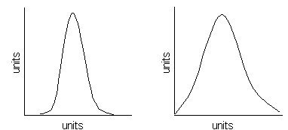
- These sets of data have the same mean (average).
- The data shows a normal distribution about the mean value – there is a bell-shaped and even distribution of values above and below the mean.
- The diagram on the left shows a smaller standard deviation, indicating there is less variation between individuals for the character mentioned.
- The diagram on the right shows a greater standard deviation, indicating there is greater variation.
The standard error is the standard deviation of the mean.
- If individuals in a number of samples are measured, then each sample will have its own mean.
- These means will usually be slightly different from each other – reflecting chance differences in samples – giving a range of values for sample means.
- Standard error is a measure of how much the value of a sample mean is likely to vary.
- The greater the standard error, the greater the variation of the mean.

Variation , Gene Pool and Populations
It is at the population level that evolution occurs. A population is a group of individuals of the same species in a given area whose members can interbreed. Because the individuals of a population can interbreed, they share a common group of genes known as the gene pool. Each gene pool contains all the alleles for all the traits of all the population. For evolution to occur in real populations, some of the gene frequencies must change with time. The gene frequency of an allele is the number of times an allele for a particular trait occurs compared to the total number of alleles for that trait.
Gene frequency = the number of a specific type of allele
the total number of alleles in the gene pool

Hardy – Weinberg Equation
G. H. Hardy, an English mathematician, and W.R. Weinberg, a German physician, independently worked out the effects of random mating in successsive generations on the frequencies of alleles in a population. This is important for biologists because it is the basis of hypothetical stability from which real change can be measured
An important way of discovering why real populations change with time is to construct a model of a population that does not change. This is just what Hardy and Weinberg did. Their principle describes a hypothetical situation in which there is no change in the gene pool (frequencies of alleles), hence no evolution.
Consider a population whose gene pool contains the alleles A and a. Hardy and Weinberg assigned the letter p to the frequency of the dominant allele A and the letter q to the frequency of the recessive allele a. Since the sum of all the alleles must equal 100%, then p + q = 1. They then reasoned that all the random possible combinations of the members of a population would equal (p+q)² or p²+ 2pq + q².
The Hardy-Weinberg equation p² + 2pq + q² = 1
The frequencies of A and a will remain unchanged generation after generation if the following conditions are met:
- Large population. The population must be large to minimize random sampling errors.
- Random mating. There is no mating preference. For example an AA male does not prefer an aa female.
- No mutation. The alleles must not change.
- No migration. Exchange of genes between the population and another population must not occur.
- No natural selection. Natural selection must not favour any particular individual.
Let’s look at an analogy to help demonstrate Hardy-Weinberg Equilibrium. Imagine a ‘swimming’ pool of genes as shown in Figure 1.  Find: Frequencies of A and a. and the genotypic frequencies of AA, Aa and aa.  Solution:  f(A) = 12/30 = 0.4 = 40%  f(a) = 18/30 = 0.6 = 60%  then, p + q = 0.4 + 0.6 = 1  and p² + 2pq + q² = AA + Aa + aa  = .24 + .48 + .30 = 1 | 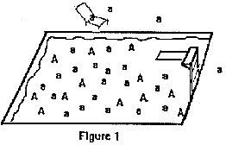
As long as the conditions of Hardy-Weinberg are met, the population can increase in size and the gene frequencies of A and a will remain the same. Thus, the gene pool does not change.
Now, suppose more 'swimmers' dive in as shown in Figure 2. What will the gene and genotypic frequencies be?  Solution:  f(A) = 12/34 = .35 = 35 %  f(a) = 22/34 = .65 = 65%  f(AA) = .12, f(Aa) = .23 and f (aa) = .42 | 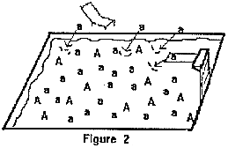
The results show that Hardy-Weinberg Equilibrium was not maintained. The migration of swimmers (genes) into the pool (population) resulted in a change in the population's gene frequencies. If the migrations were to stop and the other agents of evolution (i.e., mutation, natural selection and non-random mating) did not occur, then the population would maintain the new gene frequencies generation after generation. It is important to note that a fifth factor affecting gene frequencies is population size. The larger a population is the number of changes that occur by chance alone becomes insignificant. In the analogy above, a small population was deliberately used to simplify the explanation.

