NUCLEIC ACIDS

DNA:
DNA and its close relative RNA are perhaps the most important molecules in biology. They contains the instructions that make every single living organism on the planet. DNA stands fordeoxyribonucleic acid and RNA for ribonucleic acid. They are polymers (long chain molecules) made from nucleotides.
Nucleotides
Nucleotides have three parts to them:  - a phosphate group, which is negatively charged.  - a pentose sugar, which has 5 carbon atoms in it. In RNA the sugar is ribose. In DNA the sugar isdeoxyribose.  - a nitrogenous base. There are five different bases (you don't need to know their structures). The bases are usually known by there first letters only, you don't need to learn the full names. The basethymine is found in DNA only and the base uracil is found in RNA only. | 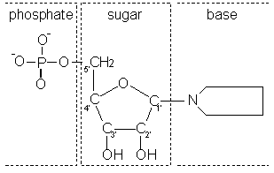
The Bases:
Adenine (A), Thymine (T), Cytosine (C), Guanine (G) and Uracil (U)

Nucleotide Polymerisation:
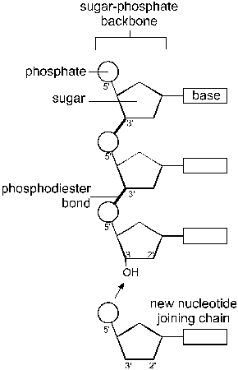 | Nucleotides polymerise by forming bonds between the carbon of the sugar and an oxygen atom of the phosphate. The bases do not take part in the polymerisation, so the chain is held together by a sugar-phosphate backbone with the bases extending off it. This means that the nucleotides can join together in any order along the chain. Many nucleotides form a polynucleotide.  A polynucleotide has a free phosphate group at one end and a free OH group at the other end.
Structure of DNA:
The main features of the three-dimensional structure of DNA are:
- DNA is double-stranded, so there are two polynucleotide stands alongside each other.
- The two strands are wound round each other to form a double helix.
- The two strands are joined together by hydrogen bonds between the bases. The bases therefore form base pairs, which are like rungs of a ladder.
- The base pairs are specific. A only binds to T (and T with A), and C only binds to G (and G with C). These are called complementary base pairs. This means that whatever the sequence of bases along one strand, the sequence of bases on the other strand must be complementary to it. (Incidentally, complementary, which means matching, is different from complimentary, which means being nice.)
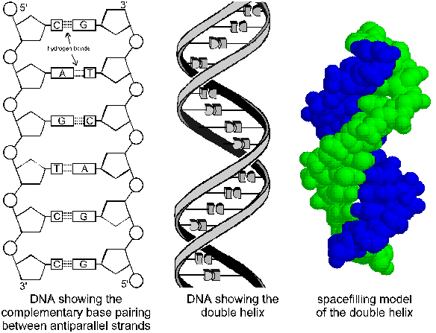

Function of DNA
DNA is the genetic material, and genes are made of DNA. DNA therefore has two essential functions: replication and expression.
- Replication means that the DNA, with all its genes, must be copied every time a cell divides.
- Expression means that the genes on DNA must control characteristics. A gene is a section of DNA that codes for a particular protein. Characteristics are controlled by genes through the proteins they code for, like this:
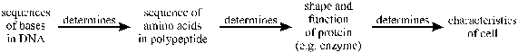
Expression can be split into two parts: transcription (making RNA) and translation (making proteins). These two functions are shown in this diagram.
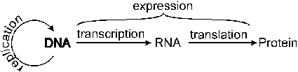
No one knows exactly how many genes we humans have to control all our characteristics, the latest estimates are 60-80,000. The sum total of all the genes in an organism is called the genome.

Genes only seem to comprise about 2% of the DNA in a cell. The majority of the DNA does not form genes and doesn’t seem to do anything. The purpose of this junk DNA remains a mystery!

RNA
RNA is a nucleic acid like DNA, but with 4 differences:
- RNA has the sugar ribose instead of deoxyribose
- RNA has the base uracil instead of thymine
- RNA is usually single stranded
- RNA is usually shorter than DNA
Messenger RNA (mRNA)
mRNA carries the "message" that codes for a particular protein from the nucleus (where DNA is) to the cytoplasm (where proteins are synthesised). It is single stranded and just long enough to contain one gene only.
Ribosomal RNA (rRNA)
A structural molecule part of ribosomes - details are not required

Transfer RNA (tRNA)
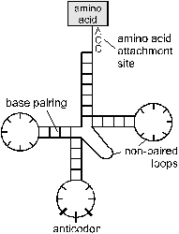 | - tRNA matches amino acids to their codon.  - tRNA is only about 80 nucleotides long, and it folds up by complementary base pairing to form a clover-leaf structure. At one end of the molecule there is an amino acid binding site. On the middle loop there is a triplet nucleotide sequence called the anticodon.  - There are 64 different tRNA molecules, each with a different anticodon sequence complementary to the 64 different codons on mRNA.

The Genetic Code
The sequence of bases on DNA codes for the sequence of amino acids in proteins. But there are 20 different amino acids and only 4 different bases, so the bases are read in groups of 3. This gives 64 combinations, more than enough to code for 20 amino acids. A group of three bases coding for an amino acid is called a codon, and the meaning of each of the 64 codons is called the genetic code.
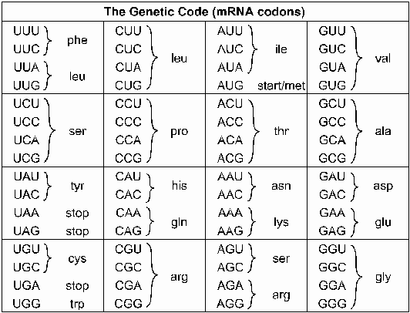
There are several interesting points from this code (which by the wat you do not need to know):
- The code is degenerate, i.e. there is often more than one codon for an amino acid. The degeneracy is on the third base of the codon, which is therefore less important than the others.
- One codon means "start" i.e. the start of the gene sequence. It is AUG.
- Three codons mean "stop" i.e. the end of the gene sequence. They do not code for amino acids.
- The code is only read in one direction along the mRNA molecule.

Replication - DNA Synthesis
DNA is copied, or replicated, before every cell division, so that one identical copy can go to each daughter cell. The double helix unzips and two new strands are built up by complementary base-pairing onto the two old strands.
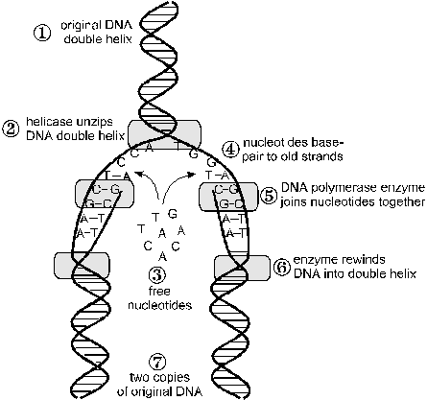 | 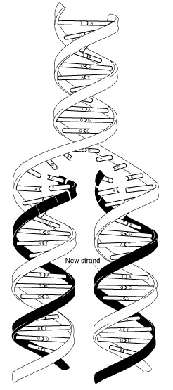
- Replication starts at a specific sequence on the DNA molecule.
- An enzyme unwinds and unzips DNA, breaking the hydrogen bonds that join the base pairs, and forming two separate strands.
- The new DNA is built up from the four nucleotides (A, C, G and T) that are abundant in the nucleoplasm.
- These nucleotides attach themselves to the bases on the old strands by complementary base pairing. Where there is a T base, only an A nucleotide will bind, and so on.
- The enzyme DNA polymerase joins the new nucleotides to each other by strong covalent bonds, forming the sugar-phosphate backbone.
- A winding enzyme winds the new strands up to form double helices.
- The two new molecules are identical to the old molecule.
The Meselson-Stahl Experiment
This replication mechanism is sometimes called semi-conservative replication, because each new DNA molecule contains one new strand and one old strand. There was an alternative theory which suggested that a "photocopy" of the original DNA was made, leaving the original DNA conserved (conservative replication). The proof that the semi-conservative method was the correct method came from an experiment performed by Meselson and Stahl using the bacterium E. coli together with the technique of density gradient centrifugation, which separates molecules on the basis of their density.
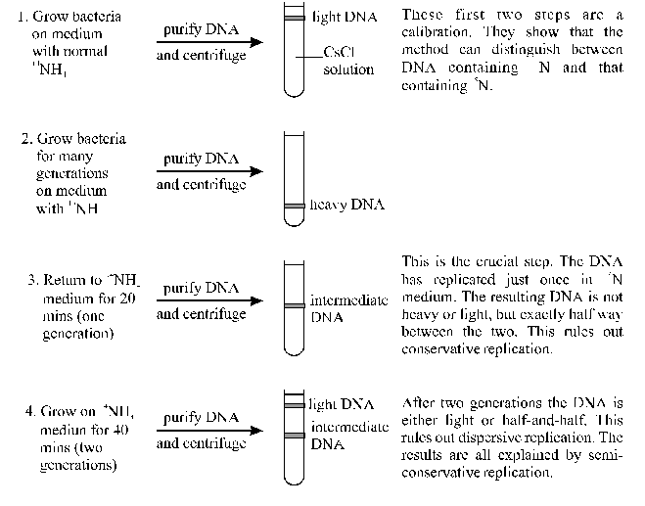

Transcription - RNA Synthesis
DNA never leaves the nucleus, but proteins are synthesised in the cytoplasm, so a copy of each gene is made to carry the "code" from the nucleus to the cytoplasm. This copy is mRNA, and the process of copying is called transcription.
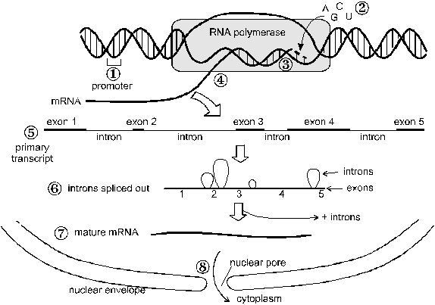
- The start of each gene on DNA is marked by a special sequence of bases.
- The RNA molecule is built up from the four ribose nucleotides (A, C, G and U) in the nucleoplasm. The nucleotides attach themselves to the bases on the DNA by complementary base pairing, just as in DNA replication. However, only one strand of RNA is made.
- The new nucleotides are joined to each other by covalent bonds by the enzyme RNA polymerase
- The initial mRNA contains some regions that are not part of the protein code. These are called introns
- The introns are cut out by enzymes
- The result is a shorter mature RNA.
- The mRNA diffuses out of the nucleus through a nuclear pore into the cytoplasm.

Translation - Protein Synthesis

- A ribosome attaches to the mRNA at an initiation codon (AUG). The ribosome encloses two codons.
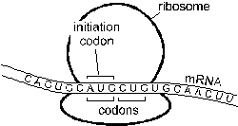

- met-tRNA diffuses to the ribosome and attaches to the mRNA initiation codon by complementary base pairing.
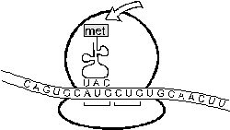

- The next amino acid-tRNA attaches to the adjacent mRNA codon (leu in this case).
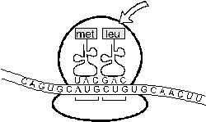

- The bond between the amino acid and the tRNA is cut and a peptide bond is formed between the two amino acids.
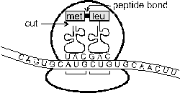

5. The ribosome moves along one codon so that a new amino acid-tRNA can attach. The free tRNA molecule leaves to collect another amino acid. The cycle repeats from step 3.
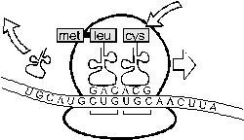
6. The polypeptide chain elongates one amino acid at a time, and peels away from the ribosome, folding up into a protein as it goes. This continues for hundreds of amino acids until a stop codon is reached.
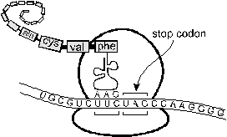

A single piece of mRNA can be translated by many ribosomes simultaneously. A group of ribosomes all attached to one piece of mRNA is called a polysome.
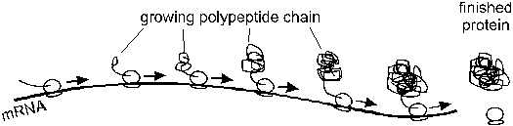

Post-Translational Modification
In eukaryotes, proteins often need to be altered before they become fully functional. Modifications are carried out by other enzymes and include: chain cutting, adding sugars (to make glycoproteins) or lipids (to make lipoproteins). These changes occur in the Golgi Apparatus

Mutations
Mutations are changes in genes, which are passed on to daughter cells. DNA is a very stable molecule, and it doesn't suddenly change without reason, but bases can change when DNA is being replicated. Normally replication is extremely accurate but very occasionally mistakes do occur (such as a T-C base pair). Changes in DNA can lead to changes in cell function like this:
There are basically three kinds of gene mutation, shown in this diagram:
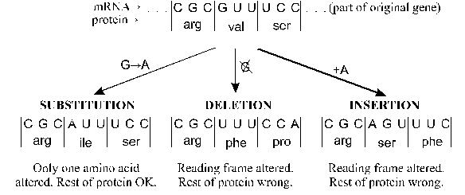
The actual effect of a single mutation depends on many factors:
- A substitution on the third base of a codon may have no effect because the third base is less important (e.g. all codons beginning with CC code for proline).
- If a single amino acid is changed to a similar one, then the protein structure and function may be unchanged, but if an amino acid is changed to a very different one, then the structure and function of the protein will be very different.
- If the changed amino acid is at the active site of the enzyme then it is more likely to affect enzyme function than if it is part of the supporting structure.
- Additions and Deletions are Frame shift mutations and are far more serious than substitutions because more of the protein is altered.
- If a frame-shift mutation is near the end of a gene it will have less effect than if it is near the start of the gene
- If the mutation is in a gene that is not expressed in this cell (e.g. the insulin gene in a red blood cell) then it won't matter.
- Some proteins are simply more important than others. For instance non-functioning receptor proteins in the tongue may lead to a lack of taste but is not life-threatening, whereas non-functioning haemoglobin is fatal.
- Some cells are more important than others. Mutations in somatic cells (i.e. non-reproductive body cells) will only affect cells that derive from that cell, so will probably have a small local effect like a birthmark (although they can cause widespread effects like diabetes or cancer). Mutations in germ cells (i.e. reproductive cells) will affect every single cell of the resulting organism as well as its offspring. These mutations are one source of genetic variation.
As a result of a mutation there are three possible phenotypic effects:
- Most mutations have no observable (phenotypic) effect.
- Of the mutations that have a phenotypic effect, most will have a negative effect. Most of the proteins in cells are enzymes, and most changes in enzymes will stop them working. When an enzyme stops working, a metabolic block can occur, when a reaction in cell doesn't happen, so the cell's function is changed. An example of this is the genetic disease phenylketonuria (PKU), caused by a mutation in the gene for an enzyme. This causes a metabolic block in the pathway involving the amino acid phenylalanine, which builds up, causing mental retardation.
- Very rarely a mutation can have a beneficial phenotypic effect, such as making an enzyme work faster, or a structural protein stronger, or a receptor protein more sensitive. Although rare beneficial mutations are important as they drive evolution.

These kinds of mutation are called point or gene mutations because they affect specific points within a gene. There are other kinds of mutation that can affect many genes at once or even whole chromosomes. These chromosome mutations can arise due to mistakes in cell division. A well-known example is Down syndrome (trisonomy 21) where there are three copies of chromosome 21 instead of the normal two.
Mutation Rates and Mutagens
Mutations are normally very rare, which is why members of a species all look alike and can interbreed. However the rate of mutations is increased by chemicals or by radiation. These are called mutagenic agents or mutagens, and include:
- High energy ionising radiation such as x-rays, ultraviolet rays, rays from radioactive sources all ionise the bases so that they don't form the correct base pairs.
- Intercalating chemicals such as mustard gas (used in World War 1), which bind to DNA separating the two strands.
- Chemicals that react with the DNA bases such as benzene and tar in cigarette smoke.

DNA and Chromosomes
The DNA molecule in a single human cell is about 1m long so in order to fit into the cell the DNA is cut into shorter lengths and each length is tightly wrapped up with histone proteins to form a complex called chromatin. During most of the life of a cell the chromatin is dispersed throughout the nucleus and cannot be seen with a light microscope.
Just before cell division the DNA is replicated so there is temporarily twice the normal amount DNA. Following replication the chromatin then coils up even tighter to form short fat bundles calledchromosomes. These are about 100 000 times shorter than fully stretched DNA and are thick enough to be seen under the microscope. Each chromosome is roughly X-shaped because it contains two replicated copies of the DNA. The two arms of the X are therefore identical. They are called chromatids, and are joined at the centromere. (Do not confuse the two chromatids with the two strands of DNA.) The complex folding of DNA into chromosomes is shown below.
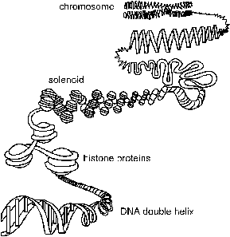 | 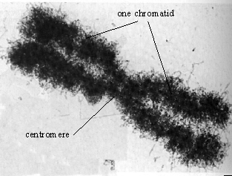  micrograph of a single chromosome
- Chromatin DNA + histones at any stage of the cell cycle
- Chromosome compact X-shaped form of chromatin formed (and visible) during mitosis
- Chromatid single arm of an X-shaped chromosome
Since the DNA molecule extends from one end of a chromosome to the other, and the genes are distributed along the DNA, then each gene has a defined position on a chromosome. This position is called the locus of the gene.

Karyotypes and Homologous Chromosomes
If a dividing cell is stained with a special fluorescent dye and examined under a microscope during cell division, the individual chromosomes can be distinguished. They can then be photographed and studied. This is a difficult and skilled procedure, and it often helps if the chromosomes are cut out and arranged in order of size.
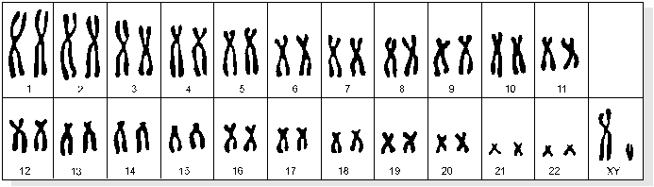
This display is called a karyotype, and it shows several features:
- Different species have different number of chromosomes, but all members of the same species have the same number. Humans have 46.
- Each chromosome has a characteristic size, shape and banding pattern, which allows it to be identified and numbered. The chromosomes are numbered from largest to smallest.
- Chromosomes come in pairs, with the same size, shape and banding pattern, called homologous pairs ("same shaped"). So there are two chromosome number 1s, two chromosome number 2s, etc, and humans really have 23 pairs of chromosomes. Homologous chromosomes are a result of sexual reproduction, and the homologous pairs are the maternal and paternalversions of the same chromosome, so they have the same sequence of genes
- 1 pair of chromosomes is different in males and females. These are the sex chromosomes, and are non-homologous in one of the sexes. In humans sex chromosomes are homologous in females (XX) and non-homologous in males (XY). (In birds it is the other way round!) The non-sex chromosomes are sometimes called autosomes, so humans have 22 pairs of autosomes, and 1 pair of sex chromosomes.

