1. Biochemical Tests
These five tests identify the main biologically important chemical compounds. For each test take a small amount of the substance to test, and shake it in water in a test tube. If the sample is a piece of food, then grind it with some water in a pestle and mortar to break up the cells and release the cell contents. Many of these compounds are insoluble, but the tests work just as well on a fine suspension.
- Starch (iodine test). To approximately 2 cm³ of test solution add two drops of iodine/potassium iodide solution. A blue-black colour indicates the presence of starch as a starch-polyiodide complex is formed. Starch is only slightly soluble in water, but the test works well in a suspension or as a solid.

- Reducing Sugars (Benedict's test). All monosaccharides and most disaccharides (except sucrose) will reduce copper (II) sulphate, producing a precipitate of copper (I) oxide on heating, so they are called reducing sugars. Benedict’s reagent is an aqueous solution of copper (II) sulphate, sodium carbonate and sodium citrate. To approximately 2 cm³ of test solution add an equal quantity of Benedict’s reagent. Shake, and heat for a few minutes at 95°C in a water bath. A precipitate indicates reducing sugar. The colour and density of the precipitate gives an indication of the amount of reducing sugar present, so this test is semi-quantitative. The original pale blue colour means no reducing sugar, a green precipitate means relatively little sugar; a brown or red precipitate means progressively more sugar is present

- Non-reducing Sugars (Benedict's test). Sucrose is called a non-reducing sugarbecause it does not reduce copper sulphate, so there is no direct test for sucrose. However, if it is first hydrolysed (broken down) to its constituent monosaccharides (glucose and fructose), it will then give a positive Benedict's test. So sucrose is the only sugar that will give a negative Benedict's test before hydrolysis and a positive test afterwards. First test a sample for reducing sugars, to see if there are any present bef7ore hydrolysis. Then, using a separate sample, boil the test solution with dilute hydrochloric acid for a few minutes to hydrolyse the glycosidic bond. Neutralise the solution by gently adding small amounts of solid sodium hydrogen carbonate until it stops fizzing, then test as before for reducing sugars.

- Lipids (emulsion test). Lipids do not dissolve in water, but do dissolve in ethanol. This characteristic is used in the emulsion test. Do not start by dissolving the sample in water, but instead shake some of the test sample with about 4 cm³ of ethanol. Decant the liquid into a test tube of water, leaving any undissolved substances behind. If there are lipids dissolved in the ethanol, they will precipitate in the water, forming a cloudy white emulsion.

- Protein (biuret test). To about 2 cm³ of test solution add an equal volume of biuret solution, down the side of the test tube. A blue ring forms at the surface of the solution, which disappears on shaking, and the solution turns lilac-purple, indicating protein. The colour is due to a complex between nitrogen atoms in the peptide chain and Cu²⁺ ions, so this is really a test for peptide bonds.
2. Chromatography
Chromatography is used to separate pure substances from a mixture of substances, such as a cell extract. It is based on different substances having different solubilities in different solvents. A simple and common form of chromatography uses filter paper.
- Pour some solvent into a chromatography tank and seal it, so the atmosphere is saturated with solvent vapour. Different solvents are suitable for different tasks, but they are usually mixtures of water with organic liquids such as ethanol or propanone.
- Place a drop of the mixture to be separated onto a sheet of chromatography paper near one end. This is the origin of the chromatogram. The spot should be small but concentrated. Repeat for any other mixtures. Label the spots with pencil, as ink may dissolve.
- Place the chromatography sheet into the tank so that the origin is just above the level of solvent, and leave for several hours. The solvent will rise up the paper by capillary action carrying the contents of the mixture with it. Any solutes dissolved in the solvent will be partitioned between the organic solvent (the moving phase) and the water, which is held by the paper (the stationary phase). The more soluble a solute is in the solvent the further up the paper it will move.
- When the solvent has nearly reached the top of the paper, the paper is removed and the position of the solvent front marked. The chromatogram may need to be developed to make the spots visible. For example amino acids stain purple with ninhydrin.
- The chromatogram can be analysed by measuring the distance travelled by the solvent front, and the distance from the origin to the centre of each spot. This is used to calculate the R_{f} (relative front) value for each spot:
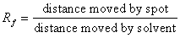
An R_{f} value is characteristic of a particular solute in a particular solvent. It can be used to identify components of a mixture by comparing to tables of known R_{f} values.
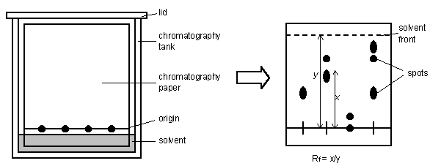

Sometimes chromatography with a single solvent is not enough to separate all the constituents of a mixture. In this case the separation can be improved by two-dimensional chromatography, where the chromatography paper is turned through 90° and run a second time in a second solvent. Solutes that didn't separate in one solvent will separate in another because they have different solubilities.
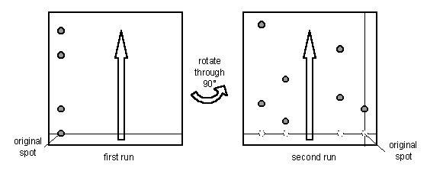
There are many different types of chromatography.

- Paper chromatography is the simplest, but does not always give very clean separation.

- Thin layer chromatography (tlc) uses a thin layer of cellulose or silica coated onto a plastic or glass sheet. This is more expensive, but gives much better and more reliable separation.

- Column chromatography uses a glass column filled with a cellulose slurry. Large samples can be pumped through the column and the separated fractions can be collected for further experiments, so this is preparative chromatography as opposed to analytical chromatography.
- High performance liquid chromatography (HPLC) is an improved form of column chromatography that delivers excellent separation very quickly.

- Electrophoresis uses an electric current to separate molecules on the basis of charge. It can also be used to separate on the basis of molecular size, and as such is used in DNA sequencing.

3. Cell Fractionation
This means separating different parts and organelles of a cell, so that they can be studied in detail. All the processes of cell metabolism (such as respiration or photosynthesis) have been studied in this way. The most common method of fractionating cells is to use differential centrifugation:
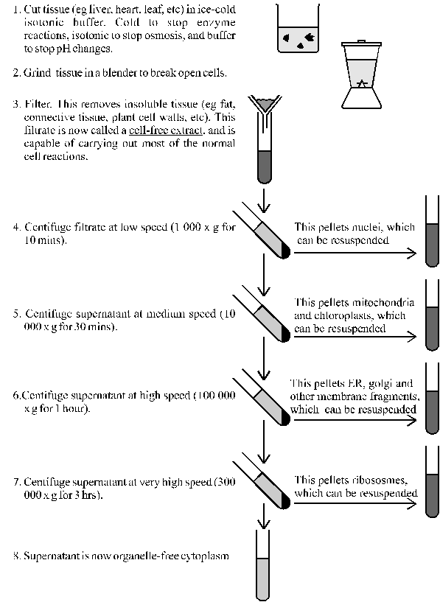

A more sophisticated separation can be performed by density gradient centrifugation. In this, the cell-free extract is centrifuged in a dense solution (such as sucrose or caesium chloride). The fractions don't pellet, but instead separate out into layers with the densest fractions near the bottom of the tube. The desired layer can then be pipetted off. This is the technique used in the Meselson-Stahl experiment (module 2) and it is also used to separate the two types of ribosomes. The terms 70S and 80S refer to their positions in a density gradient.

4. Enzyme Kinetics
This means measuring the rate of enzyme reactions.

- Firstly you need a signal to measure that shows the progress of the reaction. The signal should change with either substrate or product concentration, and it should preferably be something that can be measured continuously. Typical signals include colour changes, pH changes, mass changes, gas production, volume changes or turbidity changes. If the reaction has none of these properties, it can sometimes be linked to a second reaction which does generate one of these changes.
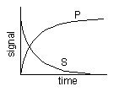
- If you mix your substrate with enzyme and measure your signal, you will obtain a time-course. If the signal is proportional to substrate concentration it will start high and decrease, while if the signal is proportional to product it will start low and increase. In both cases the time-course will be curved (actually an exponential curve).
- How do you obtain a rate from this time-course? One thing that is not a good idea is to measure the time taken for the reaction, for as the time-course shows it is very difficult to say when the reaction ends: it just gradually approaches the end-point. A better method is to measure theinitial rate - that is the initial slope of the time-course. This also means you don't need to record the whole time-course, but simply take one measurement a short time after mixing.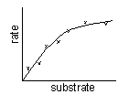
- Repeat this initial rate measurement under different conditions (such as different substrate concentrations) and then plot a graph of rate vs. the factor. Each point on this second graph is taken from a separate initial rate measurement (or better still is an average of several initial rate measurements under the same conditions). Draw a smooth curve through the points.
Be careful not to confuse the two kinds of graph (the time-course and rate graphs) when interpreting your data.
One useful trick is to dissolve the substrate in agar in an agar plate. If a source of enzyme is placed in the agar plate, the enzyme will diffuse out through the agar, turning the substrate into product as it goes. There must be a way to distinguish the substrate from the product, and the reaction will then show up as a ring around the enzyme source. The higher the concentration of enzyme, the higher the diffusion gradient, so the faster the enzyme diffuses through the agar, so the larger the ring in a given time. The diameter of the ring is therefore proportional to the enzyme concentration. This can be done for many enzymes, e.g. a protein agar plate can be used for a protease enzyme, or a starch agar plate can be used for the enzyme amylase.
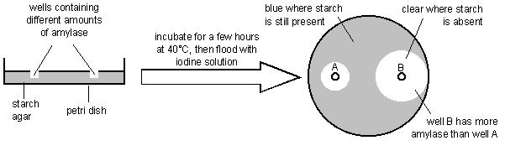

5. Microscopy
Of all the techniques used in biology microscopy is probably the most important. The vast majority of living organisms are too small to be seen in any detail with the human eye, and cells and their organelles can only be seen with the aid of a microscope. Cells were first seen in 1665 by Robert Hooke (who named them after monks' cells in a monastery), and were studied in more detail by Leeuwehoek using a primitive microscope.

Units of measurement. The standard SI units of measurement used in microscopy are:

metre | m | = 1 m
millimetre | mm | = 10⁻³ m
micrometre | μm | = 10⁻⁶ m
nanometre | nm | = 10⁻⁹ m
picometre | pm | = 10⁻¹² m
angstrom | Å | = 10⁻¹⁰ m (obsolete)

Magnification and Resolving Power. By using more lenses microscopes can magnify by a larger amount, but this doesn't always mean that more detail can be seen. The amount of detail depends on the resolving power of a microscope, which is the smallest separation at which two separate objects can be distinguished (or resolved). It is calculated by the formula:
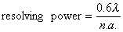
where λ is the wavelength of light, and n.a. is the numerical aperture of the lens (which ranges from about 0.5 to 1.4). So the resolving power of a microscope is ultimately limited by the wavelength of light (400-600nm for visible light). To improve the resolving power a shorter wavelength of light is needed, and sometimes microscopes have blue filters for this purpose (because blue has the shortest wavelength of visible light).

Different kinds of Microscope.
Light Microscope. This is the oldest, simplest and most widely-used form of microscopy. Specimens are illuminated with light, which is focussed using glass lenses and viewed using the eye or photographic film. Specimens can be living or dead, but often need to be stained with a coloured dye to make them visible. Many different stains are available that stain specific parts of the cell such as DNA, lipids, cytoskeleton, etc. All light microscopes today are compound microscopes, which means they use several lenses to obtain high magnification. Light microscopy has a resolution of about 200 nm, which is good enough to see cells, but not the details of cell organelles. There has been a recent resurgence in the use of light microscopy, partly due to technical improvements, which have dramatically improved the resolution far beyond the theoretical limit. For example fluorescence microscopy has a resolution of about 10 nm, while interference microscopy has a resolution of about 1 nm.

Electron Microscope. This uses a beam of electrons, rather than electromagnetic radiation, to "illuminate" the specimen. This may seem strange, but electrons behave like waves and can easily be produced (using a hot wire), focussed (using electromagnets) and detected (using a phosphor screen or photographic film). A beam of electrons has an effective wavelength of less than 1 nm, so can be used to resolve small sub-cellular ultrastructure. The development of the electron microscope in the 1930s revolutionised biology, allowing organelles such as mitochondria, ER and membranes to be seen in detail for the first time.
The main problem with the electron microscope is that specimens must be fixed in plastic and viewed in a vacuum, and must therefore be dead. Other problems are that the specimens can be damaged by the electron beam and they must be stained with an electron-dense chemical (usually heavy metals like osmium, lead or gold). Initially there was a problem of artefacts (i.e. observed structures that were due to the preparation process and were not real), but improvements in technique have eliminated most of these.
There are two kinds of electron microscope. The transmission electron microscope (TEM) works much like a light microscope, transmitting a beam of electrons through a thin specimen and then focussing the electrons to form an image on a screen or on film. This is the most common form of electron microscope and has the best resolution. The scanning electron microscope (SEM) scans a fine beam of electron onto a specimen and collects the electrons scattered by the surface. This has poorer resolution, but gives excellent 3-dimentional images of surfaces.
- X-ray Microscope. This is an obvious improvement to the light microscope, since x-rays have wavelengths a thousand time shorter than visible light, and so could even be used to resolve atoms. Unfortunately there are no good x-ray lenses, so an image cannot be focussed, and useable x-ray microscopes do not yet exist. However, x-rays can be used without focussing to give a diffraction pattern, which can be used to work out the structures of molecules, such as those of proteins and DNA.

- Scanning Tunnelling Microscope (or Atomic Force Microscope). This uses a very fine needle to scan the surface of a specimen. It has a resolution of about 10 pm, and has been used to observe individual atoms for the first time.

Comparison of Light and Electron Microscopes
 | LIGHT MICROSCOPE | ELECTRON MICROSCOPE
illumination and source | light from lamp | electrons from hot wire
focusing | glass lenses | electromagnets
detection | eye or film | phosphor screen or film
magnification | 1 500 x | 500 000 x
resolution | 200 nm | 1 nm
specimen | living or dead | dead
staining | coloured dyes | heavy metals
cost | cheap to expensive | very expensive

