Enzymes
Enzymes are biological catalysts. There are about 40,000 different enzymes in human cells, each controlling a different chemical reaction. They increase the rate of reactions by a factor of between 10⁶ to 10¹² times, allowing the chemical reactions that make life possible to take place at normal temperatures. They were discovered in fermenting yeast in 1900 by Buchner, and the name enzyme means "in yeast". As well as catalysing all the metabolic reactions of cells (such as respiration, photosynthesis and digestion), they also act as motors, membrane pumps and receptors.
Enzyme Structure
Enzymes are proteins, and their function is determined by their complex structure. The reaction takes place in a small part of the enzyme called the active site, while the rest of the protein acts as "scaffolding". This is shown in this diagram of a molecule of the enzyme amylase, with a short length of starch being digested in its active site. The amino acids around the active site attach to the substrate molecule and hold it in position while the reaction takes place. This makes the enzyme specific for one reaction only, as other molecules won't fit into the active site.
Many enzymes need cofactors (or coenzymes) to work properly. These can be metal ions (such as Fe²⁺, Mg²⁺, Cu²⁺) or organic molecules (such as haem, biotin, FAD, NAD or coenzyme A). Many of these are derived from dietary vitamins, which is why they are so important. The complete active enzyme with its cofactor is called a holoenzyme, while just the protein part without its cofactor is called the apoenzyme.
How do enzymes work?
There are three ways of thinking about enzyme catalysis. They all describe the same process, though in different ways, and you should know about each of them.

1. Reaction Mechanism
In any chemical reaction, a substrate (S) is converted into a product (P):
S P
(There may be more than one substrate and more than one product, but that doesn't matter here.) In an enzyme-catalysed reaction, the substrate first binds to the active site of the enzyme to form an enzyme-substrate (ES) complex, then the substrate is converted into product while attached to the enzyme, and finally the product is released. This mechanism can be shown as:
E + S ES EP E + P
The enzyme is then free to start again. The end result is the same (S P), but a different route is taken, so that the S P reaction as such never takes place. In by-passing this step, the reaction can be made to happen much more quickly.
2. Molecule Geometry
The substrate molecule fits into the active site of the enzyme molecule like a key fitting into a lock (in fact it is sometimes called a lock and key mechanism). Once there, the enzyme changes shape slightly, distorting the molecule in the active site, and making it more likely to change into the product. For example if a bond in the substrate is to be broken, that bond might be stretched by the enzyme, making it more likely to break. Alternatively the enzyme can make the local conditions inside the active site quite different from those outside (such as pH, water concentration, charge), so that the reaction is more likely to happen.
It's a bit more complicated than that though. Although enzymes can change the speed of a chemical reaction, they cannot change its direction, otherwise they could make "impossible" reactions happen and break the laws of thermodynamics. So an enzyme can just as easily turn a product into a substrate as turn a substrate into a product, depending on which way the reaction would go anyway. In fact the active site doesn't really fit the substrate (or the product) at all, but instead fits a sort of half-way house, called the transition state. When a substrate (or product) molecule binds, the active site changes shape and fits itself around the molecule, distorting it into forming the transition state, and so speeding up the reaction. This is sometimes called the induced fit mechanism.
3. Energy Changes
The way enzymes work can also be shown by considering the energy changes that take place during a chemical reaction. We shall consider a reaction where the product has a lower energy than the substrate, so the substrate naturally turns into product (in other words the equilibrium lies in the direction of the product). Before it can change into product, the substrate must 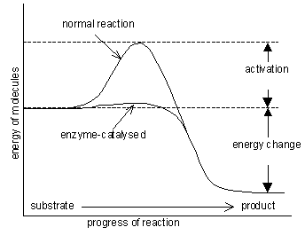overcome an "energy barrier" called the activation energy (E_{A}). The larger the activation energy, the slower the reaction will be because only a few substrate molecules will by chance have sufficient energy to overcome the activation energy barrier. Imagine pushing boulders over a hump before they can roll down hill, and you have the idea. Most physiological reactions have large activation energies, so they simply don't happen on a useful time scale. Enzymes dramatically reduce the activation energy of a reaction, so that most molecules can easily get over the activation energy barrier and quickly turn into product.
For example for the catalase reaction (2H₂O₂ 2H₂O + O₂) the activation energy is 86 kJ mol⁻¹ with no catalyst, 62 kJ mol⁻¹ with an inorganic catalyst of iron filings, and just 1 kJ mol⁻¹ in the presence of the enzyme catalase.
The activation energy is actually the energy required to form the transition state, so enzymes lower the activation energy by stabilising the transition state, and they do this by changing the conditions within the active site of the enzyme. So the three ideas above are really three ways of describing the same process.
Factors that Affect the Rate of Enzyme Reactions
1. Temperature
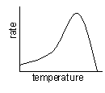
Enzymes have an optimum temperature at which they work fastest. For mammalian enzymes this is about 40°C, but there are enzymes that work best at very different temperatures, e.g. enzymes from the arctic snow flea work at -10°C, and enzymes from thermophilic bacteria work at 90°C.
Up to the optimum temperature the rate increases geometrically with temperature (i.e. it's a curve, not a straight line). The rate increases because the enzyme and substrate molecules both have more kinetic energy so collide more often, and also because more molecules have sufficient energy to overcome the (greatly reduced) activation energy. The increase in rate with 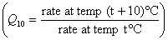temperature can be quantified as a Q₁₀, which is the relative increase for a 10°C rise in temperature. Q₁₀ is usually 2-3 for enzyme-catalysed reactions (i.e. the rate doubles every 10°C) and usually less than 2 for non-enzyme reactions.
The rate is not zero at 0°C, so enzymes still work in the fridge (and food still goes off), but they work slowly. Enzymes can even work in ice, though the rate is extremely slow due to the very slow diffusion of enzyme and substrate molecules through the ice lattice.
Above the optimum temperature the rate decreases as more and more of the enzyme molecules denature. The thermal energy breaks the hydrogen bonds holding the secondary and tertiary structure of the enzyme together, so the enzyme (and especially the active site) loses its shape to become a random coil. The substrate can no longer bind, and the reaction is no longer catalysed. At very high temperatures this is irreversible. Remember that only the weak hydrogen bonds are broken at these mild temperatures; to break strong covalent bonds you need to boil in concentrated acid for many hours.
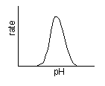2. pH
Enzymes have an optimum pH at which they work fastest. For most enzymes this is about pH 7-8 (physiological pH of most cells), but a few enzymes can work at extreme pH, such as protease enzymes in animal stomachs, which have an optimum of pH 1. The pH affects the charge of the amino acids at the active site, so the properties of the active site change and the substrate can no longer bind. For example a carboxyl acid R groups will be uncharged a low pH (COOH), but charged at high pH (COO⁻).
3. Enzyme concentration
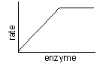
As the enzyme concentration increases the rate of the reaction increases linearly, because there are more enzyme molecules available to catalyse the reaction. At very high enzyme concentration the substrate concentration may become rate-limiting, so the rate stops increasing. Normally enzymes are present in cells in rather low concentrations.
4. Substrate concentration
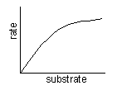
The rate of an enzyme-catalysed reaction shows a curved dependence on substrate concentration. As the substrate concentration increases, the rate increases because more substrate molecules can collide with enzyme molecules, so more reactions will take place. At higher concentrations the enzyme molecules become saturated with substrate, so there are few free enzyme molecules, so adding more substrate doesn't make much difference (though it will increase the rate of E-S collisions).
The maximum rate at infinite substrate concentration is called v_{max}, and the substrate concentration that give a rate of half v_{max} is called K_{M}. These quantities are useful for characterising an enzyme. A good enzyme has a high v_{max} and a low K_{M}.
5. Covalent modification
The activity of some enzymes is controlled by other enzymes, which modify the protein chain by cutting it, or adding a phosphate or methyl group. This modification can turn an inactive enzyme into an active enzyme (or vice versa), and this is used to control many metabolic enzymes and to switch on enzymes in the gut (see later) e.g. hydrochloric acid in stomach® activates pepsin® activates rennin.
6. Inhibitors
Inhibitors inhibit the activity of enzymes, reducing the rate of their reactions. They are found naturally, but are also used artificially as drugs, pesticides and research tools. There are two kinds of inhibitors.
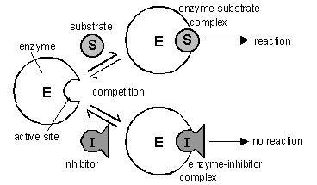
(a) A competitive inhibitor molecule has a similar structure to the normal substrate molecule, and it can fit into the active site of the enzyme. It therefore competes with the substrate for the active site, so the reaction is slower. Competitive inhibitors increase K_{M} for the enzyme, but have no effect on v_{max}, so the rate can approach a normal rate if the substrate concentration is increased high enough. The sulphonamide anti-bacterial drugs are competitive inhibitors.
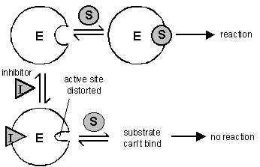
(b) A non-competitive inhibitor molecule is quite different in structure from the substrate molecule and does not fit into the active site. It binds to another part of the enzyme molecule, changing the shape of the whole enzyme, including the active site, so that it can no longer bind substrate molecules. Non-competitive inhibitors therefore simply reduce the amount of active enzyme (just like decreasing the enzyme concentration), so they decrease v_{max}, but have no effect on K_{M}. Inhibitors that bind fairly weakly and can be washed out are sometimes called reversible inhibitors, while those that bind tightly and cannot be washed out are called irreversible inhibitors. Poisons like cyanide, heavy metal ions and some insecticides are all non-competitive inhibitors.
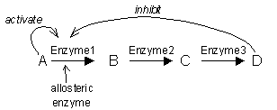7. Allosteric Effectors
The activity of some enzymes is controlled by certain molecules binding to a specific regulatory (or allosteric) site on the enzyme, distinct from the active site. Different molecules can inhibit or activate the enzyme, allowing sophisticated control of the rate. Only a few enzymes can do this, and they are often at the start of a long biochemical pathway. They are generally activated by the substrate of the pathway and inhibited by the product of the pathway, thus only turning the pathway on when it is needed.

