CELLS

All living things are made of cells, and cells are the smallest units that can be alive. Life on Earth is classified into five kingdoms, and they each have their own characteristic kind of cell. However the biggest division is between the cells of the prokaryote kingdom (the bacteria) and those of the other four kingdoms (animals, plants, fungi and protoctista), which are all eukaryotic cells. Prokaryotic cells are smaller and simpler than eukaryotic cells, and do not have a nucleus.
- Prokaryote = without a nucleus
- Eukaryote = with a nucleus

Eukaryotic Cells
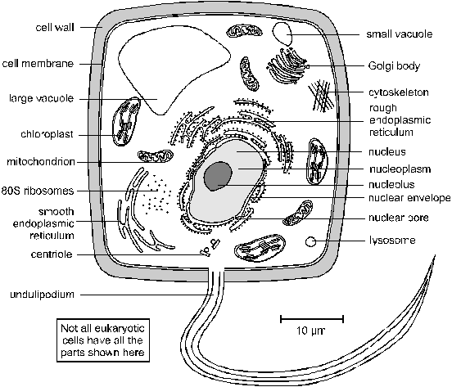
- Cytoplasm (or Cytosol). This is the solution within the cell membrane. It contains enzymes for metabolic reactions together with sugars, salts, amino acids, nucleotides and everything else needed for the cell to function.
- Nucleus. This is the largest organelle. Surrounded by a nuclear envelope, which is a double membrane with nuclear pores - large holes containing proteins that control the exit of substances such as RNA from the nucleus. The interior is called the nucleoplasm, which is full of chromatin- a DNA/protein complex containing the genes. During cell division the chromatin becomes condensed into discrete observable chromosomes. The nucleolus is a dark region of chromatin, involved in making ribosomes.
- Mitochondrion (pl. Mitochondria). This is a sausage-shaped organelle (8µm long), and is where aerobic respiration takes place in all eukaryotic cells. Mitochondria are surrounded by a double membrane: the outer membrane is simple, while the inner membrane is highly folded into cristae, which give it a large surface area. The space enclosed by the inner membrane is called the matrix, and contains small circular strands of DNA. The inner membrane is studded with stalked particles, which are the site of ATP synthesis.
- Chloroplast. Bigger and fatter than mitochondria, chloroplasts are where photosynthesis takes place, so are only found in photosynthetic organisms (plants and algae). Like mitochondria they are enclosed by a double membrane, but chloroplasts also have a third membrane called the thylakoid membrane. The thylakoid membrane is folded into thylakoid disks, which are then stacked into piles called grana. The space between the inner membrane and the thylakoid is called the stroma. The thylakoid membrane contains chlorophyll and stalked particles, and is the site of photosynthesis and ATP synthesis. Chloroplasts also contain starch grains, ribosomes and circular DNA.
- Ribosomes. These are the smallest and most numerous of the cell organelles, and are the sites of protein synthesis. They are composed of protein and RNA, and are manufactured in the nucleolus of the nucleus. Ribosomes are either found free in the cytoplasm, where they make proteins for the cell's own use, or they are found attached to the rough endoplasmic reticulum, where they make proteins for export from the cell. They are often found in groups called polysomes. All eukaryotic ribosomes are of the larger, "80S", type.
- Smooth Endoplasmic Reticulum (SER). Series of membrane channels involved in synthesising and transporting materials, mainly lipids, needed by the cell.
- Rough Endoplasmic Reticulum (RER). Similar to the SER, but studded with numerous ribosomes, which give it its rough appearance. The ribosomes synthesise proteins, which are processed in the RER (e.g. by enzymatically modifying the polypeptide chain, or adding carbohydrates), before being exported from the cell via the Golgi Body.
- Golgi Body (or Golgi Apparatus). Another series of flattened membrane vesicles, formed from the endoplasmic reticulum. Its job is to transport proteins from the RER to the cell membrane for export. Parts of the RER containing proteins fuse with one side of the Golgi body membranes, while at the other side small vesicles bud off and move towards the cell membrane, where they fuse, releasing their contents by exocytosis.
- Vacuoles. These are membrane-bound sacs containing water or dilute solutions of salts and other solutes. Most cells can have small vacuoles that are formed as required, but plant cells usually have one very large permanent vacuole that fills most of the cell, so that the cytoplasm (and everything else) forms a thin layer round the outside. Plant cell vacuoles are filled with cell sap, and are very important in keeping the cell rigid, or turgid. Some unicellular protoctists have feeding vacuoles for digesting food, or contractile vacuoles for expelling water.
- Lysosomes. These are small membrane-bound vesicles formed from the RER containing a cocktail of digestive enzymes. They are used to break down unwanted chemicals, toxins, organelles or even whole cells, so that the materials may be recycled. They can also fuse with a feeding vacuole to digest its contents.
- Cytoskeleton. This is a network of protein fibres extending throughout all eukaryotic cells, used for support, transport and motility. The cytoskeleton is attached to the cell membrane and gives the cell its shape, as well as holding all the organelles in position. There are three types of protein fibres (microfilaments, intermediate filaments and microtubules), and each has a corresponding motor protein that can move along the fibre carrying a cargo such as organelles, chromosomes or other cytoskeleton fibres. These motor proteins are responsible for such actions as: chromosome movement in mitosis, cytoplasm cleavage in cell division, cytoplasmic streaming in plant cells, cilia and flagella movements, cell crawling and even muscle contraction in animals.
- Centriole. This is a pair of short microtubules involved in cell division.
- Cilium and Flagellum. These are flexible tails present in some cells and used for motility. They are an extension of the cytoplasm, surrounded by the cell membrane, and are full of microtubules and motor proteins so are capable of complex swimming movements. There are two kinds: flagella (pl.) (no relation of the bacterial flagellum) are longer than the cell, and there are usually only one or two of them, while cilia (pl.) are identical in structure, but are much smaller and there are usually very many of them.
- Microvilli. These are small finger-like extensions of the cell membrane found in certain cells such as in the epithelial cells of the intestine and kidney, where they increase the surface area for absorption of materials. They are just visible under the light microscope as a brush border.
- Cell Membrane (or Plasma Membrane). This is a thin, flexible layer round the outside of all cells made of phospholipids and proteins. It separates the contents of the cell from the outside environment, and controls the entry and exit of materials. The membrane is examined in detail later.
- Cell Wall. This is a thick layer outside the cell membrane used to give a cell strength and rigidity. Cell walls consist of a network of fibres, which give strength but are freely permeable to solutes (unlike membranes). Plant cell walls are made mainly of cellulose, but can also contain hemicellulose, pectin, lignin and other polysaccharides. There are often channels through plant cell walls called plasmodesmata, which link the cytoplasms of adjacent cells. Fungal cell walls are made of chitin. Animal cells do not have a cell wall.

Prokaryotic Cells

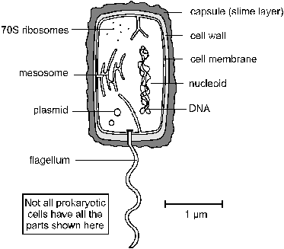
- Cytoplasm. Contains all the enzymes needed for all metabolic reactions, since there are no organelles
- Ribosomes. The smaller (70 S) type.
- Nuclear Zone. The region of the cytoplasm that contains DNA. It is not surrounded by a nuclear membrane.
- DNA. Always circular, and not associated with any proteins to form chromatin.
- Plasmid. Small circles of DNA, used to exchange DNA between bacterial cells, and very useful for genetic engineering.
- Cell membrane. made of phospholipids and proteins, like eukaryotic membranes.
- Mesosome. A tightly-folded region of the cell membrane containing all the membrane-bound proteins required for respiration and photosynthesis.
- Cell Wall. Made of murein, which is a glycoprotein (i.e. a protein/carbohydrate complex). There are two kinds of cell wall, which can be distinguished by a Gram stain: Gram positive bacteria have a thick cell wall and stain purple, while Gram negative bacteria have a thin cell wall with an outer lipid layer and stain pink.
- Capsule (or Slime Layer). A thick polysaccharide layer outside of the cell wall. Used for sticking cells together, as a food reserve, as protection against desiccation and chemicals, and as protection against phagocytosis.
- Flagellum. A rigid rotating helical-shaped tail used for propulsion. The motor is embedded in the cell membrane and is driven by a H⁺ gradient across the membrane. Clockwise rotation drives the cell forwards, while anticlockwise rotation causes a chaotic spin. This is an example of a rotating motor in nature.

Summary of the Differences Between Prokaryotic and Eukaryotic Cells
Prokaryotic Cells | Eukaryotic cells
small cells (< 5 μm) | larger cells (> 10 μm)
always unicellular | often multicellular
no nucleus or any membrane-bound organelles | always have nucleus and other membrane-bound organelles
DNA is circular, without proteins | DNA is linear and associated with proteins to form chromatin
ribosomes are small (70S) | ribosomes are large (80S)
no cytoskeleton | always has a cytoskeleton
cell division is by binary fission | cell division is by mitosis or meiosis
reproduction is always asexual | reproduction is asexual or sexual

Endosymbiosis
Prokaryotic cells are far older and more diverse than eukaryotic cells. Prokaryotic cells have probably been around for 3.5 billion years - 2.5 billion years longer than eukaryotic cells. It is thought that eukaryotic cell organelles like mitochondria and chloroplasts are derived from prokaryotic cells that became incorporated inside larger prokaryotic cells. This idea is called endosymbiosis, and is supported by these observations:
- organelles contain circular DNA, like bacteria cells.
- organelles contain 70S ribosomes, like bacteria cells.
- organelles have double membranes, as though a single-membrane cell had been engulfed and surrounded by a larger cell.

The Cell Membrane
The cell membrane (or plasma membrane) surrounds all living cells. It controls how substances can move in and out of the cell and is responsible for many other properties of the cell as well. The membranes that surround the nucleus and other organelles are almost identical to the cell membrane. Membranes are composed of phospholipids, proteins and carbohydrates arranged in a fluid mosaic structure, as shown in this diagram.
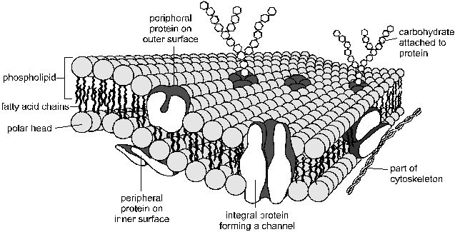
The phospholipids form a thin, flexible sheet, while the proteins "float" in the phospholipid sheet like icebergs, and the carbohydrates extend out from the proteins.
The phospholipids are arranged in a bilayer, with their polar, hydrophilic phosphate heads facing outwards, and their non-polar, hydrophobic fatty acid tails facing each other in the middle of the bilayer. This hydrophobic layer acts as a barrier to all but the smallest molecules, effectively isolating the two sides of the membrane. Different kinds of membranes can contain phospholipids with different fatty acids, affecting the strength and flexibility of the membrane, and animal cell membranes also contain cholesterol linking the fatty acids together and so stabilising and strengthening the membrane.
The proteins usually span from one side of the phospholipid bilayer to the other (intrinsic proteins), but can also sit on one of the surfaces (extrinsic proteins). They can slide around the membrane very quickly and collide with each other, but can never flip from one side to the other. The proteins have hydrophilic amino acids in contact with the water on the outside of membranes, and hydrophobic amino acids in contact with the fatty chains inside the membrane. Proteins comprise about 50% of the mass of membranes, and are responsible for most of the membrane's properties.
- Proteins that span the membrane are usually involved in transporting substances across the membrane (more details below).
- Proteins on the inside surface of cell membranes are often attached to the cytoskeleton and are involved in maintaining the cell's shape, or in cell motility. They may also be enzymes, catalysing reactions in the cytoplasm.
- Proteins on the outside surface of cell membranes can act as receptors by having a specific binding site where hormones or other chemicals can bind. This binding then triggers other events in the cell. They may also be involved in cell signalling and cell recognition, or they may be enzymes, such as maltase in the small intestine (more in digestion).
The carbohydrates are found on the outer surface of all eukaryotic cell membranes, and are usually attached to the membrane proteins. Proteins with carbohydrates attached are called glycoproteins. The carbohydrates are short polysaccharides composed of a variety of different monosaccharides, and form a cell coat or glycocalyx outside the cell membrane. The glycocalyx is involved in protection and cell recognition, and antigens such as the ABO antigens on blood cells are usually cell-surface glycoproteins.
Remember that a membrane is not just a lipid bilayer, but comprises the lipid, protein and carbohydrate parts.

Transport Across The Membrane
Cell membranes are a barrier to most substances, and this property allows materials to be concentrated inside cells, excluded from cells, or simply separated from the outside environment. This is compartmentalization is essential for life, as it enables reactions to take place that would otherwise be impossible. Eukaryotic cells can also compartmentalize materials inside organelles. Obviously materials need to be able to enter and leave cells, and there are five main methods by which substances can move across a cell membrane:
- 1. Simple Diffusion
- 2. Osmosis
- 3. Facilitated Diffusion
- 4. Active Transport
- 5. Vesicles
1. Simple Diffusion
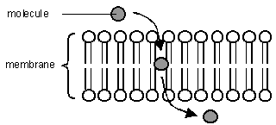
A few substances can diffuse directly through the lipid bilayer part of the membrane. The only substances that can do this are lipid-soluble molecules such as steroids, or very small molecules, such as H₂O, O₂ and CO₂. For these molecules the membrane is no barrier at all. Since lipid diffusion is (obviously) a passive diffusion process, no energy is involved and substances can only move down their concentration gradient. Lipid diffusion cannot be controlled by the cell, in the sense of being switched on or off.
2. Osmosis
Osmosis is the diffusion of water across a membrane. It is in fact just normal lipid diffusion, but since water is so important and so abundant in cells (its concentration is about 50 M), the diffusion of water has its own name - osmosis. The contents of cells are essentially solutions of numerous different solutes, and the more concentrated the solution, the more solute molecules there are in a given volume, so the fewer water molecules there are. Water molecules can diffuse freely across a membrane, but always down their concentration gradient, so water therefore diffuses from a dilute to a concentrated solution.
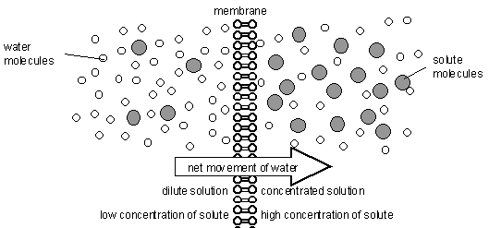
Water Potential. Osmosis can be quantified using water potential, so we can calculate which way water will move, and how fast. Water potential (Ψ, the Greek letter psi, pronounced "sy") is a measure of the water molecule potential for movement in a solution. It is measured in units of pressure (Pa, or usually kPa), and the rule is that water always moves by osmosis from less negative to more negative water potential (in other words it's a bit like gravity potential or electrical potential). 100% pure water has Ψ = 0, which is the highest possible water potential, so all solutions have Ψ < 0 (i.e. a negative number), and you cannot get Ψ > 0.
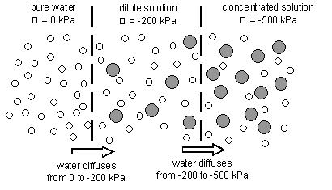
Cells and Osmosis. The concentration (or OP) of the solution that surrounds a cell will affect the state of the cell, due to osmosis. There are three possible concentrations of solution to consider:
- Isotonic solution a solution of equal OP (or concentration) to a cell
- Hypertonic solution a solution of higher OP (or concentration) than a cell
- Hypotonic solution a solution of lower OP (or concentration) than a cell
- The effects of these solutions on cells are shown in this diagram:
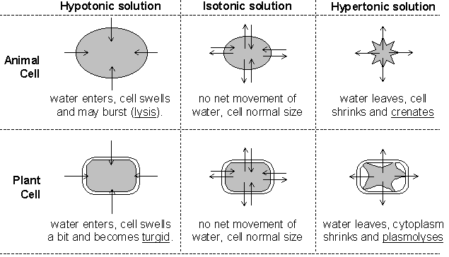
The diagram below shows what happens when 2 fresh raw eggs with their shells removed with acid are placed into sucrose solution (hypertonic) and distilled water (hypotonic). Water enters the egg in water (endosmosis) causing it to swell and water leaves the egg in sucrose causing it to shrink (exosmosis).
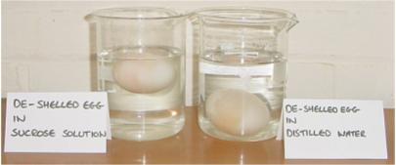
These are problems that living cells face all the time. For example:
- Simple animal cells (protozoans) in fresh water habitats are surrounded by a hypotonic solution and constantly need to expel water using contractile vacuoles to prevent swelling and lysis.
- Cells in marine environments are surrounded by a hypertonic solution, and must actively pump ions into their cells to reduce their water potential and so reduce water loss by osmosis.
- Young non-woody plants rely on cell turgor for their support, and without enough water they wilt. Plants take up water through their root hair cells by osmosis, and must actively pump ions into their cells to keep them hypertonic compared to the soil. This is particularly difficult for plants rooted in salt water.

3. Facilitated Diffusion.
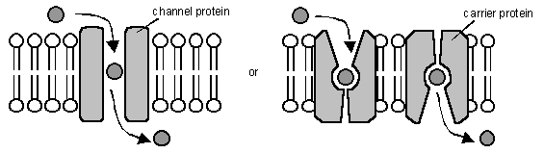
Facilitated diffusion is the transport of substances across a membrane by a trans-membrane protein molecule. The transport proteins tend to be specific for one molecule (a bit like enzymes), so substances can only cross a membrane if it contains the appropriate protein. As the name suggests, this is a passive diffusion process, so no energy is involved and substances can only move down their concentration gradient. There are two kinds of transport protein:
- Channel Proteins form a water-filled pore or channel in the membrane. This allows charged substances (usually ions) to diffuse across membranes. Most channels can be gated (opened or closed), allowing the cell to control the entry and exit of ions.
- Carrier Proteins have a binding site for a specific solute and constantly flip between two states so that the site is alternately open to opposite sides of the membrane. The substance will bind on the side where it at a high concentration and be released where it is at a low concentration.
The rate of diffusion of a substance across a membrane increases as its concentration gradient increases, but whereas lipid diffusion shows a linear relationship, facilitated diffusion has a curved relationship with a maximum rate. This is due to the rate being limited by the number of transport proteins.
4. Active Transport (or Pumping).
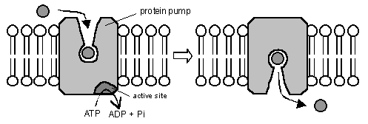
Active transport is the pumping of substances across a membrane by a trans-membrane protein pump molecule. The protein binds a molecule of the substance to be transported on one side of the membrane, changes shape, and releases it on the other side. The proteins are highly specific, so there is a different protein pump for each molecule to be transported. The protein pumps are also ATPase enzymes, since they catalyse the splitting of ATP into ADP + phosphate (Pi), and use the energy released to change shape and pump the molecule. Pumping is therefore an active process, and is the only transport mechanism that can transport substances up their concentration gradient.
The Na⁺K⁺ Pump. This transport protein is present in the cell membranes of all animal cells and is the most abundant and important of all membrane pumps. We look at it in more detail in module 4 (A2 course)
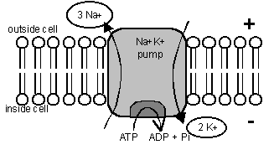

5. Vesicles
The processes described so far only apply to small molecules. Large molecules (such as proteins, polysaccharides and nucleotides) and even whole cells are moved in and out of cells by using membrane vesicles.
Endocytosis is the transport of materials into a cell. Materials are enclosed by a fold of the cell membrane, which then pinches shut to form a closed vesicle. Strictly speaking the material has not yet crossed the membrane, so it is usually digested and the small product molecules are absorbed by the methods above. When the materials and the vesicles are small (such as a protein molecule) the process is known as pinocytosis (cell drinking), and if the materials are large (such as a white blood cell ingesting a bacterial cell) the process is known as phagocytosis (cell eating).
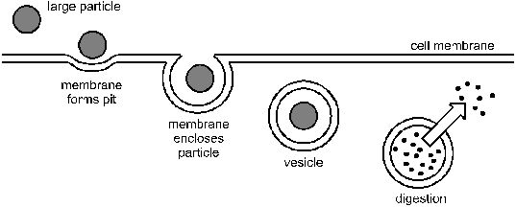
Exocytosis is the transport of materials out of a cell. It is the exact reverse of endocytosis. Materials to be exported must first be enclosed in a membrane vesicle, usually from the RER and Golgi Body. Hormones and digestive enzymes are secreted by exocytosis from the secretory cells of the intestine and endocrine glands.
Sometimes materials can pass straight through cells without ever making contact with the cytoplasm by being taken in by endocytosis at one end of a cell and passing out by exocytosis at the other end.
Summary of Membrane Transport

method | uses energy | uses proteins | specific | controllable
Simple Diffusion | N | N | N | N
Osmosis | N | N | Y | N
Facilitated Diffusion | N | Y | Y | Y
Active Transport | Y | Y | Y | Y
Vesicles | Y | N | Y | Y

